Consultancy Services for Preparation of Expressway Development Master Plan (EDMP) for Uganda

Contract No. UNRA/SRVCS/16-17/00069

Traffic Survey Report

Final, 17th June 2020

Korea Expressway Corporation in Joint Venture with Kyong Dong Engineering Co., Ltd. and in association with Centre for Infrastructure Consulting Ltd.
Document Verification
List of Acronyms
Lot1: Consultancy Services for Preparation of Expressway Development Master Plan (EDMP) for Uganda |  |  |  |  | Job number
 |  |  |  |  | UNRA/SRVCS/16-17/00069
Document title |  | TRAFFIC SURVEY REPORT |  |  | File reference
 |  |  |  |  | Final
Document ref
Revision | Date | Filename | Traffic Survey Report (Draft).pdf
Draft | 20/03/20 | Description | Traffic Survey Report for EDMP
Draft | 20/03/20 | Description | Prepared by | Checked by |  | Approved by
Draft | 20/03/20 | Name | Isaac Muyinza | Park, Sang Hoon |  | Kang, Jeong Gyu
Draft | 20/03/20 | Signature |  | 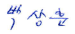 |  | 
Revision01 | 8/04/20 | Filename | EDMP_Traffic_Survey_Report_Rev01.pdf
Revision01 | 8/04/20 | Description | Traffic Survey Report for EDMP
Revision01 | 8/04/20 | Description | Prepared by | Checked by |  | Approved by
Revision01 | 8/04/20 | Name | Isaac Muyinza | Park, Sang Hoon |  | Kang, Jeong Gyu
Revision01 | 8/04/20 | Signature
Final | 17/06/20 | Filename | EDMP_Traffic_Survey_Report_Final.pdf
Final | 17/06/20 | Description | Traffic Survey Report for EDMP
Final | 17/06/20 | Description | Prepared by | Checked by |  | Approved by
Final | 17/06/20 | Name | Isaac Muyinza | Park, Sang Hoon |  | Kang, Jeong Gyu
Final | 17/06/20 | Signature
 |  | Filename
 |  | Description
 |  | Description | Prepared by | Checked by |  | Approved by
 |  | Name
 |  | Signature

AADT | Annual Average Daily Traffic
ALS | Axle Load Survey
ATC | Automated Traffic Counts
BCR | Benefit to Cost Ratio
BRT | Bus Rapid Transit
CAPEX | Capital Expenditure
CBD | Central Business District
COMESA | Common Market for Eastern and Southern Africa
CPI | Consumer Price Index
CSI | Construction Sector Index
DRC | Democratic Republic of Congo
EAC | East Africa Community
EDMP | Expressway Development Master Plan
EIA | Environmental Impact Assessment
ESIA | Environmental and Social Impact Assessment
EU | European Union
FHWA | Federal Highway Administration
FF | Free Flow or Friction Factor
GDP | Gross Domestic Product
GIS | Geographic Information Systems
GKMA | Greater Kampala Metropolitan Area
GKMAPDF | Greater Kampala Metropolitan Area Physical Development Framework
GPS | Global Positioning System
GUI | Graphic User Interface
HBE_H | Home-Based Education, High-income
HBE_L | Home-Based Education, Low-income
HBE_M | Home-Based Education, Medium-income
HBO | Home-Based Other
HBW_H | Home-Based Work, High-Income
HBW_L | Home-Based Work, Low-Income
HBW_M | Home-Based Work, Medium-Income
HDM4 | Highway Development and Management Model (version 4)
HIV/AIDS | Human Immunodeficiency Virus Infection/Acquired Immunodeficiency Syndrome
IP | Inter Peak
ITS | Intelligent Transportation System
JTC | Junction Turning Count
JTS | Journey Time Survey
KCC | Kampala City Council
KCCA | Kampala Capital City Authority
KDEC | Kyong Dong Engineering Co., Ltd.
KEC | Korea Expressway Corporation
KIIDP | Kampala Institutional and Infrastructure Development Project
Km | Kilometre
Km/h | Kilometres per hour
KUTIP | Kampala Urban Traffic Improvement Plan
LOS | Level of Service
LRT | Light Rail Transport
LU | Land Use
MCC | Manual Classified Counts
MoWHC | Ministry of Works, Housing and Communications
MoWT | Ministry of Works & Transport
MRT | Mass Rapid Transit
NDP | National Development Plan
NEF | Night Equivalent Factor
NHB | Non-Home Based
NPDP | National Physical Development Plan
NTMP | National Transport Master Plan
OD | Origin-Destination
OECD | Organisation for Economic Cooperation and Development
PCE | Passenger Car Equivalent
PDF | Physical Development Framework
PPP | Public Private Partnership
PT | Public Transport
RoW | Right of Way
RP | Revealed Preference
RUC | Road User Cost
SCF | Seasonal Correction Factor
SGR | Standard Gauge Railway
SP | Stated Preference
sqm | Square Meter
TAZ | Traffic Analysis Zone
TDM | Travel Demand Model
TOR | Terms of Reference
UBOS | Uganda bureau of statistics
UDB | Uganda Development Bank
UDC | Uganda Development Corporation
UGX | Uganda Shilling
UNBS | Uganda National Bureau of Standards
UNRA | Uganda National Roads Authority
USH | Uganda Shilling
VDF | Volume Delay Function
VHT | Vehicle Hours Travelled
VKT | Vehicle Kilometers Travelled
VOT | Value of Time
WTP | Willingness to Pay

TABLE OF CONTENTS | 1 INTRODUCTION 19  1.1 Background 19  1.1.1 Roads Management in Uganda 19  1.1.2 Engagement of Consultant 19  1.1.3 Objectives of the Assignment 19  1.2 Purpose of the Traffic Survey 20  1.3 Purpose of Report 21  1.4 Schedule of Traffic Surveys 21  2 SCOPE OF SURVEYS 23  2.1 Traffic Survey Sites 23  2.1.1 Selection of Traffic Survey Sites 23  2.1.2 Inspection and Approval of Survey Sites 25  2.2 Location of Traffic Survey Sites 25  2.2.1 MCC and OD Surveys 25  2.2.2 Location of Junction Turning Counts 33  2.2.3 Journey Time Survey Routes 34  2.2.4 Location of Stated Preference Survey Sites 38  2.2.5 Location of Public Transport (Bus) Survey Sites 39  2.2.6 Accident Data 40  2.2.7 Locations for Ferry Surveys 40  2.2.8 Locations of Automatic Traffic Counts (ATC) Sites 41  2.2.9 Locations of Axle Load Survey (ALS) Sites 42  2.3 Vehicle Classification 43  2.4 Survey Forms 44  3 MANUAL CLASSIFIED COUNTS (MCC) SURVEYS 45  3.1 Introduction and Methodology 45  3.1.1 Survey Personnel and Training 45  3.1.2 Survey Period 45  3.1.3 Survey Diary 46  3.2 Collected MCC Data 46  3.2.1 ATC Data - Estimation of Seasonal Correction Factors 47  3.2.2 Cordon 1 MCC Data 48  3.2.3 Cordon 2 MCC Data 50  3.2.4 Cordon 3 MCC Data 51  3.2.5 Cordon 4 and 5 MCC Data 52  3.3 Hourly Variation of Traffic 54  3.3.1 MCC Data Analysis – Cordon 1 54  3.3.2 MCC Data Analysis – Cordon 2 55  3.3.3 MCC Data Analysis – Cordon 3 57  3.3.4 MCC Data Analysis – Cordon 4 58  3.3.5 MCC Data Analysis – Cordon 5 59  3.3.6 Overall Observations from MCC Data 61  3.4 Vehicle Registrations in Uganda 62  3.4.1 New Vehicle Registration Data 62  3.4.2 Total Number of Vehicles in the Country 63  3.4.3 Estimation of Scrappage Rates and Residual Vehicle Population 65  4 ORIGIN – DESTINATION SURVEYS 68  4.1 Introduction 68  4.2 Methodology 68  4.2.1 Site Selection 68  4.2.2 Survey Personnel and Training 68  4.2.3 Site Layouts, Signage and Notices 68  4.2.4 Survey Direction and Period 69  4.2.5 Interviews 69  4.2.6 Survey Diary 69  4.3 Sampling 71  4.4 Collected OD Data 72  4.4.1 Cordon 1 OD Sample Rates 72  4.4.2 Cordon 2 Sample Rates 74  4.4.3 Cordon 3 Sample Rates 75  4.4.4 Cordon 4 and Cordon 5 Sample Rates 76  4.5 Sample Rates by Vehicle Type 77  4.5.1 Analysis Results 77  4.5.2 Observations 79  4.6 Journey Purpose 80  4.6.1 Analysis Results 80  4.6.2 Observations 84  4.7 Average Trip Length 85  4.7.1 Analysis Results 85  4.7.2 Observations 86  4.8 Average Journey Time 87  4.8.1 Analysis Results 87  4.8.2 Observations 89  4.9 Trip Frequency 89  4.9.1 Analysis Results 89  4.9.2 Observations 91  4.10 Future Use of Expressways 92  4.10.1 Analysis Results 92  4.10.2 Observations 94  4.11 Nationwide OD Matrix 95  4.11.1 Vehicle Classes 95  4.11.2 Zone Structure 95  4.11.3 OD Matrices 96  5 JUNCTION TURNING COUNTS (JTC) SURVEYS 97  5.1 Introduction and Methodology 97  5.1.1 Survey Period 97  5.1.2 Survey Diary 97  5.2 Results and Analysis 97  6 jOURNEY TIME AND GIS DATA 100  6.1 Journey Time Surveys 100  6.1.1 General Approach 100  6.1.2 Survey Period 100  6.1.3 Survey Diary 100  6.2 Journey Time Surveys - Results and Analysis 101  6.2.1 Journey Time Analysis for JT1 Kampala – Jinja Highway 104  6.2.2 Journey Time Analysis for JT18 Kampala Northern Bypass (Busega) to Entebbe (Old Entebbe Road) 105  6.2.3 Journey Time Analysis for JT20 Kampala Northern Bypass – Luwero – Karuma 107  6.2.4 Journey Time Analysis for JT23 Kampala Northern Bypass – Kiboga – Hoima 108  6.2.5 Journey Time Analysis for JT24 Kampala Northern Bypass – Mubende – Fort Portal 110  6.2.6 Journey Time Analysis for JT31 Busega – Buwama - Masaka 111  6.2.7 Overall Journey Time Analysis 113  6.3 GIS Data 114  7 STATED PREFERENCE SURVEYS 116  7.1 Introduction 116  7.2 Methodology 116  7.2.1 Site Selection 116  7.2.2 Survey Personnel and Training 117  7.2.3 Survey Period 117  7.2.4 Willingness to Pay (WTP) Surveys 118  7.2.5 Sampling 118  7.3 SP Data Analysis Results 118  7.3.1 Summary Totals 118  7.3.2 Summary Results – All Regions 120  8 PUBLIC TRANSPORT (PT) SURVEYS 127  8.1 Introduction 127  8.2 Methodology 127  8.2.1 Site Selection 127  8.2.2 Survey Personnel and Training 127  8.2.3 Survey Period 128  8.3 PT Data Analysis Results 128  8.3.1 Summary Analysis - Kampala 128  8.3.2 Summary Analysis - Countrywide 131  9 ACCIDENT DATA COLLECTION 138  9.1 Introduction 138  9.2 Methodology 138  9.3 Accident Data Analysis Results 138  9.3.1 Summary Results – Individual Stations 138  9.3.2 Summary Results – Countrywide 147  10 FERRY SURVEYS 149  10.1 Introduction 149  10.2 Methodology 149  10.3 Historic Ferry Data 149  10.4 Ferry Survey Data Analysis Results 150  11 AUTOMATIC TRAFFIC COUNT (ATC) SURVEYS 154  11.1 Introduction 154  11.2 Objective of the Survey 154  11.3 Methodology 155  11.3.1 Method of Collection 155  11.3.2 Site Selection 155  11.4 ATC Equipment 156  11.4.1 Vehicle Classification System 156  11.4.2 Calibration of the RSU 156  11.5 ATC Data Analysis Results 157  12 AXLE LOAD SURVEYS 162  12.1 Introduction 162  12.1.1 Location of Survey Sites 162  12.2 Methodology 162  12.2.1 Survey Equipment 162  12.2.2 Survey Team 163  12.2.3 Survey Period 163  12.3 Vehicle Classifications and Axle Load Configurations 163  12.4 Axle Weight Limits 164  12.5 Axle Load Survey Samples 165  12.6 Axle Load Analysis for Selected Routes 166  12.6.1 Kampala – Masaka Highway 167  12.6.2 Kampala – Hoima Highway 170  12.6.3 Kampala – Gulu Highway 172  12.6.4 Kampala – Jinja Highway 175  13 APPENDICES 178  13.1 Appendix A – Survey Forms 178  13.2 Appendix B – MCC Data Analysis Results 179  13.3 Appendix C – OD Data Analysis Results 186  13.4 Appendix D – JTC Data 192  13.5 Appendix E – Journey Time and GIS Data 193  13.6 Appendix F – Stated Preference Data 196  13.7 Appendix G – Public Transport Data (on CD) 197  13.8 Appendix H – Accident Data (on CD) 198  13.9 Appendix I – Ferry Data Analysis 199  13.10 Appendix J –ATC Data 200  13.11 Appendix K – Axle Load Data Analysis 201
LIST OF TABLES
Table 1-1: Summary survey schedule 21
Table 2-1: Description and location of survey sites on Cordon 1 (C1) 26
Table 2-2: Description and location of survey sites on Cordon 2 (C2) 28
Table 2-3: Description and location of survey sites on Cordon 3 (C3) 30
Table 2-4: Description and location of survey sites on Cordons 4 and 5 (C4 and C5) 32
Table 2-5: Description of junction turning counts 34
Table 2-6: Description of journey time survey routes 35
Table 2-7: Description of Stated Preference Survey sites 38
Table 2-8: Description and location of ferry survey routes 41
Table 2-9: Description and location of ATC survey sites 42
Table 2-10: Description and location of Axle Load survey sites 43
Table 3-1: Estimation of Seasonal Correction Factor (SCF) 47
Table 3-2: Seasonal Correction Factor (SCF) values used to convert ADT 48
Table 3-3: MCC Survey Traffic Volumes for Cordon 1 (C1) 48
Table 3-4: MCC Survey Traffic Volumes for Cordon 2 (C2) 50
Table 3-5: MCC Survey Traffic Volumes for Cordon 3 (C3) 51
Table 3-6: MCC Survey Traffic Volumes for Cordon 4 and 5 (C4 and C5) 52
Table 3-7: New vehicle registrations in Uganda 2013-2019 63
Table 3-8: Estimated vehicle population in Uganda (not adjusted for scrappage) 2005-2019 64
Table 3-9: Estimated residual vehicle population in Uganda (adjusted for scrappage) 2005-2019 65
Table 4-1: Comparison of collected and required OD sample for Cordon 1 (C1) 72
Table 4-2: Comparison of collected and required OD sample for Cordon 2 (C2) 74
Table 4-3: Comparison of collected and required OD sample for Cordon 3 (C3) 75
Table 4-4: Comparison of collected and required OD sample for Cordon 4 and 5 (C4 and C5) 76
Table 5-1: Summary JTC data for Kitgum Junction (ADT) 98
Table 5-2: Summary JTC data for Clock Tower Junction (ADT) 98
Table 5-3: Summary JTC data for Kibuye Junction (ADT) 98
Table 5-4: Summary JTC data for Mulago Junction (ADT) 98
Table 5-5: Summary JTC data for Nateete Junction (ADT) 99
Table 6-1: Journey time analysis results for routes JT1 to JT15 101
Table 6-2: Journey time analysis results for routes JT16 to JT28 102
Table 6-3: Journey time analysis results for routes JT29 to JT36 103
Table 7-1: Number of SP interviews 119
Table 7-2: Willingness to pay toll charges by typical journey distance 122
Table 7-3: Willingness to pay toll charges by income of respondent 124
Table 7-4: Willingness to pay toll charges by vehicle type 125
Table 8-1: PT survey results for Kampala 128
Table 8-2: PT survey results for Jinja 131
Table 8-3: PT survey results for Soroti 131
Table 8-4: PT survey results for Tororo 132
Table 8-5: PT survey results for Mbale 132
Table 8-6: PT survey results for Lira 133
Table 8-7: PT survey results for Gulu 133
Table 8-8: PT survey results for Arua 134
Table 8-9: PT survey results for Hoima 134
Table 8-10: PT survey results for Kasese 134
Table 8-11: PT survey results for Luwero 135
Table 8-12: PT survey results for Masaka 135
Table 8-13: PT survey results for Mityana 136
Table 8-14: PT survey results for Mubende 136
Table 8-15: PT survey results for Mbarara 136
Table 8-16: PT survey results for Kabale 136
Table 8-17: PT survey results for Bushenyi 137
Table 8-18: PT survey results for Rukungiri 137
Table 8-19: PT survey results for Kitgum 137
Table 10-1: Analysis of historic ferry data (three-month ADT) 149
Table 11-1: Advantages of ATC surveys 154
Table 11-2: Comparison of control MCC count with ATC count 157
Table 12-1: Description and location of axle load surveys 162
Table 12-2: Description and location of axle load surveys 166

LIST OF FIGURES
Figure 2-1: Location of survey cordon lines 24
Figure 2-2: Location of Cordon 1 (C1) traffic survey sites 26
Figure 2-3: Location of Cordon 2 (C2 North) traffic survey sites 28
Figure 2-4: Location of Cordon 2 (C2 South) traffic survey sites 28
Figure 2-5: Location of Cordon 3 (C3) traffic survey sites 30
Figure 2-6: Location of Cordons 4 and 5 (C4 and C5) traffic survey sites 31
Figure 2-7: Location of junction turning traffic survey sites 33
Figure 2-8: Location of journey time survey routes 35
Figure 2-9: Location of journey time survey routes 38
Figure 2-10: Location of ferry survey routes 40
Figure 2-11: Location of ATC survey sites 41
Figure 2-12: Location of Axle Load survey 42
Figure 3-1: Hourly variation of traffic for Cordon 1 54
Figure 3-2: Average vehicle proportion for Cordon 1 55
Figure 3-3: Hourly variation of traffic for Cordon 2 56
Figure 3-4: Average vehicle proportion for Cordon 2 56
Figure 3-5: Hourly variation of traffic for Cordon 3 57
Figure 3-6: Average vehicle proportion for Cordon 3 57
Figure 3-7: Hourly variation of traffic for Cordon 4 58
Figure 3-8: Average vehicle proportion for Cordon 4 59
Figure 3-9: Hourly variation of traffic for Cordon 5 60
Figure 3-10: Average vehicle proportion for Cordon 5 60
Figure 3-11: Variation of AADT by cordon 62
Figure 3-12: Format of raw vehicle registration data 63
Figure 3-13: Breakdown of the vehicle population in Uganda 66
Figure 3-14: Growth of vehicle population in Uganda (2005-2019) 67
Figure 4-1: Sample rates by vehicle type for Cordon 1 78
Figure 4-2: Sample rates by vehicle type for Cordon 2 78
Figure 4-3: Sample rates by vehicle type for Cordon 3 78
Figure 4-4: Sample rates by vehicle type for Cordon 4 79
Figure 4-5: Sample rates by vehicle type for Cordon 5 79
Figure 4-6: Journey purpose analysis for Cordon 1 80
Figure 4-7: Journey purpose analysis for Cordon 2 81
Figure 4-8: Journey purpose analysis for Cordon 3 82
Figure 4-9: Journey purpose analysis for Cordon 4 83
Figure 4-10: Journey purpose analysis for Cordon 5 84
Figure 4-11: Average trip length for Cordon 1 85
Figure 4-12: Average trip length for Cordon 2 85
Figure 4-13: Average trip length for Cordon 3 86
Figure 4-14: Average trip length for Cordon 4 86
Figure 4-15: Average trip length for Cordon 5 86
Figure 4-16: Average journey time for Cordon 1 87
Figure 4-17: Average journey time for Cordon 2 88
Figure 4-18: Average journey time for Cordon 3 88
Figure 4-19: Average journey time for Cordon 4 88
Figure 4-20: Average journey time for Cordon 5 89
Figure 4-21: Average trip frequency for Cordon 1 90
Figure 4-22: Average trip frequency for Cordon 2 90
Figure 4-23: Average trip frequency for Cordon 3 90
Figure 4-24: Average trip frequency for Cordon 4 91
Figure 4-25: Average trip frequency for Cordon 5 91
Figure 4-26: Potential use of expressways and willingness to pay toll charges for Cordon 1 92
Figure 4-27: Potential use of expressways and willingness to pay toll charges for Cordon 2 93
Figure 4-28: Potential use of expressways and willingness to pay toll charges for Cordon 3 93
Figure 4-29: Potential use of expressways and willingness to pay toll charges for Cordon 4 93
Figure 4-30: Potential use of expressways and willingness to pay toll charges for Cordon 5 94
Figure 6-1: Average journey time by period for JT1 Kampala - Jinja 104
Figure 6-2: Average journey time per Km for PM for JT1 Kampala - Jinja 105
Figure 6-3: Average journey time by period for JT18 Busega – Entebbe (Old Route) 106
Figure 6-4: Average journey time per Km for PM for JT18 Busega – Entebbe (Old Route) 106
Figure 6-5: Average journey time by period for JT20 Northern Bypass – Luwero - Karuma 107
Figure 6-6: Average journey time per Km for PM for JT20 Northern Bypass – Luwero - Karuma 108
Figure 6-7: Average journey time by period for JT23 Northern Bypass – Kiboga - Hoima 109
Figure 6-8: Average journey time per Km for PM for JT23 Northern Bypass – Kiboga - Hoima 109
Figure 6-9: Average journey time by period for JT24 Northern Bypass – Mubende – Fort Portal 110
Figure 6-10: Average journey time per Km for PM for JT24 Northern Bypass – Mubende – Fort Portal 111
Figure 6-11: Average journey time by period for JT31 Busega – Buwama - Masaka 112
Figure 6-12: Average journey time per Km for PM for JT31 Busega – Buwama - Masaka 112
Figure 6-13: Average speed profile for arterial routes in Uganda 113
Figure 6-14: Format of collected GIS data 115
Figure 7-1: SP Survey Locations 117
Figure 7-2: Gender and age of respondents 120
Figure 7-3: Journey purpose by gender or respondents – Eastern Region 121
Figure 7-4: Journey distance for a typical journey 121
Figure 7-5: Journey time for a typical journey 122
Figure 7-6: Willingness to pay toll charges by typical journey distance 123
Figure 7-7: Willingness to pay toll charges by income of respondent 124
Figure 7-8: Willingness to pay toll charges by vehicle type 126
Figure 9-1: Accident analysis – Jinja District 138
Figure 9-2: Accident analysis – Soroti District 139
Figure 9-3: Accident analysis – Tororo District 139
Figure 9-4: Accident analysis – Mbale District 140
Figure 9-5: Accident analysis – Lira District 140
Figure 9-6: Accident analysis – Gulu District 141
Figure 9-7: Accident analysis – Hoima District 141
Figure 9-8: Accident analysis – Kasese District 142
Figure 9-9: Accident analysis – Luwero District 142
Figure 9-10: Accident analysis – Masaka District 143
Figure 9-11: Accident analysis – Mubende District 143
Figure 9-12: Accident analysis – Mbarara District 144
Figure 9-13: Accident analysis – Kabale District 144
Figure 9-14: Accident analysis – Bushenyi District 145
Figure 9-15: Accident analysis – Rukungiri District 145
Figure 9-16: Accident analysis – Kitgum District 146
Figure 9-17: Accident analysis – Iganga District 146
Figure 9-18: Accident analysis – Arua District 147
Figure 9-19: Accident analysis – All stations combined 147
Figure 10-1: Analysis results for Bukakata-Kalangala ferry 150
Figure 10-2: Analysis results for Zengebe-Namasale (Amolatar) ferry 150
Figure 10-3: Analysis results for Agule-Kokorio (Lake Bisina) ferry 151
Figure 10-4: Analysis results for Nakiwogo-Buwaya ferry 151
Figure 10-5: Analysis results for Omi-Laropi ferry 151
Figure 10-6: Analysis results for Obongi-Sinyanya ferry 152
Figure 10-7: Analysis results for Wanseko-Panyimur ferry 152
Figure 10-8: Analysis results for Kiyindi-Buvuma ferry 152
Figure 10-9: Analysis results for Masindi-Kungu ferry 153
Figure 11-1: ADT variation for KNBP Mityana Rd to Sentema Rd 158
Figure 11-2: ADT variation for KNBP Sentema Rd to Hoima Rd 158
Figure 11-3: ADT variation for KNBP Hoima Rd to Bwaise Junction 159
Figure 11-4: ADT variation for KNBP Gayaza Rd to Kyebando Rd 159
Figure 11-5: ADT variation for KNBP Kyebando Rd to Kisaasi Rd 160
Figure 11-6: ADT variation for KNBP Kisaasi Rd to Nalya Junction 160
Figure 11-7: ADT variation for KNBP Nalya Junction to Bweyogerere 160
Figure 11-8: ADT profile for Northern Bypass highway 161
Figure 12-1: Truck configuration guide 164
Figure 12-2: Axle weight limit guide 165
Figure 12-3: Average total truck loading (Kampala-Masaka Highway) 167
Figure 12-4: Average proportion of overloaded trucks (Kampala-Masaka Highway) 168
Figure 12-5: Percentage by which trucks are overloaded (Kampala-Masaka Highway) 168
Figure 12-6: Load description (Kampala-Masaka Highway) 169
Figure 12-7: Average total truck loading (Kampala-Hoima Highway) 170
Figure 12-8: Average proportion of overloaded trucks (Kampala-Hoima Highway) 171
Figure 12-9: Average proportion of overloaded trucks (Kampala-Hoima Highway) 171
Figure 12-10: Load description (Kampala-Hoima Highway) 172
Figure 12-11: Average total truck loading (Kampala-Gulu Highway) 173
Figure 12-12: Average proportion of overloaded trucks (Kampala-Gulu Highway) 173
Figure 12-13: Average proportion of overloaded trucks (Kampala-Gulu Highway) 174
Figure 12-14: Load description (Kampala-Gulu Highway) 174
Figure 12-15: Average total truck loading (Kampala-Jinja Highway) 175
Figure 12-16: Average proportion of overloaded trucks (Kampala-Jinja Highway) 176
Figure 12-17: Average proportion of overloaded trucks (Kampala-Jinja Highway) 176
Figure 12-18: Load description (Kampala-Jinja Highway) 177

INTRODUCTION

Background

Roads Management in Uganda
The road transport infrastructure in Uganda comprises about 140,000 km of road, including about 20,544 km of national roads; 34,281 km of district roads; 10,108 km of urban roads; and 78,567 km of community access roads. Road transport is by far the most dominant mode of transport in Uganda, carrying over 90% of passenger and freight traffic. Roads provide the only means of access to most of the rural communities and effective management of this asset is of vital importance to the Government of Uganda’s strategy for economic development and poverty reduction. Within the road sector the national roads make up about 15% of the network but carry about 80% of the total road traffic. They also provide vital transport corridors linking the land-locked countries of Rwanda and Burundi, parts of Eastern DRC and Southern Sudan to the sea.
The Government of Uganda (GOU), through the Ministry of Works and Transport (MoWT) has overall responsibility for all roads in Uganda. The Uganda National Roads Authority (UNRA) is responsible for the maintenance and management of the national roads network, whilst the district and urban authorities are responsible for the management and maintenance of district and urban roads, respectively. UNRA's Mandate is to develop and maintain the national roads network, manage ferries linking the national roads network and control axle overloading.

Engagement of Consultant
Korea Expressway Corporation (KEC) in joint venture with Kyong Dong Engineering Company (KDEC) in association with Centre for Infrastructure Consulting (CIC) (collectively referred to as the Consultant), was commissioned by the Uganda National Roads Authority (UNRA) to prepare an Expressway Development Master Plan (EDMP) for Uganda.

Objectives of the Assignment
The objective of the study is to prepare an expressway development master plan EDMP) that would gradually cover the country on new alignments commencing with the highest trafficked sections of the primary national road network near Kampala.
This study will also determine the framework necessary for the progressive introduction of expressways in Uganda taking into account financing and operational modalities.
The anticipated benefits of this expressway system include but are not limited to the following:
- Provision of an integrated road network that will promote economic development of the country, by taking into consideration the immediate and future socio-economic development plans and policies of the Government of Uganda;
- Improved roadway capacity thus reducing congestion, user delays, vehicle emissions and vehicle operating costs;
- Increased mobility between viable demand and supply locations in the country;
- Facilitation of faster and safe uninterrupted flow of traffic, reduction in travel times and costs and improved accessibility; and
- Supporting social and economic growth in Uganda;
- Maximizing the catchment for motorists by meeting the current and expected future transport needs of both passenger and freight and ensuring efficient utilization of assets and investments.

Purpose of the Traffic Survey
The traffic survey exercise responds to the ToR Section 4 – Scope of Work. The ToR required the Consultant to “conduct necessary surveys for traffic counts, OD for each major category of vehicle, and travel speed. Prepare a nationwide OD matrix distributed by key freight types and major domestic and regional points of OD”.
Subsequent to the presentation of the Inception Report, the scope of the surveys was agreed to include the following surveys:
- Manual Classified Counts (MCC);
- Origin – Destination (OD) Surveys;
- Junction Turning Counts (JTC);
- Journey Time and Speed Data;
- Axle Load Surveys;
- Stated Preference Surveys;
- Public Transport Surveys;
- Traffic Accident Data;
- Ferry Surveys;
- Automated Traffic Counts (ATC); and
- Axle Load Surveys.
The objectives of each of the surveys is further discussed in the report. However, the overarching objective was to collect data through the surveys that would help formulate an expressway development master plan for Uganda.

Purpose of Report
The purpose of the report is to present the data collected during the traffic survey exercise for each survey type. For each survey type, the report discusses in brief the approach to the survey. The data collected for each survey type is then presented together with brief analysis to identify the key characteristics of the traffic flow captured within the survey.
It should be noted that the analysis of data presented in this report is meant to identify key traffic characteristics and is meant to be exhaustive to provide a comprehensive analysis of all existing traffic movement patterns.

Schedule of Traffic Surveys
The traffic survey exercise commenced on 22nd July 2019 and was fully completed on 31st January 2020. This period included a break of approximately one month between 27th August and 23rd September 2019 corresponding to school holidays and assignment reorganization.
A summary schedule of the surveys is presented in Table 1-1 below.
Table 0-1: Summary survey schedule
Summary survey schedule
Survey Type | No. Survey Sites | Survey Period | Description of Survey
Manual Classified Counts (MCC) | 146 | 22nd July – 05th November 2019 | Total 7 days. 5 days 12-hours (7 am – 7 pm), 2 days 24-hours
Origin – Destination (OD) Surveys | 171 | 22nd July – 05th November 2019 | Total 2 days. 1 day for 24-hours (7am - 7am), and 1 day for 12-hours (7am - 7pm).
Junction Turning Counts (JTC) | 5 | 23rd-September– 25th October 2019 | Total 3 days, 12 hours (6 am – 6 pm)
Journey Time and Speed Data | 36 | 16th October – 25th October 2019 | Total 30 days, 1-3passes / Dir, for AM&PM
Axle Load Surveys | 10 | 17th October – 20th October 2019 | Total 3 days, 12 hours, (7 am – 7 pm)
Stated Preference Surveys | 21 | 12th August – 27th October 2019 | Total 3 days, 12 hrs (7 am – 7 pm)
Public Transport Surveys | 20 | 19th September – 29th October 2019 | Total 1 day, 12 hours (6 am – 6 pm)
Traffic Accident Data | 18 | 14th October– 29th October 2019 | Total 30 days
Ferry Surveys | 10 | 14th October– 28th October 2019 | Total 3 days, 12-hours (6 am – 6 pm)
Automated Traffic Counts (ATC) | 7 | 20th October– 06th October 2019 | Total 7 days, 24 hours (6 am – 6 am)
Axle Load Surveys | 10 | 19th September – 29th October 2019 | 3 days, 12 hours (7am-7pm)

SCOPE OF SURVEYS

Traffic Survey Sites

Selection of Traffic Survey Sites
The proposed Expressway road network is intended to cover the entire country as much as possible. As such the project study area was the entire country. Traffic data collection was therefore required to cover the whole country. However, due to the always limited resources; time, manpower and funding, it is not feasible to collect data from all existing roads in the country.
Consideration was carefully taken of the nature of the project and the anticipated outcome using experienced traffic engineering judgement. The following was taken into account:
- The most popular origins and destinations of traffic within the road network;
- The potential routes of the expressways;
- The nature and density of the existing national road network;
- The existing and known future land use patterns and changes which would have an influence upon the proposed expressway network such as the proposed new cities, oil production in Western Uganda, border routes, etc.
Traffic surveys based on cordon lines (better referred to screen lines) were considered most appropriate. Imaginary cordon lines were setout across the entire road network moving from close to Kampala towards all parts of the country (Figure 2-1). The objective in a cordon line survey is to ensure that each trip crosses the line once. However, given the radial nature of the main routes, more than one cordon line crossed the same key route. Still, this has an advantage of ensuring that the detection of trips at the cordon survey sites is clear to avoid multiple counting of any single trip.
Cordon line surveys are also helpful in identifying the variation of traffic along a given route for example, the variation of traffic volume along the Kampala – Jinja highway as one moves from Kampala to Jinja.
Figure 2-1 below presents the cordon lines that were used to set out the traffic survey points.
Figure 2-1: Location of survey cordon lines
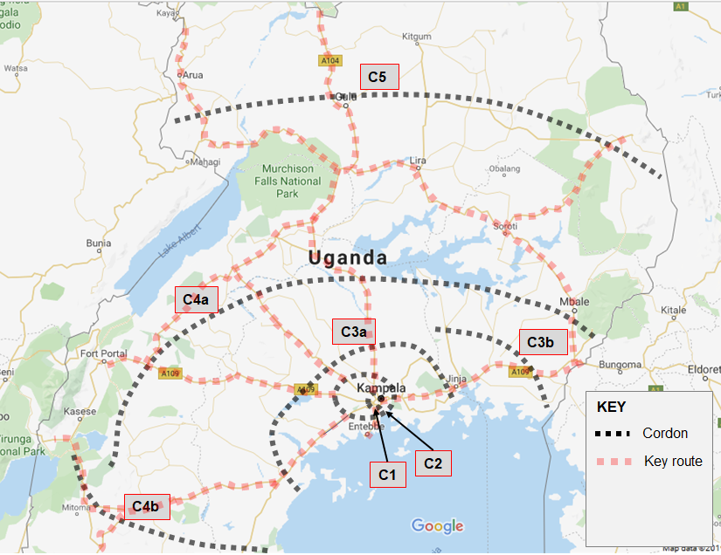

The cordon lines are described below:
- C1 – encircles the Kampala central along the Kampala Northern Bypass to the north, Kampala Jinja Road and Kibuye – Busega highway (Masaka Road);
- C2 – follows the expected route of the proposed Kampala Outer Beltway project. It encircles the Greater Kampala Metropolitan Area (GKMA) at a distance of approximately 20 Km from Kampala city centre, through Wakiso on Hoima Road, Matugga on Bombo Road, Seeta on the Kampala-Jinja highway, Nsangi on Masaka Road and Kajjansi on Entebbe Road.
- C3 – it is the line of an anticipated future second outer belt. The cordon line crosses commences at Masaka, cutting through Sembabule and Mityana, Busunju on Hoima Road, Luwero along the Kampala – Gulu highway and covers the immediate east of Jinja including Busia and Malaba border points. The cordon line runs at a distance of 70 – 200 Km from Kampala.
- C4 – covers the south west, west, central and eastern Uganda. The cordon line runs at an average distance of 200 – 400 Km from Kampala city.
- C5 – generally covers the north of the country. It runs at approximately 350 Km from Kampala in the northern region and covers the West Nile region, the northern and north eastern subregions of the country.

Inspection and Approval of Survey Sites
As part of the preparations for undertaking the traffic survey exercise, the Consultant prepared a Traffic Survey Proposal, a final version of which was presented to the Uganda National Roads Authority (UNRA) on 21st June 2020.
Prior to the commencement of traffic surveys at the identified survey sites, an inspection of the proposed survey sites was undertaken as part of the survey preparation process. The survey sites indicated in the Traffic Survey Proposal were thoroughly inspected to establish the following:
- Suitable locations for undertaking the survey to ensure the safety of both the survey personnel and the motorists;
- Convenience of the proposed survey station for enumerators;
- Minimisation of accident risks and delays to traffic especially for OD survey sites; and
- Rescheduling of surveys to fit with planning constraints, convenience and resource availability.
A joined-up review of the proposed surveys and proposed traffic modelling process was also undertaken to fully rationalise the importance of each proposed survey site.
The survey process described in this report therefore reflects the survey programme subsequent to these changes.

Location of Traffic Survey Sites

MCC and OD Surveys
The establishment of the cordon lines as described above, helped to systematically establish the traffic survey points. Figures 2-2, 2-3, 2-4, 2-5 and 2-6 show the approximate locations of the survey points used. Tables 2-1, 2-2, 2-3 and 2-4 provide the coordinates of the survey stations.
Figure 2-2: Location of Cordon 1 (C1) traffic survey sites
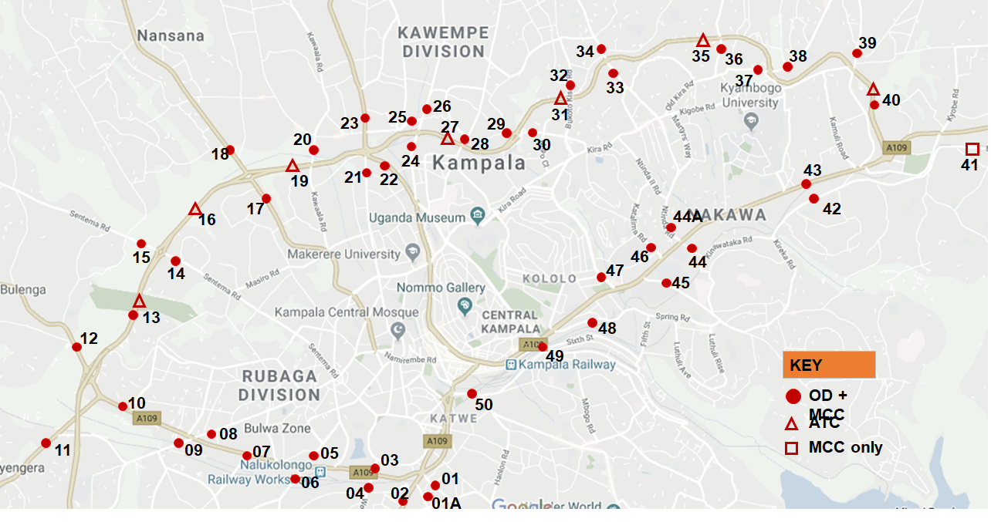

Table 2-2: Description and location of survey sites on Cordon 1 (C1)
DESCRIPTION AND LOCATION OF MCC and OD SURVEY SITES – CORDON 1
Site Ref. | Highway / Link Name | Survey Type | Description of Site | Site Coordinates
01 | Mobutu Road | MCC & OD | Katwe Police | 0.290673, 32.575600
01A | Salama Road | MCC & OD | Calendar Rest House | 0.285704, 32.574774
02 | Entebbe Road | MCC & OD | Kibuye Area | 0.280650, 32.566231
03 | Kalinda Rd | MCC & OD | Kalinda Rd | 0.294576, 32.564423
04 | Weraga Road | MCC & OD | Weraga Road | 0.288085, 32.562599
05 | Kabusu Rd | MCC & OD | Kabusu Rd, North | 0.296818, 32.554118
06 | Kabusu Rd | MCC & OD | Kabusu Road South | 0.291314, 32.549955
07 | Masaka Rd Ndeeba | MCC & OD | Ndeeba Opportunity Bank | 0.295187, 32.548689
08 | Wakaliga Rd North | MCC & OD | Petro City | 0.301002, 32.537499
09 | Wakaliga Rd South | MCC & OD | Family Loaf | 0.298406, 32.529549
10 | Masaka Rd Busega | MCC & OD | Quick Trip Petrol Stn | 0.305455, 32.519442
11 | Masaka Rd Kyengera | MCC & OD | Kalina Pub | 0.299080, 32.508039
12 | Mityana Rd | MCC & OD | Kitoogo Area | 0.315527, 32.512427
13 | Mityana-Sentema | MCC & OD | Mityana-Sentema | 0.320012, 32.521890
14 | Sentema Rd | MCC & OD | Sentema South | 0.330655, 32.530473
15 | Sentema Rd | MCC & OD | Sentema Nth | 0.335000, 32.520699
16 | Northern Bypass | MCC | Northern Bypass | 0.333581, 32.528210
17 | Hoima Rd South | MCC & OD | Namungoona | 0.340879, 32.545912
18 | Hoima Rd Nth | MCC & OD | Lubigi, Kampala Hoima Road | 0.350524, 32.538788
20 | Kawaala Rd | MCC & OD | Kawaala Rd | 0.348475, 32.553808
21 | Sir Apollo Kaggwa Road | MCC & OD | Sir Apollo | 0.345213, 32.562820
22 | Bombo Road North | MCC & OD | Makerere Kavule | 0.346769, 32.567079
23 | Bombo Road North | MCC & OD | Bwaise | 0.355803, 32.562584
24 | Gayaza Rd | MCC & OD | Kalerwe Market | 0.345031, 32.571030
25 | Tula Rd | MCC & OD | Tula Rd Scrap | 0.354754, 32.571201
26 | Gayaza Rd | MCC & OD | Kanyanya | 0.356213, 32.572939
28 | Kisingiri Street | MCC & OD | Kisingiri Rd O/Pass | 0.351458, 32.579985
29 | Kyebando Ring | MCC & OD | Kyebando Ring RD | 0.353347, 32.579129
30 | Kyebando-Kisalosalo | MCC & OD | Kyebando-Kisalosalo | 0.352859, 32.590625
32 | Bukoto Kisasi Rd | MCC & OD | Bukoto Kisasi O/P | 0.360903, 32.598658
33 | Kisasi-Ntinda Rd | MCC & OD | Kisasi-Ntinda Rd | 0.363292, 32.606426
34 | Kisasi-Kyanja Rd | MCC & OD | Kisasi-Kyanja Rd | 0.367922, 32.603860
34 | Kisasi-Kyanja Rd | MCC & OD | Kisasi-Kyanja Rd | 0.367922, 32.603860
36 | Mbogo Road | MCC & OD | Mbogo Rd O/P along Mbogo Road | 0.370118, 32.624462
37 | Naalya Road | MCC & OD | Nalya Road West | 0.363439, 32.631545
38 | Naalya Road | MCC & OD | Nalya Road East | 0.363867, 32.635436
39 | Namugongo Rd | MCC & OD | Namugongo Road O/P | 0.365559, 32.648376
40 | Bweyogerere - Nalya | MCC & OD | Northern Bypass | 0.356779, 32.651061
41 | Namanve Ind Park | MCC | Bweyogerere -Mukono Lower Road | 0.350390, 32.667224
42 | Kinawataka | MCC & OD | Kireka Road | 0.341715, 32.642292
43 | Kla-Jinja Hway | MCC & OD | Kyambogo | 0.334609, 32.616881
44 | Nakawa-Jinja Rd | MCC & OD | URA | 0.332839, 32.619005
44A | Ntinda Road | MCC & OD | Ntinda Road MICD | 0.334612, 32.616827
45 | New Port Bell Rd | MCC & OD | MUBS | 0.326986, 32.613302
46 | Katalima Road | MCC & OD | Katalima Road | 0.335609, 32.609976
47 | Lugogo Bypass | MCC & OD | Lugogo Bypass | 0.326840, 32.605141
48 | Old Port Bell Road | MCC & OD | Old Port Bell Road | 0.319329, 32.599589
49 | Access Road | MCC & OD | Access | 0.315844, 32.593938
50 | Nsambya Rd | MCC & OD | Post Office | 0.307334, 32.579817

Figure 2-3: Location of Cordon 2 (C2 North) traffic survey sites
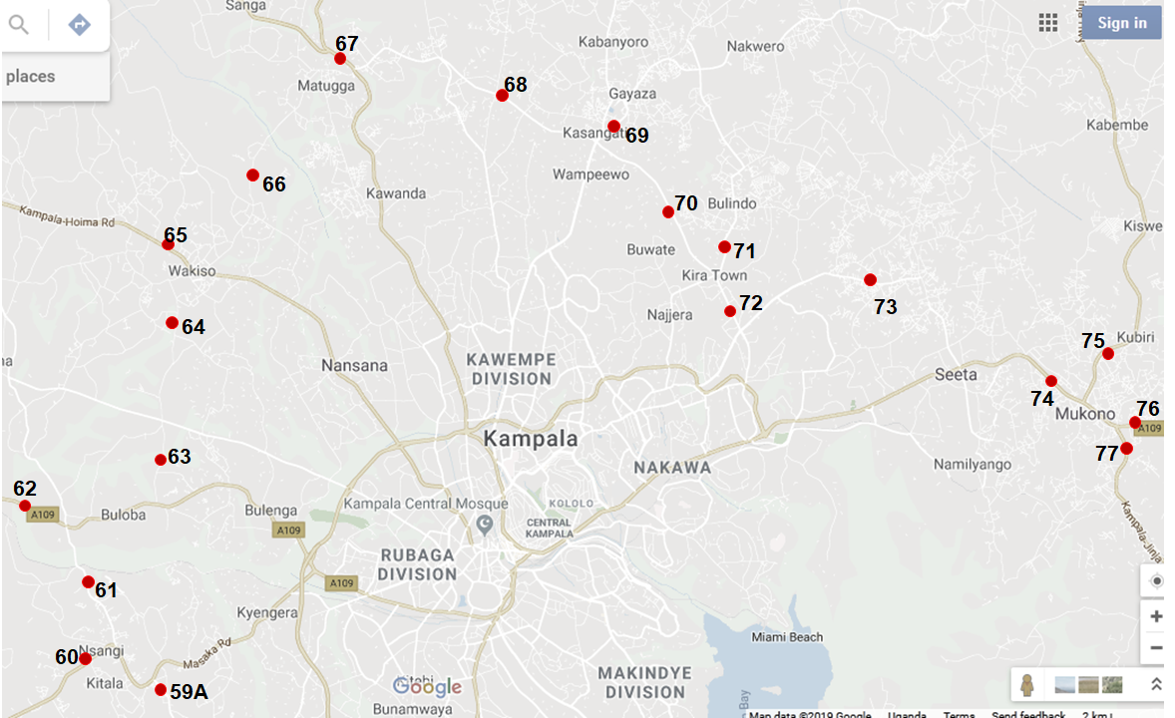

Figure 2-4: Location of Cordon 2 (C2 South) traffic survey sites
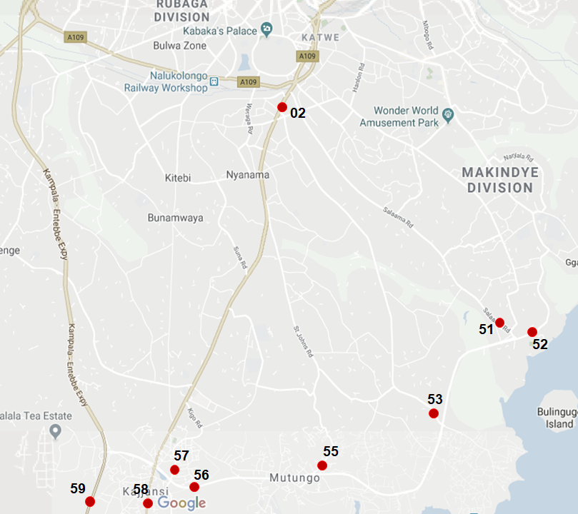

Table 2-3: Description and location of survey sites on Cordon 2 (C2)
DESCRIPTION AND LOCATION OF MCC AND OD SURVEY SITES - CORDON 2
Site Ref. | Highway / Link Name | Survey Type | Description of Site | Site Coordinates
51 | Salama Road | MCC & OD | Former Cloud Nine | 0.241482, 32.619008
52 | Wavamunno Rd | MCC & OD | Wavamunno Rd | 0.239626, 32.622495
53 | Busabala Road | MCC & OD | Busabala | 0.222691, 32.603730
55 | Lubugumu Road | MCC & OD | Lubugumu Road | 0.211428, 32.577503
56 | Munyonyo Spur | MCC & OD | Munyonyo | 0.208439, 32.546453
57 | Kigo Road | MCC & OD | Kigo Road | 0.210418, 32.545842
58 | Entebbe Road | MCC & OD | Entebbe Dual Section | 0.090099, 32.491886
59 | Kampala Entebbe Expressway | MCC & OD | Kitende | 0.115952, 32.512044
59A | Budo Road | MCC & OD | Budo Road | 0.272468, 32.468676
60 | Masaka Rd | MCC & OD | Maya | 0.280159, 32.448202
61 | Nsangi-Buloba Road | MCC & OD | Nsangi-Buloba | 0.285838, 32.455233
62 | Mityana Road | MCC & OD | Buloba, Mityana | 0.322739, 32.436379
63 | Buloba-Bukasa Rd | MCC & OD | Buloba-Bukasa | 0.357924, 32.469542
64 | Bukasa-Wakiso Road | MCC & OD | Bukasa-Wakiso | 0.393462, 32.472860
65 | Hoima Road | MCC & OD | Wakiso | 0.402065, 32.476697
66 | Wakiso-Matugga Rd | MCC & OD | Wakiso-Matugga Rd | 0.401003, 32.485440
67 | Bombo Road | MCC & OD | Matugga Gaz Fuel Station | 0.464554, 32.523192
68 | Matugga-Kasangati Road | MCC & OD | Matugga-Kasangati | 0.440817, 32.596578
69 | Gayaza Road | MCC & OD | Kasangati-Gayaza | 0.441040, 32.605949
70 | Kasangati-Kira Rd | MCC & OD | Kasangati-Kira | 0.435823, 32.605117
71 | Kira-Bulindo Rd | MCC & OD | Bulindo | 0.399256, 32.640667
72 | Kira-Kyaliwajjala Rd | MCC & OD | Kira-Kyaliwajjala | 0.393285, 32.640646
73 | Sonde Road | MCC & OD | Sonde | 0.395449, 32.684640
74 | Kampala -Jinja Road | MCC & OD | Near Kigunga | 0.371954, 32.728287
75 | Mukono-Kalagi Rd | MCC & OD | Mukono-Kalagi | 0.375153, 32.760370
76 | Kla-Jinja Hway | MCC & OD | Near Wantoni | 0.351310, 32.765739
77 | Katosi Rd | MCC & OD | Katosi Rd | 0.348475, 32.762688
Figure 2-5: Location of Cordon 3 (C3) traffic survey sites
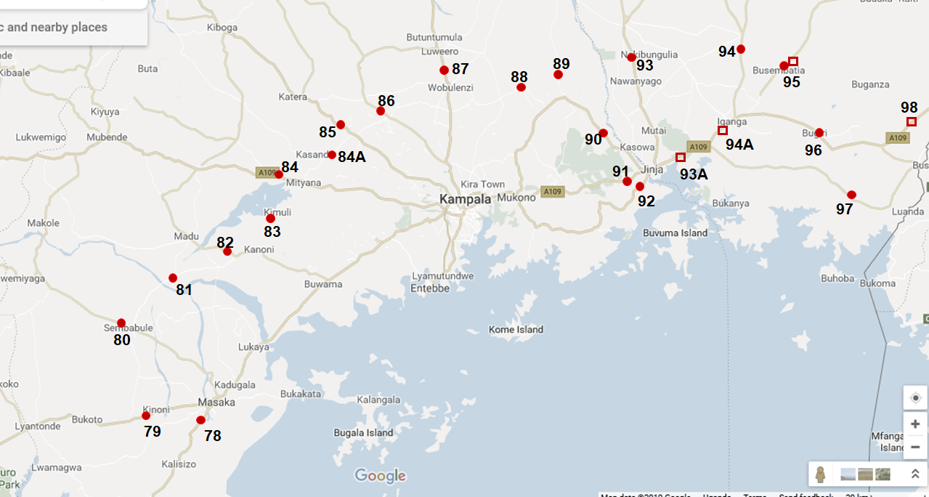

Table 2-4: Description and location of survey sites on Cordon 3 (C3)
DESCRIPTION AND LOCATION OF MCC AND OD SURVEY SITES - CORDON 3
Site Ref. | Highway / Link Name | Survey Type | Description of Site | Site Coordinates
78 | Masaka - Mbarara | MCC & OD | Kirimya Township | -0.371753, 31.715768
79 | Masaka - Mbarara | MCC & OD | Kinoni, Masaka-Mbarara Rd | -0.353466, 31.555108
80 | Villa Rd | MCC & OD | Near Sembabule | -0.087033, 31.469836
81 | Sembabule-Kabulasoke | MCC & OD | Sembabule-Kabulasoke | -0.044441, 31.483455
82 | Kanoni-Maddu | MCC & OD | Kanoni-Maddu | 0.175392, 31.900612
83 | Kanoni-Maddu | MCC & OD | Kanoni-Mityana | 0.260097, 31.965118
84 | Mityana Road | MCC & OD | Mityana – Myanzi | 0.410743, 32.028316
84 A | Mityana-Busunju | MCC & OD | Sekanyonyi | 0.498563, 32.132057
85 | Hoima Rd | MCC & OD | Matte | 0.573336, 32.192723
86 | Semuto Rd | MCC & OD | Kapeka, Semuto Rd | 0.664668, 32.259268
87 | Kla-Gulu Hway | MCC & OD | Luwero, Kampala – Gulu Highway | 0.806460, 32.506018
88 | Wobulenzi-Zirobwe | MCC & OD | Near Zirobwe | 0.678795, 32.690069
89 | Galiraya-Kayunga | MCC & OD | Near Kayunga | 0.697010, 32.910770
90 | Kangulumira | MCC & OD | Kayunga-Kangulumira | 0.595725, 33.014055
91 | Kampala-Jinja Highway | MCC & OD | Njeru | 0.412772, 33.135522
92 | Nalubaale Rd | MCC & OD | Nyenga | 0.413047, 33.182318
93 | Jinja - Kamuli Rd | MCC & OD | Namulesa | 0.494510, 33.216542
93 A | Jinja - Iganga | MCC | Jinja - Iganga | 0.473575, 33.257824
94 | Jinja - Kaliro Rd | MCC & OD | Near Kaliro | 0.632684, 33.480546
94A | Musita-Iganga | MCC | Musita-Iganga | 0.529569, 33.388857
95 | Tirinyi Road | MCC & OD | Namutumba | 0.815870, 33.664797
96 | Bugiri | MCC & OD | Jinja - Tororo Hway | 0.605292, 33.687402
97 | Musita-Lumino | MCC & OD | Musita-Lumino | 0.525134, 33.391733
98 | Busia Rd - Tororo | MCC | Busia Road | 0.549275, 34.019232
119 | Tororo-Mbale | MCC & OD | Tororo-Mbale | 1.014194, 34.174336
142 | Busia Boarder | MCC & OD | Busia Rd - Tororo | 0.465118, 34.098315
143 | Malaba Boarder | MCC & OD | Malaba Boarder | 0.638549, 34.264929

Figure 2-6: Location of Cordons 4 and 5 (C4 and C5) traffic survey sites
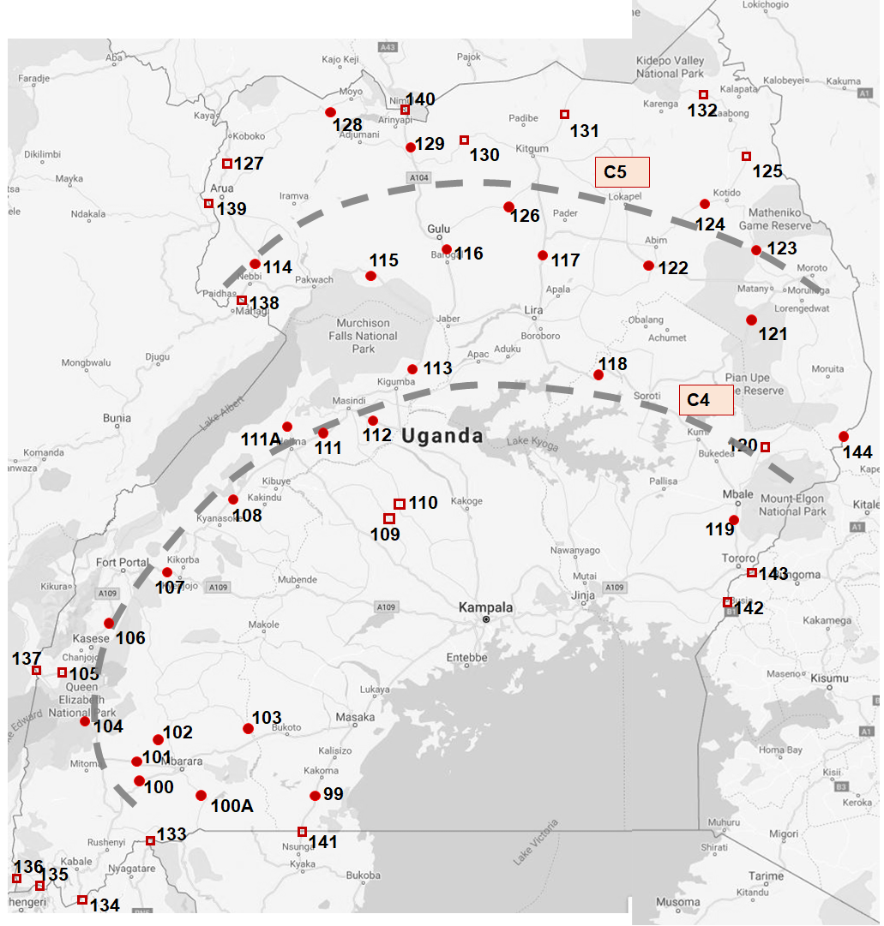

Table 2-5: Description and location of survey sites on Cordons 4 and 5 (C4 and C5)
DESCRIPTION AND LOCATION OF SURVEY SITES ON CORDONS 4 AND 5
Site Ref. | Highway / Link Name | Survey Type | Description of Site | Site Coordinates
Cordon 4 – Mid Country & Western Region
99 | Masaka-Mutukula | MCC & OD | Near Mutukula | -0.998586, 31.417639
100 | Mbarara-Ntungamo | MCC & OD | Mbarara-Ntungamo | -0.642561, 30.570337
100 A | Mbarara-Kikagata | MCC & OD | Mbarara-Kikagata | -0.640244, 30.675225
101 | Mbarara-Bushenyi | MCC & OD | Mbaarar-Bushenyi | -0.579578, 30.390501
102 | Mbarara-Ibanda | MCC & OD | Mbarara-Ibanda | -0.578657, 30.609883
103 | Lyantonde-Kiruhura | MCC & OD | Lyantonde-Kiruhura | -0.415457, 31.116216
104 | Ishaka-Katunguru | MCC & OD | Ishaka-Katunguru | -0.292987, 30.104367
105 | Bwera - Mpondwe | MCC & OD | Bwera, Bwera – Mpondwe Rd | 0.035206, 29.734605
106 | Kasese-Fort Portal | MCC & OD | Kasese-Fort Portal | 0.192190, 30.102165
107 | Fort Portal - Kyenjojo | MCC & OD | Fort portal – Kyenjojo | 0.620760, 30.627410
108 | Kyenjojo-Hoima | MCC & OD | Kyenjojo-Hoima | 1.359576, 31.279663
109 | Kateera-Kyankwanzi | MCC & OD | Kateera-Kyankwanzi | 0.703403, 32.041824
110 | Ngoma-Kapeeka | MCC & OD | Ngoma-Kapeeka | 0.832835, 32.236081
111 | Hoima-Masindi | MCC & OD | Hoima-Masindi (Lot W) | 0.620463, 30.629362
111A | Bulisa-Hoima | MCC & OD | Bulisa-Hoima | 1.460976, 31.338734
112 | Masindi-Kibangya | MCC & OD | Masindi-Kibangya | 1.568050, 31.971597
113 | Kigumba-Karuma | MCC & OD | Kigumba-Karuma | 2.091945, 32.195992
118 | Soroti-Kumi | MCC & OD | Soroti-Kumi | 1.575409, 33.853673
119 | Tororo - Mbale | MCC & OD | Tororo - Mbale | 0.978157, 34.168724
120 | Sironko Road | MCC & OD | Moroto - Mbale | 1.146321, 34.195497
133 | Mirama Hills Border | MCC | Mirama Hills Border Post | -1.033666, 30.460638
134 | Katuna Border | MCC | Near Katuna Border Post | -1.424435, 30.011466
135 | Cyahafi Border | MCC | Near Cyahafi Border Post | -1.335839, 29.737391
136 | Bunagana Border | MCC | Near Bunagana Border Post | -1.294117, 29.606016
137 | Mpondwe Border | MCC | Near Mpondwe Border Post | 0.042339, 29.723972
144 | Suam Border | MCC | Near Suam Border Post | 1.217108, 34.716599
Cordon 5 – Northern Region
114 | Nebbi-Arua | MCC & OD | Nebbi - Arua | 2.494334, 31.091114
115 | Karuma-Pakwach | MCC & OD | Karuma-Pakwach | 2.547125, 31.826231
116 | Karuma -Gulu | MCC & OD | Karuma - Gulu | 2.632568, 32.331442
117 | Lira-Kitgum | MCC & OD | Lira-Kitgum | 3.249089, 32.910044
121 | Soroti-Moroto | MCC & OD | Soroti- Moroto | 2.490282, 34.527947
122 | Matany-Kilak | MCC & OD | Matany-Kilak | 2.577189, 33.642365
123 | Moroto-Kotido | MCC & OD | Moroto-Kotido | 2.518873, 34.524507
124 | Abim - Kotido | MCC & OD | Abim - Kotido | 3.004329, 34.082223
125 | Kotido - Kabong | MCC & OD | Kotido - Kabong | 3.014975, 34.080389
126 | Gulu - kitgum | MCC & OD | Gulu - kitgum | 2.820371, 32.343396
127 | Arua - Koboko | MCC | Arua - Koboko | 3.054507, 30.921233
128 | Koboko - Moyo | MCC & OD | Koboko - Moyo | 3.434504, 30.989237
129 | Atiak - Nimule | MCC & OD | Atiak - Nimule | 3.299421, 32.111235
130 | Kitgum - Atiak | MCC & OD | Kitgum - Atiak | 3.244852, 32.135562
131 | Kitgum - Madi Opei | MCC & OD | Kitgum - Madi Opei | 3.322660, 32.901827
132 | Kabong - Apoka | MCC & OD | Kabong - Apoka | 3.322660, 32.901827
138 | Goli Border | MCC | Near Goli Border post | 2.389214, 31.030323
139 | Vurra Border | MCC | Near Vurra Border post | 2.907638, 30.877134
140 | Nimule Border | MCC | Near Nimule Border post | 3.571259, 32.073669

Location of Junction Turning Counts
A limited number of junction turning counts (JTC) were undertaken in central Kampala. It was envisaged that even with the national nature of the model, some calibration would be required in and around Kampala. Figure 2-7 and Table 2-5 show the location of the junctions at which the surveys were undertaken.
Figure 2-7: Location of junction turning traffic survey sites
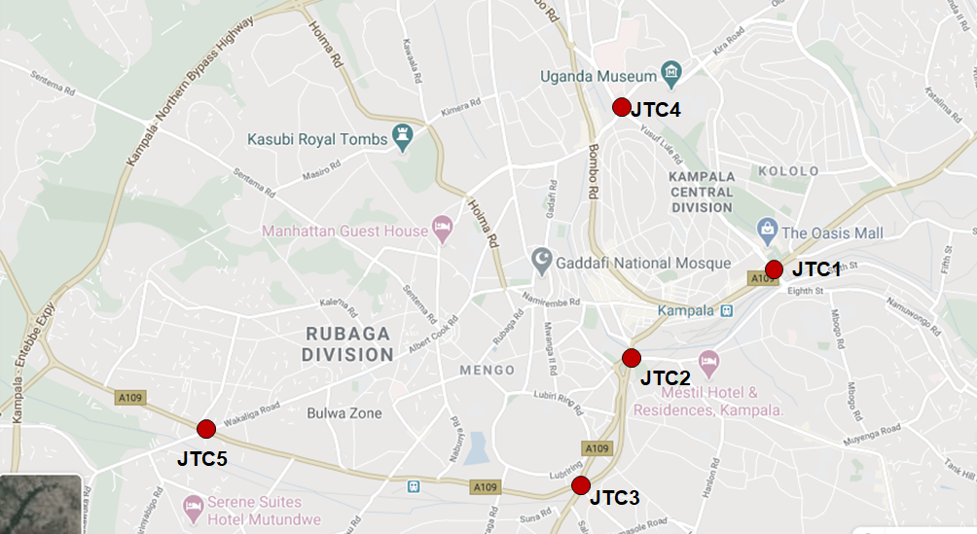

Table 2-6: Description of junction turning counts
DESCRIPTION AND LOCATION OF JUNCTION TURNING SURVEY SITES
Site Ref. | Highway / Link Name | Survey Type | Description of Site | Site Coordinates
JTC1 | Jinja Road / Access Road | JTC | Jinja Road (A109) / Access Road junction | 0.316674, 32.593326
JTC2 | Queensway/Nsambya | JTC | Clock Tower Junction, Queensway / Nsambya Rd | 0.307457, 32.578022
JTC3 | Entebbe Rd/Masaka Rd | JTC | Kibuye Juncion, Entebbe Rd/ Masaka Rd | 0.309331, 32.580087
JTC4 | Hajji Musa/Yusuf Lule | JTC | Mulago Junction, Hajji Musa/ Yusus Lule | 0.333821, 32.576948
JTC5 | Masaka / Wakaliga | JTC | Natete Junction, Masaka Wakaliga Rd | 0.299724, 32.532813

Journey Time Survey Routes
An extensive survey of route journey times was also undertaken. Figure 2-8 and Table 2-6 present the location, start and end points of each route.
Figure 2-8: Location of journey time survey routes
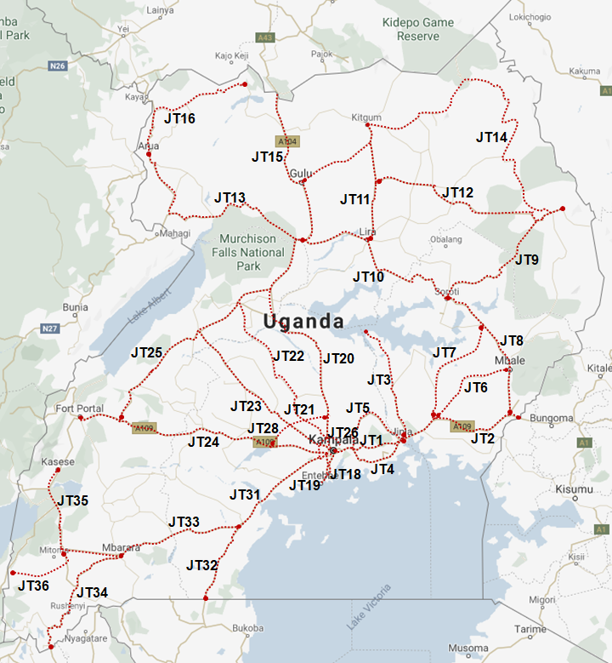

Table 2-7: Description of journey time survey routes
DESCRIPTION OF JOURNEY TIME SURVEY ROUTES
Site Ref. | Description | Start Coordinates | End Coordinates | Intermediate Points
Eastern & Northern Region Routes
JT1 | Kampala - Jinja | 0.333881, 32.618014 | 0.445048, 33.197575 | - Spear Junction, Bweyogerere, Mukono, Lugazi, Jinja Java House
JT2 | Jinja – Tororo - Malaba | 0.445218, 33.197828 | 0.634604, 34.273316 | - Jinja Java House, Iganga  Bugiri, Busia, Tororo  Mbale
JT3 | Jinja - Kamuli - Bukungu | 0.445218, 33.197828 | 1.437110, 32.868491 | - Jinja, Buwenge, Kamuli  Bukungu
JT4 | Mukono - Nkokonjeru - Jinja | 0.358366, 32.751225 | 0.445218, 33.197828 | - Mukono, Kisoga, Nkokonjeru, Buikwe,  Jinja
JT5 | Mukono - Kayunga - Jinja | 0.358405, 32.751221 | 0.445218, 33.197828 | - Mukono, Kalagi, Kayunga, Jinja
JT6 | Iganga - Budaka - Mbale | 0.614273, 33.475648 | 1.071343, 34.174977 | - Iganga, Namutumba, Budaka, Mbale
JT7 | Iganga – Pallisa - Kumi | 0.614273, 33.475648 | 1.488414, 33.935962 | - Iganga, Kaliro, Pallisa, Kumi
JT8 | Tororo - Mbale - Kumi - Soroti | 0.688226, 34.179807 | 1.715815, 33.611102 | - Tororo, Mbale, Kumi, Soroti
JT9 | Soroti – Katakwi - Moroto | 1.715815, 33.611102 | 2.533071, 34.657685 | - Soroti. Katakwi, Moroto
JT10 | Soroti – Lira - Karuma | 1.715815, 33.611102 | 2.255022, 32.242856 | - Soroti, Dokolo, Lira,  Karuma
JT11 | Lira - Kitgum | 2.238024, 32.893785 | 3.298638, 32.882310 | - Lira, Kilak, Kitgum
JT12 | Kilak - Abim - Moroto | 2.834093, 32.159512 | 2.533071, 34.657685 | - Kilak, Abim, Moroto
JT13 | Karuma – Pakwach – Arua | 2.255283, 32.242742 | 3.014483, 30.914753 | - Karuma, pakwach, Nebbi, Arua
JT14 | Karuma- Gulu – Atiaka - Nimule | 2.255283, 32.242742 | 3.591497, 32.064395 | - Karuma, Gulu, Atiak, Nimule
JT15 | Pakwach – Nebbi - Arua | 2.461580, 31.506042 | 3.014483, 30.914753 | - Moroto, Kotido, Kaabong, Karenga, Kitgum
JT16 | Gulu - Kitgum | 2.777053, 32.295405 | 3.292403, 32.883653 | - Gulu, Kitgum
JT17 | Arua – Koboko - Moyo | 3.014483, 30.914753 | 3.652952, 31.726645 | - Arua, Koboko, Moyo, Adjumani, Atiak
Central and Western Region Routes
JT18 | Northen Bypass – Entebbe (Old) | 0.350187, 32.587344 | 0.046138, 32.453557 | - Busega, Kibuye, Zzana, Kajjansi, Mpala, Entebbe Kitooro
JT19 | Northen Bypass – Entebbe KEE | 0.350187, 32.587344 | 0.164192, 32.543567 | - Busega, Kajjansi, Mpala, Entebbe Kitooro
JT20 | NBP Luwero – Nakasongora – Kigumba - Karuma | 0.842180, 32.493147 | 2.254905, 32.242658 | - NBP, Kawempe, Matugga, Luweero, Nakasongola, Kigumba, Karuma
JT21 | NBP Matuga – Kapeka | 0.465771, 32.521251 | 0.679214, 32.247670 | - NBP, Matugga, Kapeeka, Luweero
JT22 | Kapeka – Ngoma - Masindi | 0.679214, 32.247670 | 1.680659, 31.727515 | - Kapeeka, Ngoma,  Masindi
JT23 | NBP Kiboga - Hoima | 0.928414, 31.756432 | 1.421313, 31.372358 | - NBP, Wakiso, Busunju, Kiboga, Hoima
JT24 | NBP Mityana – Mubende – Kyenjojo – Fort Portal | 0.403931, 32.047801 | 0.659335, 30.292855 | - NBP, Bujuko, Mityana, Mubende, Kyenjojo, Fort Portal
JT25 | Kyenjojo – Hoima - Kigumba | 0.611926, 30.643495 | 1.809860, 32.011770 | - Kyenjojo, Kagadi, Hoima, Masindi, Kigumba
JT27 | Kira – Kasangati – Matuga- Wakiso Nsangi | 0.397350, 32.638625 | 0.282432, 32.451840 | - Kira, Kasangati, Matugga, Wakiso, Buloba, Nsangi
JT28 | Mubende – Semuto - Busunju | 0.555027, 31.393196 | 0.565905, 32.204084 | - Mityana, Busunju, Semuto, Kalule
JT29 | NBP Mulago- Kitgum Jn -Kibuye | 0.333766, 32.576993 | 0.293566, 32.572868 | - NBP, Kubbiri,  - Mulago Roundabout, Kitgum junction, Clock Tower, Kibuye
JT30 | Kibuye Busega | 0.293566, 32.572868 | 0.309657, 32.515191 | - Kibuye, Nateete, Busega
JT31 | Busega – Buwama - Masaka | 0.309657, 32.515191 | -0.327493, 31.751361 | - Busega, Nsangi, Mpigi, Lukaya, Masaka
JT32 | Masaka – Mutukula | -0.327493, 31.751361 | -1.000252, 31.416566 | - Masaka, Kalisizo, Mutukula
JT33 | Masaka – Lyantode - Mbarara | -0.327493, 31.751361 | -0.582672, 30.682528 | - Masaka, Lyantonde,  Mbarara
JT34 | Mbarara - Kabale – Katuna | -0.582672, 30.682528 | -1.433014, 30.015021 | - Mbarara, Ntungamo, Kabale, Kabale, Kisoro, Bunagana
JT35 | Mbarara – Ishaka – Kasese | -0.602408, 30.618351 | 0.172396, 30.085642 | - Mbarara, Ishaka, Kichwamba, Kikorongo, Kikorongo, Kasese
JT36 | Ishaka – Rukungiri - Kihihi | -0.545456, 30.139201 | -0.750039, 29.700285 | - Ishaka, Rukungiri, Kihihi

Location of Stated Preference Survey Sites
Figure 2-9 and Table 2-7 below present the locations where the Stated Preference (SP) survey was undertaken.
Figure 2-9: Location of journey time survey routes
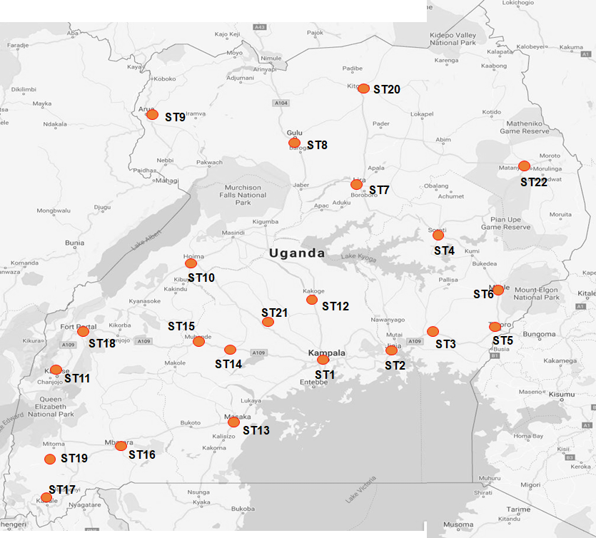

Table 2-8: Description of Stated Preference Survey sites
DESCRIPTION OF STATED PREFERENCE SURVEY SITES
Site Ref. | Site Name | Description | Start Coordinates
SP1 | Kampala | Taxi terminals, truck parking areas, shopping mall car parking areas, etc | 0.315573, 32.563151
SP2 | Jinja | Taxi terminals, truck parking areas, Jinja market, etc | 0.427418, 33.210951
SP3 | Iganga | Taxi terminals, truck parking areas, shopping areas, etc | 0.613877, 33.479433
SP4 | Soroti | Taxi terminals, truck parking areas, shopping areas, etc | 1.715791, 33.610878
SP5 | Tororo | Taxi terminals, truck parking areas, shopping areas, etc | 0.691405, 34.186706
SP6 | Mbale | Taxi terminals, truck parking areas, shopping areas, etc | 1.074244, 34.177307
SP7 | Lira | Taxi terminals, truck parking areas, shopping areas, etc | 2.254750, 32.896946
SP8 | Gulu | Taxi terminals, truck parking areas, shopping areas, etc | 2.772138, 32.299122
SP9 | Arua | Taxi terminals, truck parking areas, shopping areas, etc | 3.026798, 30.908611
SP10 | Hoima | Taxi terminals, truck parking areas, shopping areas, etc | 1.432452, 31.353082
SP11 | Kasese | Taxi terminals, truck parking areas, shopping areas, etc | 0.174955, 30.081822
SP12 | Luwero | Taxi terminals, truck parking areas, shopping areas, etc | 0.844825, 32.490566
SP13 | Masaka | Taxi terminals, truck parking areas, shopping areas, etc | -0.341053, 31.737916
ST14 | Mityana | Taxi terminals, truck parking areas, shopping areas, etc | 0.399582, 32.047630
SP15 | Mubende | Taxi terminals, truck parking areas, shopping areas, etc | 0.560147, 31.389726
SP16 | Mbarara | Taxi terminals, truck parking areas, shopping areas, etc | -0.615167, 30.652319
SP17 | Kabale | Taxi terminals, truck parking areas, shopping areas, etc | -1.247297, 29.984444
SP18 | Bushenyi | Taxi terminals, truck parking areas, shopping areas, etc | -0.540754, 30.190333
SP19 | Rukungiri | Taxi terminals, truck parking areas, shopping areas, etc | -0.787624, 29.924806
SP20 | Kitgum | Taxi terminals, truck parking areas, shopping areas, etc | 3.294988, 32.881921
SP21 | Wakiso | Entebbe, Nansana, Wakiso, Kira and Makindye Sabagabo divisions | 0.384984, 32.479905

Location of Public Transport (Bus) Survey Sites
At the same locations where Stated Preference surveys were undertaken, public transport surveys were also undertaken. The only exception was Iganga.
The public transport survey focused on coach transport. As such, the survey was undertaken at bus parks and terminals in all locations where it was taken.

Accident Data
Accident data was collected from district and regional police stations across the country. The following locations provided the required information; Jinja, Soroti, Tororo, Mbale, Lira, Gulu, Hoima, Kasese, Luwero, Masaka, Mubende, Mbarara, Kabale, Bushenyi, Rukungiri, Kitgum, Iganga and Arua.

Locations for Ferry Surveys
Ferry surveys were undertaken at nine (9) locations as shown in Figure 2-10 and Table 2-8 below.
Figure 2-10: Location of ferry survey routes
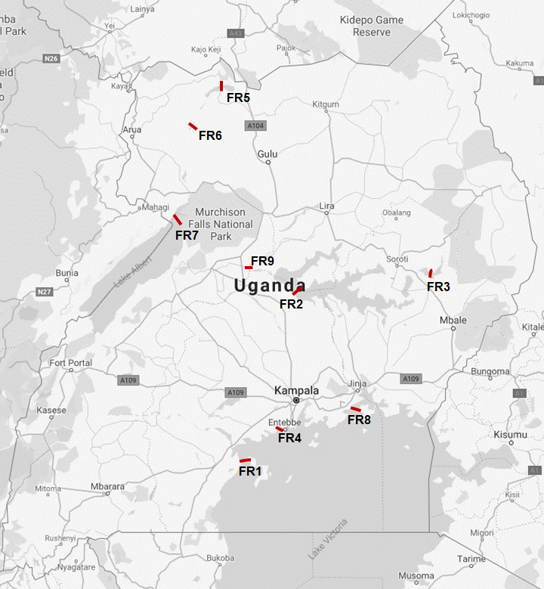

Table 2-9: Description and location of ferry survey routes
DESCRIPTION AND LOCATION OF FERRY SURVEY ROUTES
Site Ref. | Ferry Name | Survey Type | Description of Route | Start Coordinates | End Coordinates
FR1 | Kalangala | FR | Bukakata to Bugoma | -0.273115, 32.028387 | -0.248300, 32.065592
FR2 | Kyoga 1 | FR | Zengebe to Namasale | 1.475234, 32.529020 | 1.490234, 32.613617
FR3 | Bisina | FR | Agule to Kikorio | 1.623330, 33.922576 | 1.652045, 33.945973
FR4 | Entebbe | FR | Nakiwogo to Buwaya | 0.080005, 32.449259 | 0.089420, 32.439313
FR5 | Laropi | FR | Laropi to Omi | 3.551906, 31.812861 | 3.544139, 31.811156
FR6 | Obongi | FR | Obongi to Sinyanya | 3.236868, 31.557831 | 3.232850, 31.568090
FR7 | Panyimur | FR | Wanseko - Panyimur | 2.175454, 31.378363 | 2.294859, 31.347204
FR8 | Kiyindi | FR | Kiyindi to Buvuma | 0.278906, 33.147981 | 0.283373, 33.217005
FR9 | Nakasingola | FR | Masindi Port to Kungu | 1.694812, 32.092480 | 1.699416, 32.098755

Locations of Automatic Traffic Counts (ATC) Sites
ATC surveys were undertaken at seven (7) sites. These are identified and described in Figure 2-11 and Table 2-9 below.
Figure 2-11: Location of ATC survey sites
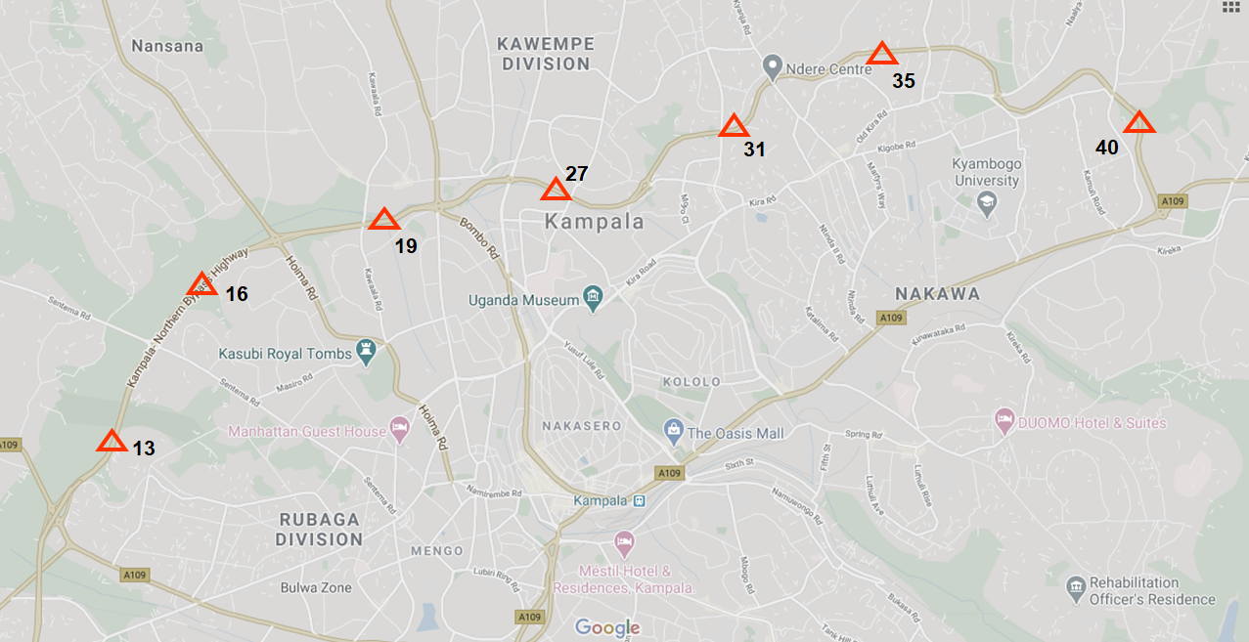

Table 2-10: Description and location of ATC survey sites
DESCRIPTION AND LOCATION OF ATC SURVEY SITES
Site Ref. | Highway / Link Name | Survey Type | Description of Site | Site Coordinates
13 | Kampala Northern Bypass | ATC | Between Mityana Road and Sentema Road junctions | 0.322564, 32.522876
16 | Kampala Northern Bypass | ATC | Between Sentema Road and Hoima Road junctions | 0.339240, 32.532805
19 | Kampala Northern Bypass | ATC | Between Hoima Road and Bombo Road junctions | 0.347578, 32.556023
27 | Kampala Northern Bypass | ATC | Between Gayaza Road and Kyebando Road junctions | 0.350289, 32.580307
31 | Kampala Northern Bypass | ATC | Between Kyebando Road and Kisaasi Road junctions | 0.359111, 32.600155
35 | Kampala Northern Bypass | ATC | Between Kisaasi Road and Nalya Road junctions | 0.368873, 32.617906
40 | Kampala Northern Bypass | ATC | Between Nalya Road and Bweyogerere junctions | 0.367638, 32.632050

Locations of Axle Load Survey (ALS) Sites
ALS surveys were undertaken at ten (10) sites. These are identified and described in Figure 2-12 and Table 2-10 below.
Figure 2-12: Location of Axle Load survey
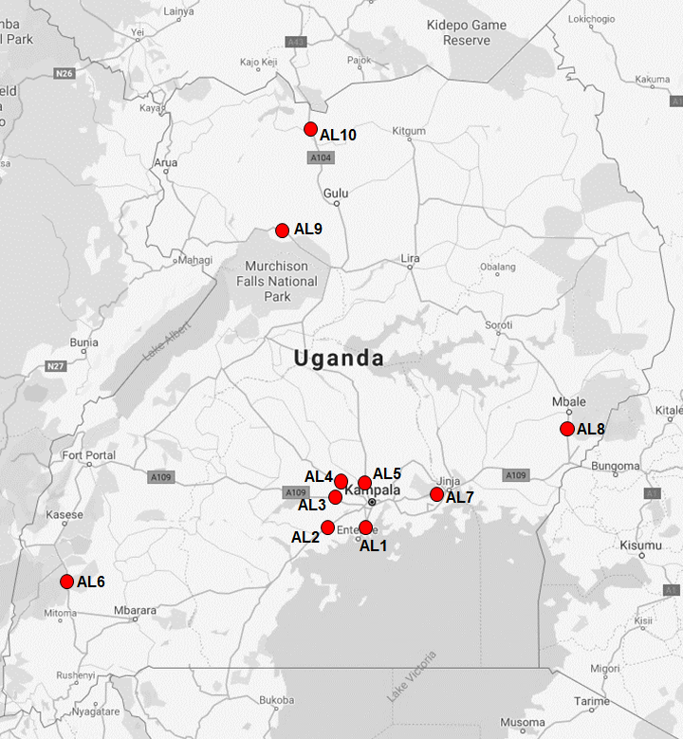

Table 2-11: Description and location of Axle Load survey sites
DESCRIPTION AND LOCATION OF ATC SURVEY SITES
Site Ref. | Highway / Link Name | Survey Type | Description of Site | Site Coordinates
AL1 | Kampala – Entebbe Highway | Axle | At the dual section of Kampala- Entebbe Road | 0.061179, 32.472757
AL2 | Kampala – Masaka Highway | Axle | Buwama | 0.064800, 32.109264
AL3 | Kampala – Mityana Highway | Axle | Bujuuko | 0.333394, 32.370712
AL4 | Kampala – Hoima Highway | Axle | Kakiri | 0.419596, 32.402159
AL5 | Kampala – Bombo Highway | Axle | Matugga | 0.472375, 32.518501
AL6 | Ishaka – Kasese Highway | Axle | Rubirizi town | -0.268438, 30.106536
AL7 | Kampala – Jinja Highway | Axle | Nakibizzi former Weighbridge location | 0.422428, 33.143343
AL8 | Mbale – Tororo Highway | Axle | Busoba town | 0.969742, 34.170843
AL9 | Karuma – Arua Highway | Axle | Purongo Town | 2.540505, 31.828369
AL10 | Gulu – Nimule Highway | Axle | Abelokodi village | 3.324474, 32.104841

Vehicle Classification
The proposal also identified the list of vehicle types to be considered. This list is in accordance with the vehicle types specified in the Manual for Road Investment Appraisal (UNRA, June 2015). Only motorized traffic was investigated in this assignment.
- Saloon car (sedan, saloon, estate, etc);
- Utility vehicle (pickup, four-wheel drive Station Wagon);
- Minibus or matatu (14-seat capacity);
- Medium bus or coaster (25-seat capacity);
- Large bus or coach (50 or higher seat capacity);
- Light truck (2 axle, gross weight of not more than 7 tonnes);
- Medium truck (2 axles, gross vehicle weight of between 7 and 15 tonnes);
- Heavy truck (3 or 4 axles, gross vehicle weight of up to 22 tonnes);
- Articulated truck (semi-trailer) (5 or more axles, gross vehicle weight of 22 - 56 tonnes);
- Motorcycles;
- Tractors – this vehicle type is not listed in the UNRA standard vehicle types. It was added to cater for agricultural vehicles (tractors) and construction equipment.

Survey Forms
The forms for use in the traffic survey exercise were designed carefully taking into consideration both the standard specifications in accordance with UNRA guidance and the specific needs of the proposed expressway master plan.
All survey forms are included in Appendix A.

MANUAL CLASSIFIED COUNTS (MCC) SURVEYS

Introduction and Methodology
MCC are typically undertaken by traffic enumerators standing by the roadside and recording each vehicle by category as it passes. They were undertaken at 172 locations countrywide. The specific locations of the survey sites are given by the location coordinates presented in Table 2-2.
Significant effort was made to ensure that errors in the data during collection are minimized. Errors in MCC data are usually due to unrecorded or unobserved traffic especially at road sections with significant volumes of traffic. To this end, the need for effective data collection was assessed on a site by site basis during an extensive pre-survey site inspection.
Errors can also result from poor site selection. To this end, the locations of the MCC surveys were carefully chosen to optimize the coverage of driver origins and destinations.

Survey Personnel and Training
The following categories of survey staff were used at all survey sites:
- Survey manager with overall responsibility for the survey programme;
- Site supervisors with overall responsibility for the operations of each of the survey sites;
- Two to four enumerators depending on the level of traffic on the road. Generally, survey sites in Cordon 1 required more enumerators. Quite frequently, one enumerator per direction was not adequate because of the high volume of traffic on the road;
- Two police officers per site for night counts.
Survey staff used for MCC surveys in this exercise were experienced, but were nonetheless trained prior to the survey. The training covered a range of issues including; details about the survey, the duties involved, roles and responsibilities, the associated health and safety requirements, vehicle recording procedure and others.

Survey Period
As described in Table 1-1, the MCC surveys were undertaken for a total of seven (7) days as follows:
- For 5 days, a 12-hour survey period (7am – 7pm) was used.
- For two days (one weekday and a Saturday), a 24-hour survey period (7am – 7am) was used.
Surveying was undertaken in both directions.

Survey Diary
For relatively small surveys (for a few survey stations) and a limited number of survey days, one of the key impacts is inclement weather. For this assignment, this was not considered a key issue. The survey was effectively collected for 7 days in a largely dry season (July to September).
The most significant issues that were experienced were as follows:
- For upcountry locations, the key issue was the ability of the limited local police resources to support the surveys or due to security reasons. At a few sites, in the Gulu area (Gulu and Atiak) and the Karuma area (Karuma-Pakwach road), the unavailability of police personnel to provide protection was experienced.
For MCC surveys, where police personnel was unavailable, the survey stations were usually moved to nearby fuel stations or towns were available local security was hired to provide protection. But in all cases, care was taken to ensure that the collected data would be representative of the survey link.
- Another key issue was the sometimes-overwhelming traffic volumes, especially for some Cordon 1 survey sites. For all key routes into the City, at least two enumerators were required for each direction. In some cases, three were used to ensure that motorcycle counts (which frequently required a specific enumerator) could be taken with high level of accuracy. It is considered that survey sites near Kampala in the future should be undertaken using automatic means.
- There were also general issues with regard to vehicle classifications. There is now marked challenges in the differentiation between some vehicle types such as cars and utility vehicles, particularly station wagons. Vehicles models such as Toyota Kluger, Subaru Forester, Suzuki Vitara seem to fall between salon cars and station wagons. There also some issues with the differentiation between minibuses for example Toyota Noah and Toyota Hiace. Also, certain light trucks seem to be closer to pickups in shape and size. The Toyota Noah is widely used in many parts of Uganda as a minibus, whereas this is not the case in Greater Kampala.

Collected MCC Data
This section presents the analysis of the MCC data collected during the survey. The data is presented as site averages by cordon. The tables provide 12-hour average traffic volumes, 24-hour average daily traffic (ADT) and the implied Night Equivalent Factor (NEF). The NEF is the ratio of the 24-hour volume to the 12-hour volume, and is hence a measure of night traffic activity on a particular link or area. Higher NEF values imply high traffic movements and vice-versa.
Further, the Annual Average Daily Traffic (AADT) volume was estimated from the ADT volume and is included in the tables. The AADT is estimated from the AADT by factoring the ADT volume with the Seasonal Correction Factor (SCF). The SCF is a month by month factor that relates the ADT for a particular month and location to the AADT for that location.
The ADT at any given location on the road network in any given month is expected to vary from the ADT at the same location in another month due to seasonal impacts such as school holidays, harvest and market seasons, rainy or dry seasons, special events, and others. However, over an entire year, the average traffic is a specific number. The SCF therefore converts the ADT observed in a specific month to the AADT volume observed over a year.

ATC Data - Estimation of Seasonal Correction Factors
The UNRA collects automated traffic counts on a daily basis at 15 selected locations in all four regions of the country. This data was obtained by the Consultant and from it an estimation of the seasonal correction factors was undertaken. To obtain the SCF for each survey site, the ADT observed in a certain month was divided by the AADT over 12 months at that survey site. As such, for each survey site, SCF values were obtained for each month. From the monthly SCF values by site, monthly SCF values were estimated by region and for the country. Table 3-1 below presents the SCF values per site, region and national.
Table 3-12: Estimation of Seasonal Correction Factor (SCF)
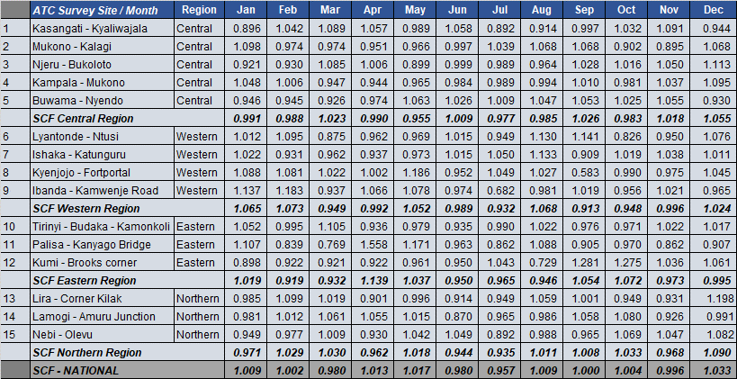
Source: UNRA Automatic Traffic Counts Data, Consultants Analysis
The SCF values provides information on the traffic activity on a particular road link or region relative to the average traffic annual activity. As such, a SCF value less than 1.0 implies traffic volumes lower than the annual average and vice-versa. From Table 3-1 above, the month of September seems to result in ADT values that are equal to the national AADT. However, the picture is different within the individual regions.
It should be noted that seasons during any one year are expected to vary by region of the country. For example, the impact of school activity on traffic volumes may be significant in Kampala and the central region but unlikely to be so in Mbale. Similarly, the impact of rain seasons may be significant in Western Uganda but not so in Greater Kampala. Therefore, for regional specific studies or projects, regional SCF values are recommended for use.
The MCC survey exercise was undertaken between July and November 2019. Table 3-2 below identifies the survey dates for each station, the region in which the station is located and the appropriate SCF value. All ADT figures were divided by their respective SCF values to obtain the equivalent AADT.
Table 3-13: Seasonal Correction Factor (SCF) values used to convert ADT
SCF VALUES USED FOR CONVERSION OF ADT
Ref | Cordon | Stations | Region | Dates of Survey | SCF Value
1 | C1 | 1-25 | Central | 22nd July – 28th July 2019 | 0.977
2 | C1 | 26-50 | Central | 29th July – 4th August 2019 | 0.981
3 | C2 | 51-77 | Central | 23rd Sept – 29th Sept 2019 | 1.026
4 | C3 | 78-92 | Central | 16th Oct – 22nd Oct 2019 | 0.983
5 | C3 | 93-98 | Eastern | 23rd Oct – 28th Oct 2019 | 1.072
6 | C4 | 99, 141 | Central | 23rd Oct – 28th Oct 2019 | 0.983
7 | C4 | 100-112, 133-137 | Western | 23rd Oct – 28th Oct 2019 | 0.948
8 | C4 | 118-119, 142, 143, 120, 144 | Eastern | 14th Aug – 27th Aug 2019 | 0.946
9 | C5 | 113-116, 126-130, 138-140, 117, 121-125, 131-132, | Northern | 31st July – 11th August 2019 | 0.935

Cordon 1 MCC Data
Table 3-3 below presents the collected MCC data for Cordon 1 survey sites. It presents the average 12-hour total traffic volumes, the average 24-hour daily traffic (ADT), the NEF and the AADT. Detailed station by station analysis results are included in Appendix B.
Table 3-14: MCC Survey Traffic Volumes for Cordon 1 (C1)
MCC SURVEY TRAFFIC VOLUMES – CORDON 1
Site | Description | Average 12-Hr | ADT (Average 24-Hr) | NEF | SCF | AADT
01 | Mobutu Road | 26,962 | 38,339 | 1.422 | 0.977 | 39,241
01A | Salama Road | 20,412 | 35,950 | 1.761 | 0.977 | 36,797
02 | Entebbe Road | 48,598 | 71,610 | 1.474 | 0.977 | 73,295
03 | Kalinda Rd | 29,590 | 38,500 | 1.301 | 0.977 | 39,406
04 | Weraga Road | 15,003 | 22,710 | 1.514 | 0.977 | 23,245
05 | Kabusu Rd North | 22,769 | 30,133 | 1.323 | 0.977 | 30,842
06 | Kabusu Rd South | 24,368 | 36,621 | 1.503 | 0.977 | 37,483
07 | Masaka Rd Ndeeba | 25,061 | 38,993 | 1.556 | 0.977 | 39,911
08 | Wakaliga Rd North | 25,690 | 40,410 | 1.573 | 0.977 | 41,362
09 | Wakaliga Rd South | 14,329 | 24,115 | 1.683 | 0.977 | 24,683
10 | Masaka Rd Busega | 33,908 | 53,416 | 1.575 | 0.977 | 54,674
11 | Masaka Rd Kyengera | 33,582 | 54,407 | 1.620 | 0.977 | 55,688
12 | Mityana Rd | 31,021 | 43,950 | 1.417 | 0.977 | 44,984
13 | KNBP Mityana-Sentema | 26,525 | 38,047 | 1.434 | 0.977 | 38,943
14 | Sentema Rd North | 13,279 | 22,734 | 1.712 | 0.977 | 23,269
15 | Sentema Rd South | 8,331 | 10,973 | 1.317 | 0.977 | 11,231
16 | Northern Bypass | 27,037 | 46,759 | 1.729 | 0.977 | 47,859
17 | Hoima Rd South | 22,335 | 33,307 | 1.491 | 0.977 | 34,091
18 | Hoima Rd Nth | 24,479 | 36,900 | 1.507 | 0.977 | 37,769
20 | Kawaala Rd | 7,229 | 12,462 | 1.724 | 0.977 | 12,755
21 | Sir Apollo Kaggwa Road | 25,412 | 41,929 | 1.650 | 0.977 | 42,916
22 | Bombo Road North | 32,687 | 47,182 | 1.443 | 0.977 | 48,293
23 | Bombo Road North | 26,186 | 38,520 | 1.471 | 0.977 | 39,427
24 | Gayaza Rd | 28,604 | 42,248 | 1.477 | 0.977 | 43,243
25 | Tula Rd | 21,520 | 31,763 | 1.476 | 0.977 | 32,511
26 | Gayaza Rd | 36,004 | 57,318 | 1.592 | 0.981 | 58,428
28 | Kisingiri Street | 19,993 | 29,829 | 1.492 | 0.981 | 30,407
29 | Kyebando Ring | 12,177 | 16,683 | 1.370 | 0.981 | 17,006
30 | Kyebando-Kisalosalo | 9,907 | 14,187 | 1.432 | 0.981 | 14,462
32 | Bukoto Kisasi Rd | 13,737 | 19,561 | 1.424 | 0.981 | 19,940
33 | Kisasi-Ntinda Rd | 17,947 | 26,848 | 1.496 | 0.981 | 27,368
34 | Kisasi-Kyanja Rd | 21,292 | 30,455 | 1.430 | 0.981 | 31,045
36 | Mbogo Road | 16,247 | 27,246 | 1.677 | 0.981 | 27,774
37 | Naalya Road North | 19,901 | 28,299 | 1.422 | 0.981 | 28,847
38 | Naalya Road South | 19,687 | 28,113 | 1.428 | 0.981 | 28,657
39 | Namugongo Rd | 21,038 | 26,592 | 1.264 | 0.981 | 27,107
40 | KNBP Bweyogerere - Nalya | 10,977 | 15,774 | 1.437 | 0.981 | 16,080
41 | Namanve Ind Park | 4,255 | 6,132 | 1.441 | 0.981 | 6,251
42 | Kinawataka | 19,942 | 32,346 | 1.622 | 0.981 | 32,972
43 | Kampala-Jinja Highway | 26,272 | 39,434 | 1.501 | 0.981 | 40,198
44 | Nakawa-Jinja Rd | 16,617 | 25,573 | 1.539 | 0.981 | 26,068
44A | Ntinda Road | 16,651 | 23,794 | 1.429 | 0.981 | 24,255
45 | New Port Bell Rd | 22,995 | 30,422 | 1.323 | 0.981 | 31,011
46 | Katalima Road | 19,428 | 24,965 | 1.285 | 0.981 | 25,449
47 | Lugogo Bypass | 31,843 | 42,478 | 1.334 | 0.981 | 43,301
48 | Old Port Bell Road | 19,377 | 28,058 | 1.448 | 0.981 | 28,601
49 | Access Road | 59,732 | 79,682 | 1.334 | 0.981 | 81,225
50 | Nsambya Rd | 57,524 | 77,197 | 1.342 | 0.981 | 78,692

Cordon 2 MCC Data
Table 3-4 below presents the collected MCC data for Cordon 2 survey sites. It presents the average 12-hour total traffic volumes, the average 24-hour daily traffic (ADT), the NEF and the AADT. Detailed station by station analysis results are included in Appendix B.
Table 3-15: MCC Survey Traffic Volumes for Cordon 2 (C2)
MCC SURVEY TRAFFIC VOLUMES – CORDON 2
Site | Description | Average 12 -Hr Traffic | ADT (Average 24-Hr) | NEF | SCF | AADT
51 | Salama Road | 8,994 | 14,600 | 1.623 | 1.026 | 14,230
52 | Wavamunno Rd | 10,225 | 16,348 | 1.599 | 1.026 | 15,934
53 | Busabala Road | 2,433 | 4,020 | 1.652 | 1.026 | 3,918
55 | Lubugumu Road | 1,348 | 1,864 | 1.383 | 1.026 | 1,817
56 | Munyonyo Spur | 7,503 | 10,713 | 1.428 | 1.026 | 10,442
57 | Kigo Road | 2,102 | 3,435 | 1.634 | 1.026 | 3,348
58 | Entebbe Road | 13,363 | 18,588 | 1.391 | 1.026 | 18,117
59 | Kampala Entebbe Expressway | 6,335 | 8,812 | 1.391 | 1.026 | 8,589
59A | Budo Road | 4,570 | 7,330 | 1.604 | 1.026 | 7,144
60 | Masaka Rd | 11,100 | 16,632 | 1.498 | 1.026 | 16,211
61 | Nsangi-Buloba Road | 2,726 | 4,010 | 1.471 | 1.026 | 3,908
62 | Mityana Road | 6,429 | 9,218 | 1.434 | 1.026 | 8,984
63 | Buloba-Bukasa Rd | 2,375 | 3,494 | 1.471 | 1.026 | 3,406
64 | Bukasa-Wakiso Road | 2,787 | 3,907 | 1.402 | 1.026 | 3,808
65 | Hoima Road | 1,659 | 2,174 | 1.310 | 1.026 | 2,119
66 | Wakiso-Matugga Rd | 4,558 | 7,210 | 1.582 | 1.026 | 7,027
67 | Bombo Road | 16,232 | 22,330 | 1.376 | 1.026 | 21,764
68 | Matugga-Kasangati Road | 6,046 | 9,409 | 1.556 | 1.026 | 9,171
69 | Gayaza Road | 22,187 | 31,561 | 1.422 | 1.026 | 30,761
70 | Kasangati-Kira Rd | 3,760 | 5,550 | 1.476 | 1.026 | 5,409
71 | Kira-Bulindo Rd | 13,917 | 20,898 | 1.502 | 1.026 | 20,368
72 | Kira-Kyaliwajjala Rd | 14,622 | 21,193 | 1.449 | 1.026 | 20,656
73 | Sonde Road | 10,469 | 14,984 | 1.431 | 1.026 | 14,604
74 | Kampala -Jinja Road | 23,750 | 35,282 | 1.486 | 1.026 | 34,388
75 | Mukono-Kalagi Rd | 4,693 | 6,596 | 1.405 | 1.026 | 6,429
76 | Kla-Jinja Highway | 20,560 | 28,223 | 1.373 | 1.026 | 27,508
77 | Katosi Rd | 12,525 | 17,091 | 1.365 | 1.026 | 16,658

Cordon 3 MCC Data
Table 3-5 below presents the collected MCC data for Cordon 3 survey sites. It presents the average 12-hour total traffic volumes, the average 24-hour daily traffic (ADT), the NEF and the AADT. Detailed station by station analysis results are included in Appendix B.
Table 3-16: MCC Survey Traffic Volumes for Cordon 3 (C3)
MCC SURVEY TRAFFIC VOLUMES – CORDON 3
Site | Description | Average 12 -Hr Traffic | ADT (Average 24-Hr) | NEF | SCF | AADT
78 | Masaka - Mutukula | 5,948 | 8,307 | 1.397 | 0.983 | 8,451
79 | Masaka - Mbarara | 3,850 | 5,695 | 1.479 | 0.983 | 5,793
80 | Villa Rd | 1,165 | 1,678 | 1.440 | 0.983 | 1,707
81 | Sembabule-Kabulasoke | 1,144 | 1,558 | 1.362 | 0.983 | 1,585
82 | Kanoni-Maddu | 1,558 | 2,023 | 1.298 | 0.983 | 2,058
83 | Kanoni-Maddu | 1,351 | 1,696 | 1.255 | 0.983 | 1,725
84 | Mityana Road | 6,573 | 8,714 | 1.326 | 0.983 | 8,865
84A | Mityana-Busunju | 1,264 | 1,847 | 1.461 | 0.983 | 1,879
85 | Hoima Rd | 1,756 | 2,584 | 1.472 | 0.983 | 2,629
86 | Semuto Rd | 2,818 | 3,610 | 1.281 | 0.983 | 3,672
87 | Kampala-Gulu Highway | 10,752 | 13,258 | 1.233 | 0.983 | 13,487
88 | Wobulenzi-Zirobwe | 1,939 | 2,659 | 1.371 | 0.983 | 2,705
89 | Galiraya-Kayunga | 1,359 | 1,747 | 1.286 | 0.983 | 1,777
90 | Kangulumira | 4,308 | 5,462 | 1.268 | 0.983 | 5,557
91 | Kampala-Jinja Highway | 9,198 | 13,691 | 1.488 | 0.983 | 13,928
92 | Nalubaale Rd | 2,691 | 3,543 | 1.317 | 0.983 | 3,604
93 | Jinja - Kamuli Rd | 6,281 | 8,286 | 1.319 | 1.072 | 7,729
93A | Jinja - Musita | 11,071 | 15,447 | 1.395 | 1.072 | 14,410
94 | Jinja - Kaliro Rd | 8,120 | 10,969 | 1.351 | 1.072 | 10,232
94A | Musita-Iganga | 6,848 | 9,948 | 1.453 | 1.072 | 9,280
95 | Tirinyi Road | 3,071 | 4,118 | 1.341 | 1.072 | 3,841
96 | Bugiri | 3,843 | 6,057 | 1.576 | 1.072 | 5,650
97 | Musita-Lumino | 5,086 | 6,661 | 1.310 | 1.072 | 6,214
98 | Busia Rd - Tororo | 2,287 | 3,530 | 1.544 | 1.072 | 3,293
119 | Tororo-Mbale | 3,972 | 4,921 | 1.239 | 0.946 | 5,202
142 | Busia Boarder | 956 | 1,175 | 1.229 | 0.946 | 1,242
143 | Malaba Boarder | 3,187 | 4,077 | 1.279 | 0.946 | 4,310

Cordon 4 and 5 MCC Data
Table 3-6 below presents the collected MCC data for Cordons 4 and 5 survey sites. It presents the average 12-hour total traffic volumes, the average 24-hour daily traffic (ADT), the NEF and the AADT. Detailed station by station analysis results are included in Appendix B.
Table 3-17: MCC Survey Traffic Volumes for Cordon 4 and 5 (C4 and C5)
MCC SURVEY TRAFFIC VOLUMES – CORDON 4 AND 5
Site | Description | Average 12 -Hr Traffic | ADT (Average 24-Hr) | NEF | SCF | AADT
Cordon 4 – Mid Country & Western Region
99 | Masaka-Mutukula | 1,674 | 2,335 | 1.395 | 0.983 | 2,375
100 | Mbarara-Ntungamo | 3,571 | 4,917 | 1.377 | 0.948 | 5,187
100A | Mbarara-Kikagata | 5,471 | 6,994 | 1.278 | 0.948 | 7,378
101 | Mbarara-Bushenyi | 8,095 | 9,675 | 1.195 | 0.948 | 10,206
102 | Mbarara-Ibanda | 1,977 | 2,565 | 1.297 | 0.948 | 2,706
103 | Lyantonde-Kiruhura | 1,315 | 2,144 | 1.630 | 0.948 | 2,262
104 | Ishaka-Katunguru | 5,647 | 7,357 | 1.303 | 0.948 | 7,761
105 | Bwera - Mpondwe | 1,416 | 1,918 | 1.355 | 0.948 | 2,023
106 | Kasese-Fort Portal | 12,226 | 15,651 | 1.280 | 0.948 | 16,509
107 | Fort Portal - Kyenjojo | 868 | 1,209 | 1.393 | 0.948 | 1,275
108 | Kyenjojo-Hoima | 4,044 | 5,070 | 1.254 | 0.948 | 5,348
109 | Kateera-Kyankwanzi | 678 | 921 | 1.358 | 0.948 | 972
110 | Ngoma-Kapeeka | 1,279 | 1,734 | 1.356 | 0.948 | 1,829
111 | Hoima-Masindi | 2,438 | 3,008 | 1.234 | 0.948 | 3,173
111A | Bulisa-Hoima | 567 | 721 | 1.272 | 0.948 | 761
112 | Masindi-Kibangya | 1,694 | 2,340 | 1.381 | 0.948 | 2,468
113 | Kigumba-Karuma | 1,516 | 2,399 | 1.582 | 0.935 | 2,565
118 | Soroti-Kumi | 1,617 | 2,343 | 1.449 | 0.946 | 2,477
119 | Tororo - Mbale | 1,604 | 2,325 | 1.450 | 0.946 | 2,458
120 | Sironko Road | 4,369 | 5,614 | 1.285 | 0.946 | 5,934
133 | Mirama Hills Border | 568 | 807 | 1.421 | 0.948 | 851
134 | Katuna Border | 996 | 1,407 | 1.413 | 0.948 | 1,484
135 | Cyahafi Border | 3,338 | 4,404 | 1.319 | 0.948 | 4,646
136 | Bunagana Border | 1,567 | 2,168 | 1.384 | 0.948 | 2,287
137 | Mpondwe Border | 6,156 | 7,580 | 1.231 | 0.948 | 7,996
141 | Mutukula Border | 543 | 854 | 1.573 | 0.983 | 869
144 | Suam Border | 1,031 | 1,299 | 1.260 | 0.946 | 1,373
Cordon 5 – Northern Region
114 | Nebbi-Arua | 1,867 | 2,576 | 1.380 | 0.935 | 2,755
115 | Karuma-Pakwach | 834 | 1,357 | 1.627 | 0.935 | 1,451
116 | Karuma -Gulu | 6,614 | 10,245 | 1.549 | 0.935 | 10,957
117 | Lira-Kitgum | 916 | 1,415 | 1.545 | 0.935 | 1,513
121 | Soroti-Moroto | 636 | 857 | 1.347 | 0.935 | 917
122 | Matany-Kilak | 726 | 1,154 | 1.590 | 0.935 | 1,234
123 | Moroto-Kotido | 265 | 348 | 1.313 | 0.935 | 372
124 | Abim - Kotido | 651 | 1,070 | 1.643 | 0.935 | 1,144
125 | Kotido - Kabong | 146 | 260.5 | 1.784 | 0.935 | 279
126 | Gulu - kitgum | 916 | 1,415 | 1.545 | 0.935 | 1,513
127 | Arua - Koboko | 4,704 | 6,426 | 1.366 | 0.935 | 6,873
128 | Koboko - Moyo | 1,268 | 1,434 | 1.131 | 0.935 | 1,534
129 | Atiak - Nimule | 485 | 746 | 1.538 | 0.935 | 798
130 | Kitgum - Atiak | 455 | 602 | 1.323 | 0.935 | 644
131 | Kitgum - Madi Opei | 1,803 | 2,248 | 1.247 | 0.935 | 2,404
132 | Kabong - Apoka | 226 | 257 | 1.137 | 0.935 | 275
138 | Goli Border | 1,484 | 1,897 | 1.278 | 0.935 | 2,029
139 | Vurra Border | 1,973 | 2,518 | 1.276 | 0.935 | 2,693
140 | Nimule Border | 1,169 | 1,212 | 1.037 | 0.935 | 1,296

Hourly Variation of Traffic
This section presents the analysis of the MCC data collected during the survey with respect to variation in traffic. The analysis is presented as average results by cordon.

MCC Data Analysis – Cordon 1
In this section, the MCC data collected at Cordon 1 is analysed. Figures 3-1 and 3-2 present the hourly variation of traffic and vehicle proportions for Cordon 1. Detailed station by station analysis results for this cordon are included in Appendix B.
Figure 3-13: Hourly variation of traffic for Cordon 1
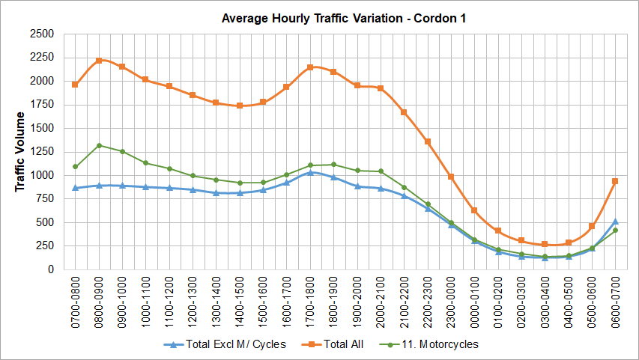

Figure 3-14: Average vehicle proportion for Cordon 1
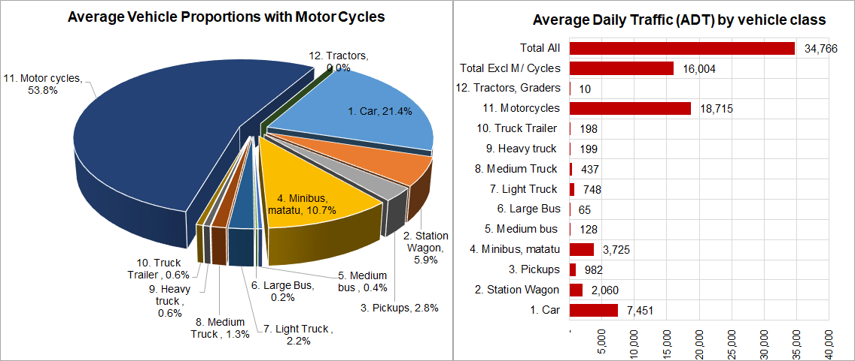
The following observations are with regard to Figures 3-1 and 3-2 (Cordon 1):
- Peak hours: AM peak hours is observed to be 8-9am with a flow of 2,214 vehicles. The PM peak hour is observed as 5 – 6pm with a flow of 2,140 vehicles.
It should be noted that traffic flow recorded from the surveys reflects vehicle movements past the survey point only and does not include queuing. The figures may hence not indicate how truly busy the link is. The 7 – 8am in the morning for cordon 1 is observed to be busier because of significant traffic jams and queuing. But MCC data is unlikely to show this.
- Night activity: there is strong night activity at Cordon 1 being an urban area. The least busy hour of the day is 3 – 4am in the morning with a significant flow of 269 vehicle per hour. Of this, 52% is motorcycle traffic, indicating higher night activity for this vulnerable class.
- Vehicle proportions: there is high motorcycle content of 53.8% (or 18,715 per day) followed by cars at 21.4% (7,451) and minibus at 10.7% (3,725).
- Average ADT: average ADT for all surveyed links across the cordon is 35,766 vehicles including motorcycles and 16,004 excluding motorcycles.

MCC Data Analysis – Cordon 2
This section presents the analysis of MCC data collected at Cordon 2. Figures 3-3 and 3-4 present the hourly variation of traffic and vehicle proportions for Cordon 2. Detailed station by station analysis results for this cordon are included in Appendix B.
Figure 3-15: Hourly variation of traffic for Cordon 2
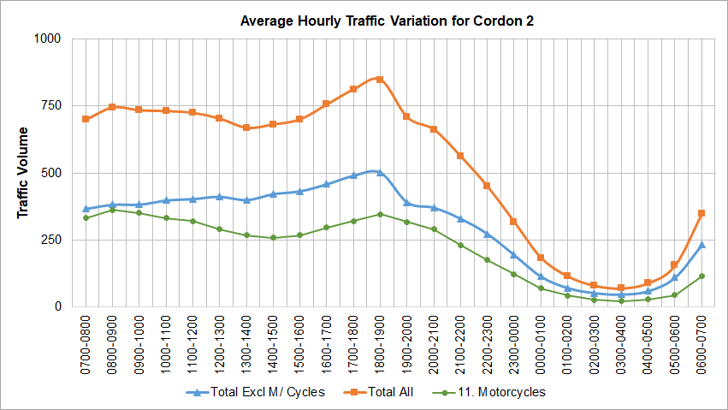

Figure 3-16: Average vehicle proportion for Cordon 2
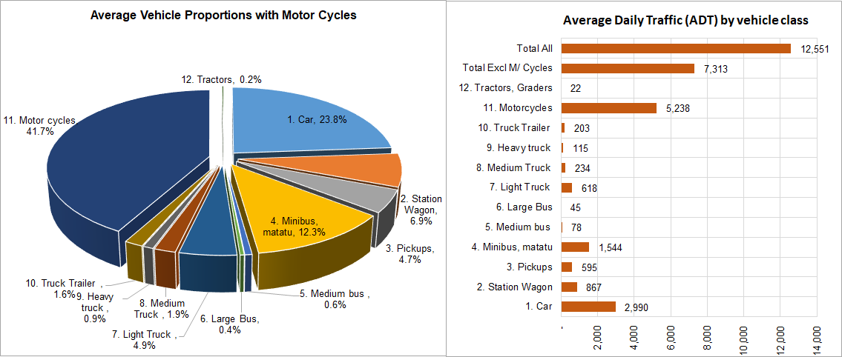
The following observations are with regard to Figures 3-3 and 3-4 (Cordon 2):
- Peak hours: AM peak hours is observed to be 8-9am with a flow of 745 vehicles. The PM peak hour is observed as 6 – 7pm with a flow of 848 vehicles.
- Night activity: night activity is less strong than for Cordon 1. The least busy hour of the day is 3 – 4am in the morning with a flow of 70 vehicle per hour. Of this, 31% is motorcycle traffic.
- Vehicle proportions: there is high motorcycle content of 41.7% (5,238 vehicles per day) followed by cars at 23.8% (2,990) and minibus at 12.3% (1,544).
- Average ADT: average ADT for all surveyed links across the cordon is 12,551 vehicles including motorcycles and 7,313 excluding motorcycles.

MCC Data Analysis – Cordon 3
This section presents the analysis of MCC data collected at Cordon 3. Figures 3-5 and 3-6 present the hourly variation of traffic and vehicle proportions for Cordon 3. Detailed station by station analysis results for this cordon are included in Appendix B.
Figure 3-17: Hourly variation of traffic for Cordon 3
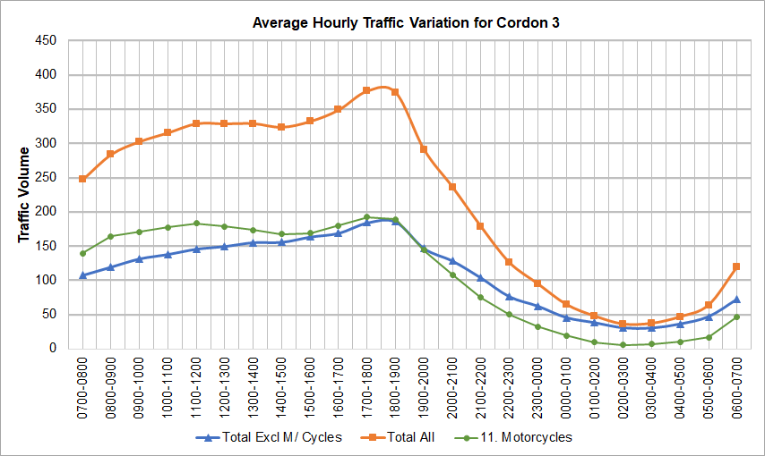

Figure 3-18: Average vehicle proportion for Cordon 3
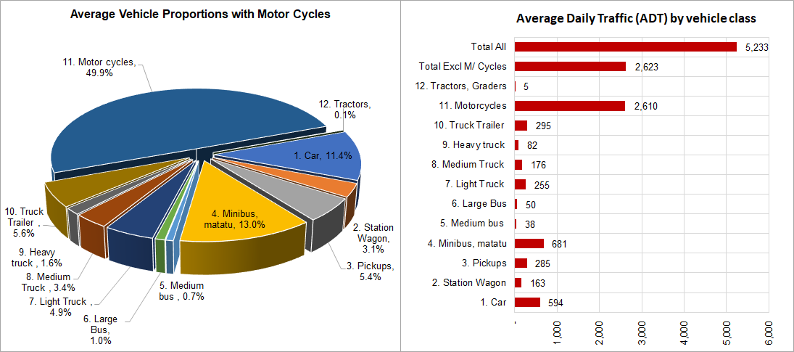
The following observations are with regard to Figures 3-5 and 3-6 (Cordon 3):
- Peak hours: The AM peak hour is not well defined, with traffic volumes increase through the period. The PM peak hour is observed as 5 – 6pm with a flow of 376 vehicles.
- Night activity: night activity is not significant. The least busy hour of the day is 2 – 3am in the morning with a flow of 36 vehicle per hour. Of this, only 16.7% is motorcycle traffic.
- Vehicle proportions: there is high motorcycle content of 49.9% (2,610 vehicles per day) followed by minibus at 13.0% (681 vehicles) and cars at 11.4% (594 vehicles).
- Average ADT: average ADT for all surveyed links across the cordon is 5,233 vehicles including motorcycles and 2,623 excluding motorcycles.

MCC Data Analysis – Cordon 4
This section presents the analysis of MCC data collected at Cordon 4. Figures 3-7 and 3-8 present the hourly variation of traffic and vehicle proportions for Cordon 4. Detailed station by station analysis results for this cordon are included in Appendix B.
Figure 3-19: Hourly variation of traffic for Cordon 4
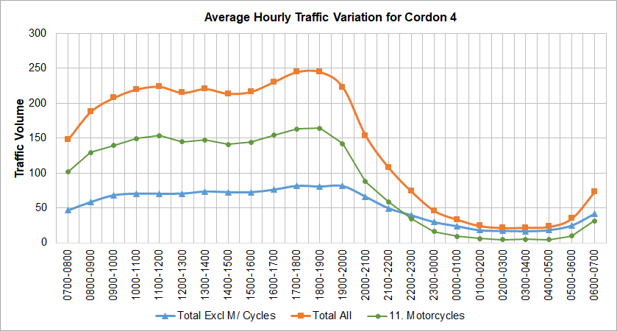

Figure 3-20: Average vehicle proportion for Cordon 4
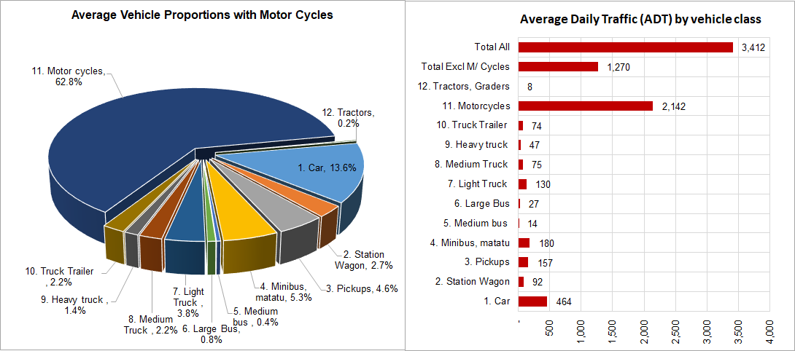
The following observations are with regard to Figures 3-7 and 3-8 (Cordon 4):
- Peak hours: The AM peak hour is not well defined, with traffic volumes increase through the period. The PM peak hours are observed as 5 - 6pm and 6 – 7pm with a flow of 245 vehicles.
- Night activity: night activity is not significant. The least busy hour of the day is 2 – 3am in the morning with a flow of 22 vehicle per hour. Of this, only 18% is motorcycle traffic.
- Vehicle proportions: there is high motorcycle content of 62.8% (or 2,142 vehicles per day) followed by car at 13.6% (464) and minibus at 5.3% (180). Other notable proportions for this cordon are pickups at 4.6% and light trucks at 3.8%.
- Average ADT: average ADT for all surveyed links across the cordon is 3,412 vehicles including motorcycles and 1,270 excluding motorcycles.

MCC Data Analysis – Cordon 5
This section presents the analysis of MCC data collected at Cordon 5. Figures 3-9 and 3-10 present the hourly variation of traffic and vehicle proportions for Cordon 5. Detailed station by station analysis results for this cordon are included in Appendix B.
Figure 3-21: Hourly variation of traffic for Cordon 5
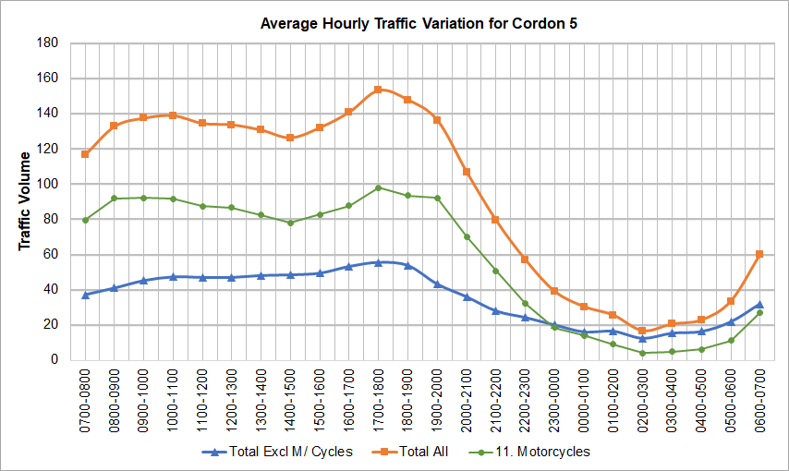

Figure 3-22: Average vehicle proportion for Cordon 5
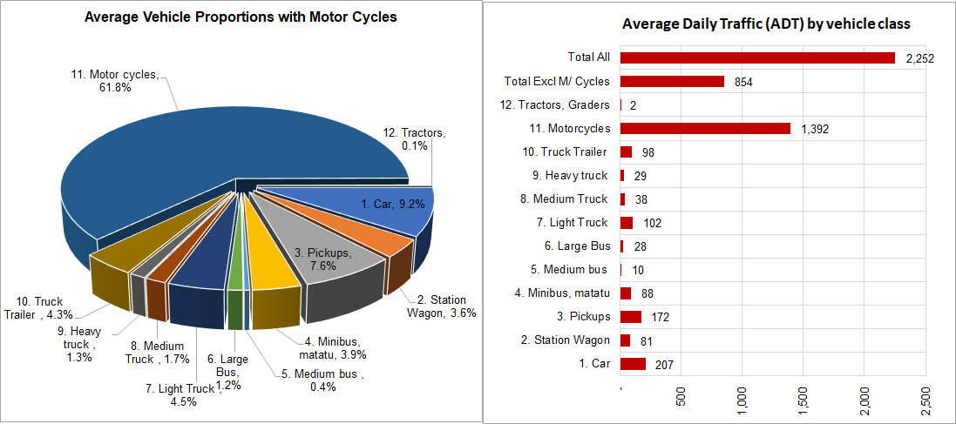
The following observations are with regard to Figures 3-9 and 3-10 (Cordon 5):
- Peak hours: The AM peak hour is observed as 9 - 10am with a traffic flow of 137 vehicles. The PM peak hour is observed as 5 - 6pm with a flow of 153 vehicles.
- Night activity: night activity is significantly low as expected for this cordon. The least busy hour of the day is 2 – 3am in the morning with a flow of 17 vehicle per hour. Of this, 23.5% is motorcycle traffic.
- Vehicle proportions: there is high motorcycle content of 61.8% (1,490 vehicles per day) followed by car at 9.2% (207) and pickups at 7.6% (172). Other notable proportions for this cordon are truck/trailers at 4.3% and light trucks at 4.5%.
- Average ADT: average ADT for all surveyed links across the cordon is 2,252 vehicles including motorcycles and 854 excluding motorcycles.

Overall Observations from MCC Surveys and Data
Peak Travel Hours
The morning (AM) peak travel hour is not uniformly defined across all cordons. For the busy C1 and C2 cordons, the peak hour is 8-9am. For C3, C4 and C5, the AM peak hour is not marked and it was observed from the data that the inter peak (IP) is busier than the AM peak. The PM peak is generally defined for all cordons as 5-6pm.
Night Activity
As expected, this was observed to be significantly high for C1, being an urban area largely.
Proportion of Motor Cycles
Motor cycle content is high for all cordons. The average for all cordons is calculated as 54% - this represents the proportion of motor cycle trips countrywide.
Vehicle Classifications
The challenges experienced in the field with regard to vehicle classification were stated in the Survey Diary (Section 3.1.3). The current standard vehicle classification seems to have been overtaken by changes in vehicle makes and shapes. The Consultant recommends a review of the vehicle classification guidelines for better alignment between current vehicle models and the requirements for traffic analysis.

Adequacy of MCC Survey Method
MCC surveys provide vital information on traffic volumes and vehicle classification in a simple, flexible and cost-effective way. This survey type was largely adequate for this purpose throughout the country. However, as discussed in the survey diary, significant challenges and high costs of the survey were experienced in Cordon 1 – Kampala CBD. The Consultant believes that for Kampala CBD, as much as possible, automatic traffic surveys (using pneumatic tubes) should be employed. This will likely produce better quality data and reduce costs.
Annual Average Daily Traffic
The variation of AADT across the nation as one moves away from Kampala Central is shown in Figure 3-11 below. In estimating the AADT, the cordon ADT was divided by a Seasonal Correction Factor (SCF) of 0.9925 established in Section 3.2.1 of this report.
Figure 3-23: Variation of AADT by cordon
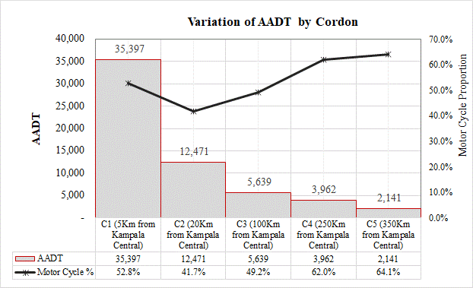

Vehicle Registrations in Uganda

New Vehicle Registration Data
As part of the survey exercise, vehicle registration data from the Uganda Revenue Authority was also analysed. The data which was requested through the Ministry of Works and Transport (MoWT) was provided for seven financial years from 2012/13 to 2018/19. This data represented newly registered vehicles only. It does not represent the total number of vehicles in the country.
The data was received in Excel format and was organized by make and model. The data was then sorted into the 11 UNRA standard vehicle types, with a 12th type added for tractors and construction equipment. Figure 3-12 presents the form of the raw data. The complete set of raw data as provided by URA is included in Appendix B.
Table 3-7 presents the sorted vehicle registration data by vehicle type.

Figure 3-24: Format of raw vehicle registration data
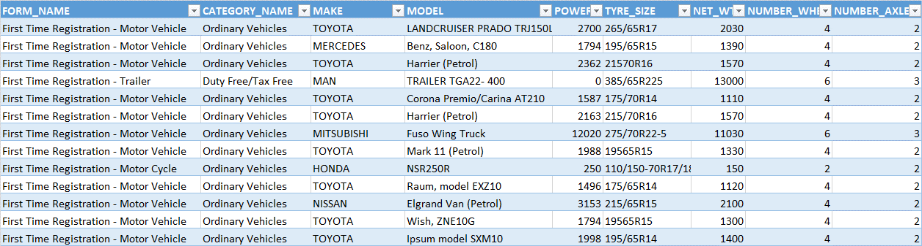
Table 3-18: New vehicle registrations in Uganda 2013-2019
VEHICLE REGISTRATION DATA 2013 - 2019
Year | Car | Station Wagon | Pickup | Mini bus | Med. Bus | Large Bus | Light Truck | Medium Truck | Hvy Truck | Truck/ Trailer | M/ Cycle | Tractor Grader | Total Vehicles
2013 | 7,930 | 2,745 | 1,185 | 2,704 | 94 | 61 | 1,044 | 393 | 522 | 622 | 25,169 | 817 | 43,286
2014 | 7,892 | 3,165 | 1,243 | 3,800 | 98 | 45 | 1,217 | 509 | 958 | 468 | 14,234 | 766 | 34,395
2015 | 8,574 | 3,641 | 1,165 | 4,414 | 124 | 83 | 1,509 | 488 | 2,883 | 199 | 13,893 | 1,672 | 38,645
2016 | 6,626 | 3,072 | 1,272 | 2,978 | 146 | 43 | 2,460 | 780 | 818 | 551 | 14,897 | 1,222 | 34,865
2017 | 9,026 | 4,194 | 1,059 | 3,463 | 178 | 40 | 1,860 | 1,926 | 1,721 | 422 | 14,259 | 1,202 | 39,350
2018 | 13,628 | 5,294 | 3,216 | 5,792 | 215 | 71 | 4,551 | 1,705 | 728 | 350 | 36,297 | 1,469 | 73,316
2019 | 11,946 | 4,186 | 3,043 | 3,757 | 156 | 84 | 3,689 | 1,518 | 1,041 | 387 | 32,525 | 1,697 | 64,028
Avge | 9,375 | 3,757 | 1,740 | 3,844 | 144 | 61 | 2,333 | 1,046 | 1,239 | 428 | 21,611 | 1,264 | 46,841
Grth | 8.5% | 8.7% | 16.6% | 5.7% | 12.3% | 4.1% | 23.7% | 28.0% | 3.6% | -4.5% | 9.5% | 11.3% | 9.7%

Table 3-7 also shows the average growth rates of vehicle registrations for each vehicle type. The medium truck vehicle type had the fastest growing vehicle registrations, followed by light trucks and pickups with 28%, 23.7% and 16.6%. Registrations for truck trailers declined over the period, with an average growth rate of -4.5%.
Motor cycles had the highest registrations but these grew at a lower average than the trucks and pickups of 9.5% over the period. The average motor cycle registrations over the seven-year period was 21,611 motorcycles. This is quite a high number when compared with other vehicle types.
Overall, vehicle registrations grew at 9.7% annually over the seven-year period, with an average total of 46,841 vehicles registered per year.

Total Number of Vehicles in the Country
It worth noting that the data presented in Table 3-7 is for vehicle registration per year and does not provide an indication of the total number vehicles in the country. To estimate the vehicle stock in the country, vehicle registrations data published in the National Master Plan were used. The NTMP reported the “Number of Registered Vehicles” in Uganda for the years 1997, 2002, and 2005 – 2009.
Assuming that this data was correct, the following were considered in this Report:
- To obtain 2012 data, an extrapolation of the NTMP data for the period 2005-2009. This would represent the number of registered vehicles in 2012.
- To obtain the cumulative number of registered vehicles for the period 2013-2019, the data in Table 3-7 above would be added to the 2012 data in sequence. That is, 2013 numbers would be obtained by adding the 2013 new registrations to the 2012 total vehicles.
The estimated total vehicles in the country obtained above was assumed not to consider scrappage i.e. the number of vehicles taken off the road per year. The correct rate of scrappage in Uganda in not known because vehicles censuses are not undertaken in the country. These would help to compare the vehicle stock in the country by year and hence enable the correct estimation of scrappage. Table 3-8 presents the estimated total number of vehicles without consideration for scrappage.
Table 3-19: Estimated vehicle population in Uganda (not adjusted for scrappage) 2005-2019
ESTIMATED VEHICLE POPULATION IN UGANDA (NOT ADJUSTED FOR SCRAPPAGE) 2005 - 2019
Year | Car | Station Wagon | Pickup | Mini bus | Med. Bus | Large Bus | Light Truck | Medium Truck | Heavy Truck | Truck/ Trailer | M/ Cycle | Tractor Grader | Total Vehicles
2005 | 65,500 | 37,159 | 16,041 | 27,600 | 546 | 354 | 7,565 | 2,848 | 3,783 | 4,504 | 108,200 | 4,600 | 278,700
2006 | 70,700 | 37,159 | 16,041 | 32,000 | 546 | 354 | 8,293 | 3,122 | 4,147 | 4,938 | 134,000 | 4,800 | 316,100
2007 | 81,300 | 39,115 | 16,885 | 39,500 | 606 | 394 | 9,426 | 3,548 | 4,713 | 5,612 | 176,500 | 5,200 | 382,800
2008 | 90,900 | 40,721 | 17,579 | 49,200 | 728 | 472 | 11,530 | 4,340 | 5,765 | 6,865 | 236,500 | 5,900 | 470,500
2009 | 96,600 | 41,699 | 18,001 | 62,300 | 910 | 590 | 13,512 | 5,086 | 6,756 | 8,045 | 292,300 | 6,900 | 552,700
2010 | 101,179 | 40,780 | 17,604 | 72,585 | 985 | 639 | 14,852 | 5,591 | 7,426 | 8,843 | 356,235 | 7,261 | 633,980
2011 | 105,975 | 39,881 | 17,216 | 84,568 | 1,067 | 693 | 16,324 | 6,145 | 8,162 | 9,719 | 434,154 | 7,641 | 731,546
2012 | 110,998 | 39,002 | 16,837 | 98,529 | 1,156 | 750 | 17,942 | 6,754 | 8,971 | 10,683 | 529,117 | 8,041 | 848,781
2013 | 118,928 | 41,747 | 18,022 | 101,233 | 1,250 | 811 | 18,986 | 7,147 | 9,493 | 11,305 | 554,286 | 8,858 | 892,066
2014 | 134,750 | 47,657 | 20,450 | 107,737 | 1,442 | 917 | 21,247 | 8,049 | 10,973 | 12,394 | 593,689 | 10,441 | 969,747
2015 | 159,146 | 57,208 | 24,043 | 118,655 | 1,758 | 1,106 | 25,017 | 9,439 | 15,336 | 13,682 | 646,985 | 13,696 | 1,086,072
2016 | 190,168 | 69,831 | 28,908 | 132,551 | 2,220 | 1,338 | 31,247 | 11,609 | 20,517 | 15,522 | 715,178 | 18,173 | 1,237,263
2017 | 230,216 | 86,648 | 34,832 | 149,910 | 2,860 | 1,610 | 39,337 | 15,705 | 27,419 | 17,784 | 797,630 | 23,852 | 1,427,804
2018 | 283,892 | 108,759 | 43,972 | 173,061 | 3,715 | 1,953 | 51,978 | 21,506 | 35,049 | 20,396 | 916,379 | 31,000 | 1,691,661
2019 | 349,514 | 135,055 | 56,155 | 199,969 | 4,727 | 2,380 | 68,309 | 28,825 | 43,720 | 23,395 | 1,067,653 | 39,845 | 2,019,547

Estimation of Scrappage Rates and Residual Vehicle Population
To overcome this challenge, significant literature has been reviewed with regard to used vehicle depreciation rates and scrappage. In particular, a study by Karl Storchmann, appeared to make a considerable amount of analysis to compared depreciation rates for OECD and non-OECD countries (including a number of countries in sub-Saharan Africa). The paper estimated a depreciation rate of used vehicles in sub-Saharan Africa of 14.5% per year. This rate related to passenger vehicles.
The above value was considered reasonable by the Consultant for passenger and light goods vehicles (including motorcycles) as a scrappage rate. This assumes that a vehicle would be scrapped before or at the point of zero value. The percentage is also assumed to account for scrappage that occurs due to accidents – this is not considered to be a significant amount.
A lower rate of 10% was considered by the Consultant for heavier vehicles such as medium and large buses, and medium to large trucks. Larger vehicles from observation tend to operate on the road network at significantly higher vehicle age than lighter vehicles.
The above rates were combined with the estimates of total vehicle population in Table 3-8 to provide an estimate of the residual vehicle population by year for the period 2005-2019. The method of adjustment for scrappage was such that the existing stock was adjusted for scrappage prior to adding the newly registered vehicles. Table 3-9 presents this estimate.
Table 3-20: Estimated residual vehicle population in Uganda (adjusted for scrappage) 2005-2019
ESTIMATED RESIDUAL VEHICLE POPULATION IN UGANDA (ADJUSTED FOR SCRAPPAGE) 2005 - 2019
Year | Car | Station Wagon | Pickup | Mini bus | Med. Bus | Large Bus | Light Truck | Medium Truck | Heavy Truck | Truck/ Trailer | M/ Cycle | Tractor Grader | Total Vehicles
2005 | 56,003 | 31,771 | 13,715 | 23,598 | 491 | 319 | 6,468 | 2,563 | 3,404 | 4,054 | 92,511 | 4,140 | 239,037
2006 | 60,449 | 31,771 | 13,715 | 27,360 | 491 | 319 | 7,091 | 2,810 | 3,732 | 4,444 | 114,570 | 4,320 | 271,071
2007 | 69,512 | 33,443 | 14,437 | 33,773 | 546 | 354 | 8,059 | 3,194 | 4,242 | 5,051 | 150,908 | 4,680 | 328,197
2008 | 77,720 | 34,816 | 15,030 | 42,066 | 655 | 425 | 9,858 | 3,906 | 5,188 | 6,178 | 202,208 | 5,310 | 403,361
2009 | 82,593 | 35,653 | 15,391 | 53,267 | 819 | 531 | 11,553 | 4,578 | 6,080 | 7,241 | 249,917 | 6,210 | 473,831
2010 | 86,508 | 34,867 | 15,052 | 62,060 | 887 | 576 | 12,698 | 5,032 | 6,683 | 7,959 | 304,581 | 6,535 | 543,436
2011 | 90,608 | 34,098 | 14,720 | 72,305 | 961 | 623 | 13,957 | 5,531 | 7,346 | 8,747 | 371,202 | 6,877 | 626,976
2012 | 94,903 | 33,347 | 14,395 | 84,242 | 1,041 | 675 | 15,341 | 6,079 | 8,074 | 9,615 | 452,395 | 7,237 | 727,344
2013 | 102,833 | 36,092 | 15,580 | 86,946 | 1,135 | 736 | 16,385 | 6,472 | 8,596 | 10,236 | 477,564 | 8,054 | 770,629
2014 | 117,505 | 41,603 | 17,837 | 93,058 | 1,317 | 836 | 18,494 | 7,334 | 10,024 | 11,264 | 513,317 | 9,555 | 842,146
2015 | 139,607 | 50,298 | 21,078 | 103,033 | 1,614 | 1,015 | 21,937 | 8,634 | 14,239 | 12,443 | 560,900 | 12,652 | 947,449
2016 | 167,092 | 61,536 | 25,422 | 115,346 | 2,045 | 1,228 | 27,620 | 10,665 | 18,984 | 14,154 | 621,365 | 16,804 | 1,082,258
2017 | 202,642 | 76,522 | 30,640 | 130,690 | 2,638 | 1,477 | 34,807 | 14,544 | 25,368 | 16,232 | 693,929 | 22,035 | 1,251,523
2018 | 250,511 | 96,195 | 38,921 | 151,324 | 3,429 | 1,792 | 46,275 | 19,936 | 32,307 | 18,618 | 800,722 | 28,615 | 1,488,645
2019 | 308,349 | 119,285 | 49,779 | 174,875 | 4,355 | 2,185 | 60,772 | 26,675 | 40,215 | 21,356 | 934,778 | 36,745 | 1,779,369
Proportion | 17.3% | 6.7% | 2.8% | 9.8% | 0.2% | 0.1% | 3.4% | 1.5% | 2.3% | 1.2% | 52.5% | 2.1%
Growth, % | 11.1% | 8.5% | 8.0% | 13.6% | 15.1% | 13.6% | 14.7% | 15.2% | 17.1% | 11.4% | 15.6% | 15.0% | 13.6%

Table 3-9 shows that the estimated total vehicle population in Uganda was 1,844,078. The largest proportion of vehicles is motor cycles with 982,321 units or 52.5%. These are followed by car vehicles and minibus with 17.3% and 9.8% respectively. Large buses have the lowest proportion with 0.1%. Figure 3-13 confirms the breakdown of the vehicle populations.
Figure 3-25: Breakdown of the vehicle population in Uganda
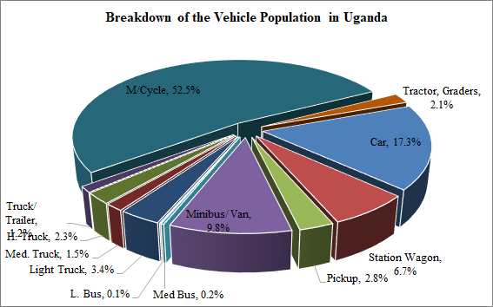
With regard to growth, all vehicle types exhibit significant growth over the 15-year period 2005-2009. This is not surprising considering the significant growth the country has experienced. Overall, the stock of vehicles in country is estimated to have grown at 13.6% per year over the last 15 years. Figure 3-14 shows the growth trend of the vehicle stock in the country.
Figure 3-26: Growth of vehicle population in Uganda (2005-2019)
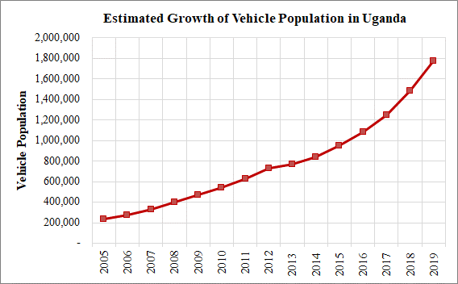

ORIGIN – DESTINATION SURVEYS

Introduction
OD surveys were undertaken at 132 locations countrywide. OD surveys are used to collect information on the origins and destinations on the road network.
The OD surveys were undertaken between 22th July 2019 and 5th November 2019. All vehicles classes were stopped for interview as part of the OD surveys except police, VIP and ambulance vehicles.

Methodology

Site Selection
The locations of the OD surveys were carefully chosen to optimize the coverage of driver origins and destinations.
The OD survey sites were also selected to maximize the safety of survey personnel and travelling public, and to minimize traffic disruptions and delays to traffic especially during the peak travel periods.

Survey Personnel and Training
The following categories of survey staff were used at all survey sites:
- Survey manager with overall responsibility for the survey programme;
- Site supervisors with overall responsibility for the operations of each of the survey sites;
- Four to ten interviewers depending on the level of traffic on the road and the required survey sample; and
- Two traffic officers per site.
Survey staff used for OD surveys in this exercise were experienced, but were nonetheless trained prior to the survey. The training covered a range of issues including; details about the survey, the duties involved, roles and responsibilities, the associated health and safety requirements, interview procedure and detailed instructions on how to complete the survey questionnaire.

Site Layouts, Signage and Notices
The site inspection undertaken as part of the survey planning enabled the determination of the actual locations for the survey sites. For safety reasons, all OD survey sites were chosen at areas of the road with adequate shoulder width and length to enable stopping traffic to safely pull off from the road.
Generally, a shoulder width that could accommodate about two truck trailers was considered. The length required for each site was estimated from the following relationship as recommended in the UK Design Manual for Roads and Bridges, Volume 5, Section 1, Part 4 (TA 11/09).
Length of site in metres = (4 + 8 x no. of interviewers). A minimum site length of 45m that would be adequate for 5 interviewers was generally considered.
Appropriate signage was also produced for each survey site. This objective of the signage was to enhance safety at the survey site by warning drivers to reduce speed as they approached the survey site.

Survey Direction and Period
As described in Table 1-1, the OD surveys were undertaken for a total of two (2) days. One (1) day for a 12-hour period (7am – 7pm) and one (1) day for a 24-hour period (7am – 7am). The survey periods sufficiently covered all travel periods.
Surveying was undertaken in both directions except where the OD survey site was located on a very busy urban road. These exception cases were used for 22 sites located on the busy cordon 1 (C1) line. For example, on the busy Bombo Road at Bwaise and other similar roads, it would be impossible to fit a survey site in both directions at the preferred short section between Bwaise and the Northern Bypass. A staggered arrangement was considered, but still in this short section, the risk of exacerbating the already high congestion was very high and Police support for the site would not be obtained. This was the consideration for all 22 sites.
The approach that was taken for the above cases was to interview in one direction on either side of the Northern Bypass. For example, sites 22 and 23, with interviews in a single direction on each site, effectively make up one dual direction survey site for Bombo Road on Cordon 1.
For an urban area were the largest proportion of trips are made daily, interview in a single direction is acceptable. OD data for the opposite direction, where required for model building and other analyses, can be obtained by transposing data from the direction that was surveyed.

Interviews
At the survey sites, enumerators positioned themselves along the survey site length ready to receive stopping traffic. A traffic police officer then waived traffic at random to stop for interview. Once all motorists had been interviewed and departed the officer waived another set of vehicles to stop. This cycle was repeated throughout the day.

Survey Diary
For relatively small surveys (for a few survey stations) and a limited number of survey days, one of the key impacts is inclement weather. For this assignment, this was not considered a key issue. The OD sample was effectively collected for 36 hours (1 day 24 hours, 1 day 12 hours) and in a largely dry season (July to September).
The most significant issue to the OD surveys frequently experienced was the unavailability of police personnel. The following issues were experienced:
- For Cordon 1 and Cordon 2 surveys, Police personnel was secured through the Greater Kampala Metropolitan Police office. The availability of these resources to support the surveys was frequently affected by activities in Greater Kampala such as political events, visiting international dignitaries, etc. The mitigation for this was to schedule the surveys in such as way that a relatively small number of police personnel would be required at any one time. This however led to significant delays to Cordon 1 and 2 surveys.
- For other cordons, the key issue was the ability of the limited local police resources to support the surveys while at the same time undertaking routine enforcement work. The mitigation for this was to request from the Officers in Charge (OCs) to avail ordinary police personnel to support the survey sites. However, even with this measure, some Police stations could not provide personnel for night surveys for example. This was experienced at Station 115.
- Further, for a limited number of stations, personnel could not be provided for night surveys due to insecurity in the regions. For example, the Police could not provide personnel for night surveys for survey sites 116, 124, 126, 129 and 130 (all in the northern region). No night OD surveys were undertaken at these stations.
- The issue of police personnel not being available for the whole survey period was also frequently encountered. For example, many police personnel argued that their working hours were 7am to 5pm. Quite often, Police personnel report at the survey sites between 8am and 9am, and left the sites at 6pm. This obviously shortens the survey period. In other cases, where police resources were limited (upcountry Police stations), the same resources supporting night surveys were also required to undertake duties the following morning at their stations. They would therefore leave the stations before end of the period, typically at 3am to 4am.
The mitigation for the above issues was to collect as much sample as possible with the availability the Police personnel could provide. In a limited few cases and on rural roads, the survey team, helped by appropriate signage, was successful in stopping vehicles for interview especially for morning periods prior to the arrival of police personnel.
It worth stating that even with the above issues, a representative OD sample was obtained generally. For those northern region survey sites where Police personnel could not be deployed for night surveys, surveys on adjacent stations or for survey sites along the same roads up or downstream were considered adequate. For example, for the key survey site 116 which had no night OD surveys, sites 113 and 118 provide adequate usable night data.

Sampling
The number of interviews (sample size) required to obtain a representative sample of vehicles using the project road is determined chiefly by the current volume of traffic on the road. Once current volume of traffic can be estimated (prior to commencement of surveys), the size of the required sample size can then be estimated.
There is no specific guidance from the Ministry of Works and Transport (MoWT), UNRA or internationally for the required sample rate. The TA 11/09 of the UK DMRB states that “When data is being collected for a large multi-zoned modal, it is impossible to calculate required sample rates for each OD site as the origins and destinations are not known. Once a survey site has been established it is best practice to collect as much data as reasonably practical”.
However, traffic engineering experience worldwide indicates that a minimum sample rate of 10% is sufficient for average traffic volume roads. The sample rate may be adjusted for lower or higher volume roads.
For reference, the Consultant has considered the following guidelines reasonable. These have also been used for another countrywide traffic survey commissioned by the MoWT.
The minimum OD sample rates were set as follows:
- 20% for survey links with ADT less than 1,000 vehicles per day;
- 10% for ADT of 1,000 to 4,999;
- 5% for ADT 5,000 to 10,000;
- 2% for ADT greater than 10,000;
During the surveys, vehicles were selected at random in order to have a representative sample with at least the minimum sample rate for all vehicle types. In order to do this, vehicles were directed at interview bays as soon as the bays were free. However, in a few cases, traffic officers seemed more inclined to stop certain vehicle type and not others. For example, significantly less large trucks, truck-trailers and coaches were stopped than minibuses and other small vehicles. To mitigate this, the survey supervisors were asked to be vigilant and encourage the officers to select the traffic at random.
Another aspect that was experienced especially in the higher trafficked areas such as Cordons 1 and 2, was the difficulty of stopping motorcycles (the majority being Boda Boda cyclists). This class of vehicles was less cooperative and the majority did not readily stop when flagged down by traffic police personnel. This resulted in significantly low samples of motorcycles especially in Cordon 1.
The above observation notwithstanding, even in less urban areas, with lower traffic levels, sample rates for motorcycles were generally low because trips at any survey site are predominantly made by the same riders i.e. one rider makes multiple trips past the site. Once he has stopped for survey once, he is less cooperative when stopped subsequently.

Collected OD Data

Cordon 1 OD Sample Rates
Tables 4-1 to 4-4 below compares the collected and expected OD sample for various survey site and cordon lines. Detailed data including vehicle by vehicle and directional disaggregation is included in Appendix C.
Table 4-21: Comparison of collected and required OD sample for Cordon 1 (C1)
Comparison of collected AND REQUIRED OD sampleS – CORDON 1
Site | Description | Interviewed Sample | Average Daily Traffic (ADT) | Collected Sample % | Required Sample, %
01 | Mobutu Road | 1,398 | 38,339 | 3.6% | 2%
01A | Salama Road | 1,643 | 35,950 | 4.6% | 2%
02 | Entebbe Road | 1,475 | 71,465 | 2.1% | 2%
03 | Kalinda Rd | 668 | 18,500 | 3.6% | 2%
04 | Weraga Road | 502 | 10,615 | 4.7% | 2%
05 | Kabusu Rd | 860 | 9,150 | 9.4% | 5%
06 | Wankulukuku Rd | 284 | 13,618 | 2.1% | 2%
07 | Masaka Rd Ndeeba | 1,306 | 38,993 | 3.3% | 2%
08 | Wakaliga Rd North | 336 | 19,200 | 1.8% | 2%
09 | Wakaliga Rd South | 374 | 12,757 | 2.9% | 2%
10 | Masaka Rd Busega | 1,238 | 53,416 | 2.3% | 2%
11 | Masaka Rd Kyengera | 1,255 | 54,407 | 2.3% | 2%
12 | Mityana Rd | 1,200 | 43,950 | 2.7% | 2%
13 | Mityana-Sentema | 726 | 38,047 | 1.9% | 2%
14 | Sentema Rd South | 604 | 11,233 | 5.4% | 2%
15 | Sentema Rd North | 574 | 5,385 | 10.7% | 5%
16 | Northern Bypass | ATC Only | 46,759 | - | -
17 | Hoima Rd South | 938 | 18,378 | 5.1% | 2%
18 | Hoima Rd Nth | 1,514 | 17,936 | 8.4% | 2%
20 | Kawaala Rd | 448 | 12,462 | 3.6% | 2%
21 | Sir Apollo Kaggwa Road | 620 | 41,929 | 1.5% | 2%
22 | Bombo Road South | 900 | 25,668 | 3.5% | 2%
23 | Bombo Road North | 628 | 21,501 | 2.9% | 2%
24 | Gayaza Rd South | 1,105 | 21,469 | 5.1% | 2%
25 | Tula Rd | 1,219 | 21,519 | 5.7% | 2%
26 | Gayaza Rd North | 1,224 | 15,299 | 8.0% | 2%
28 | Kisingiri Street | 1,260 | 19,988 | 6.3% | 2%
29 | Kyebando Ring Rd | 400 | 5,788 | 6.9% | 5%
30 | Kyebando-Kisalosalo | 398 | 4,977 | 8.0% | 5%
31 | Bukoto Kisasi Rd | 678 | 13,740 | 4.9% | 2%
33 | Kisasi-Ntinda Rd | 661 | 12,333 | 5.4% | 2%
34 | Kisasi-Kyanja Rd | 399 | 14,623 | 2.7% | 2%
36 | Mbogo Road | 728 | 27,246 | 2.7% | 2%
37 | Naalya Road West | 489 | 14,588 | 3.4% | 2%
38 | Naalya Road East | 692 | 13,936 | 5.0% | 2%
39 | Namugongo Rd | 696 | 26,592 | 2.6% | 2%
40 | Bweyogerere - Nalya | 572 | 15,774 | 3.6% | 2%
41 | Namanve Ind Park | MCC Only | 6,132 | - | -
42 | Kinawataka Road | 644 | 32,346 | 2.0% | 2%
43 | Kla-Jinja Hway | 1,957 | 63,727 | 3.1% | 2%
44 | Kinawataka - Spear Road | 798 | 11,469 | 7.0% | 2%
44A | Ntinda Road | 591 | 11,493 | 5.1% | 2%
45 | New Port Bell Rd | 905 | 30,422 | 3.0% | 2%
46 | Katalima Road | 896 | 24,965 | 3.6% | 2%
47 | Lugogo Bypass | 775 | 42,478 | 1.8% | 2%
48 | Old Port Bell Road | 630 | 28,058 | 2.2% | 2%
49 | Access Road | 1,511 | 79,682 | 1.9% | 2%
50 | Nsambya Rd | 1,205 | 57,503 | 2.1% | 2%

The following observations are with regard to Table 4-1 (OD samples for C1):
- OD surveys were conducted at 49 links for C1;
- Of the 49 survey sites, higher than the minimum sample rate was achieved at 44 sites (90%).
- Five stations did not achieve the minimum sample rates. On average these achieved 1.8%. These sites collected less than adequate motorcycle samples. Nonetheless, the collected sample totals are considered adequate.
- For Stations 3, 4, 5, 6 , 8, 9, 14, 15, 17, 18, 22, 23, 24, 26, 29, 30, 33, 34, 37, 38, 44, 44A (22 stations), OD surveys were undertaken in one direction (see Section 4.2.4) because of lack of adequate survey space. As such, the ADT has been used to calculate sample rates are the one direction (as appropriate) totals.
- Overall, nearly 40,000 interviews were undertaken in Cordon 1. This is a significant sample that is adequate for modelling and other analyses.

Cordon 2 Sample Rates
Table 4-22: Comparison of collected and required OD sample for Cordon 2 (C2)
COMPARISON OF COLLECTED AND REQUIRED OD SAMPLES – CORDON 2
Site | Description | Interviewed Sample | Average Daily Traffic (ADT) | Collected Sample % | Required Sample, %
51 | Salama Road | 487 | 14,600 | 3.3% | 2%
52 | Wavamunno Rd | 783 | 16,004 | 4.9% | 2%
53 | Busabala Road | 240 | 2,054 | 11.7% | 10%
55 | Lubugumu Road | 441 | 1,864 | 23.7% | 10%
56 | Munyonyo Spur | 768 | 10,713 | 7.2% | 2%
57 | Kigo Road | 228 | 3,435 | 6.6% | 10%
58 | Entebbe Road | 587 | 18,588 | 3.2% | 2%
59 | Kampala Entebbe Expressway | 833 | 8,812 | 9.5% | 5%
59A | Budo Road | 554 | 7,330 | 7.6% | 5%
60 | Masaka Rd | 739 | 16,632 | 4.4% | 2%
61 | Nsangi-Buloba Road | Road was closed during survey period due to heavy rains
62 | Mityana Road | 411 | 9,218 | 4.5% | 5%
63 | Buloba-Bukasa Rd | 599 | 3,494 | 17.1% | 10%
64 | Bukasa-Wakiso Road | 459 | 3,907 | 11.7% | 10%
65 | Hoima Road | 877 | 2,174 | 40.3% | 10%
66 | Wakiso-Matugga Rd | 768 | 7,210 | 10.7% | 5%
67 | Bombo Road | 862 | 22,330 | 3.9% | 2%
68 | Matugga-Kasangati Road | 485 | 9,409 | 5.2% | 5%
69 | Gayaza Road | 1123 | 31,561 | 3.6% | 2%
70 | Kasangati-Kira Rd | 717 | 16,632 | 4.3% | 2%
71 | Kira-Bulindo Rd | 634 | 20,898 | 3.0% | 2%
72 | Kira-Kyaliwajjala Rd | 883 | 21,193 | 4.2% | 2%
73 | Sonde Road | 529 | 14,984 | 3.5% | 2%
74 | Kampala -Jinja Road | 852 | 35,282 | 2.4% | 2%
75 | Mukono-Kalagi Rd | 630 | 6,596 | 9.6% | 5%
76 | Kla-Jinja Highway | 923 | 28,223 | 3.3% | 2%
77 | Katosi Rd | 798 | 17,091 | 4.7% | 2%

The following observations are with regard to Table 4-2 (OD samples for C2):
- OD surveys were conducted at 26 links for C2;
- Of the 26 survey sites, 24 (92.3%) achieved higher than the set minimum sample rate. Only site 57 achieved less due to smaller motorcycle sample; and
- Overall, 17,210 interviews were undertaken in Cordon 2. This is considered a significant and adequate sample.

Cordon 3 Sample Rates
Table 4-23: Comparison of collected and required OD sample for Cordon 3 (C3)
COMPARISON OF COLLECTED AND REQUIRED OD SAMPLES – CORDON 3
Site | Description | Interviewed Sample | Average Daily Traffic (ADT) | Collected Sample % | Required Sample, %
78 | Masaka - Mutukula | 848 | 8,307 | 10.2% | 5%
79 | Masaka - Mbarara | 748 | 5,695 | 13.1% | 5%
80 | Villa Rd | 436 | 1,678 | 26.0% | 10%
81 | Sembabule-Kabulasoke | 392 | 1,558 | 25.2% | 10%
82 | Kanoni-Maddu | 396 | 2,023 | 19.6% | 10%
83 | Kanoni-Maddu | 274 | 1,696 | 16.2% | 10%
84 | Mityana Road | 619 | 8,714 | 7.1% | 5%
84 A | Mityana-Busunju | 292 | 1,847 | 15.8% | 10%
85 | Hoima Rd | 1,235 | 2,432 | 50.8% | 10%
86 | Semuto Rd | 721 | 3,610 | 20.0% | 10%
87 | Kampala-Gulu Highway | 510 | 14,806 | 3.4% | 2%
88 | Wobulenzi-Zirobwe | 271 | 2,659 | 10.2% | 10%
89 | Galiraya-Kayunga | 378 | 917 | 41.2% | 20%
90 | Kangulumira | 1,661 | 5,462 | 30.4% | 10%
91 | Kampala-Jinja Highway | 1,008 | 13,691 | 7.4% | 2%
92 | Nalubaale Rd | 1,258 | 3,543 | 35.5% | 10%
93 | Jinja - Kamuli Rd | 907 | 8,286 | 10.9% | 5%
93 A | Jinja - Musita | MCC survey only, no OD
94 | Jinja - Kaliro Rd | 282 | 10,969 | 2.6% | 2%
94A | Musita-Iganga | MCC survey only, no OD
95 | Tirinyi Road | 1,819 | 4,118 | 44.2% | 10%
96 | Bugiri | 616 | 6,057 | 10.2% | 5%
97 | Musita-Lumino | 471 | 6,661 | 7.1% | 5%
98 | Busia Rd - Tororo | MCC survey only, no OD
119 | Tororo-Mbale | 1,971 | 4,921 | 40.1% | 10%
142 | Busia Boarder | 649 | 1,175 | 55.2% | 10%
143 | Malaba Boarder | 870 | 4,077 | 21.3% | 10%

The following observations are with regard to Table 4-3 (OD samples for C3):
- OD surveys were conducted at 27 links for C3. On three links (Jinja – Iganga, Musita-Iganga and Busia Rd - Tororo) only MCC surveys were undertaken in accordance to the survey plan;
- Average ADT for all links was 5,013 trips – moderately trafficked;
- All surveyed links had OD samples greater than the set minimum; and
- Overall, 18,632 interviews were conducted at Cordon 3.

Cordon 4 and Cordon 5 Sample Rates
Table 4-24: Comparison of collected and required OD sample for Cordon 4 and 5 (C4 and C5)
COMPARISON OF COLLECTED AND REQUIRED OD SAMPLES – CORDON 4 AND 5
Site | Description | Interviewed Sample | Average Daily Traffic (ADT) | Collected Sample % | Required Sample, %
Cordon 4 – Mid Country & Western Region
99 | Masaka-Mutukula | 493 | 2,335 | 21.1% | 10%
100 | Mbarara-Ntungamo | 318 | 4,917 | 6.5% | 10%
100 A | Mbarara-Kikagata | 361 | 6,994 | 5.2% | 5%
101 | Mbarara-Bushenyi | 390 | 9,675 | 4.0% | 5%
102 | Mbarara-Ibanda | 341 | 2,565 | 13.3% | 10%
103 | Lyantonde-Kiruhura | 272 | 2,144 | 12.7% | 10%
104 | Ishaka-Katunguru | 677 | 7,357 | 9.2% | 5%
105 | Bwera - Mpondwe | 401 | 1,918 | 20.9% | 10%
106 | Kasese-Fort Portal | 611 | 15,651 | 3.9% | 2%
107 | Fort Portal - Kyenjojo | 350 | 1,209 | 28.9% | 10%
108 | Kyenjojo-Hoima | 303 | 5,070 | 6.0% | 5%
109 | Kateera-Kyankwanzi | MCC survey only, no OD
110 | Ngoma-Kapeeka | MCC survey only, no OD
111 | Hoima-Masindi | 296 | 4,726 | 6.3% | 10%
111A | Bulisa-Hoima | 294 | 721 | 40.8% | 20%
112 | Masindi-Kibangya | 649 | 2,340 | 27.7% | 10%
113 | Kigumba-Karuma | 972 | 2,399 | 40.5% | 10%
118 | Soroti-Kumi | 881 | 2,343 | 37.6% | 10%
120 | Sironko Road | 628 | 5,614 | 11.2% | 5%
133 | Mirama Hills Border | 287 | 807 | 35.6% | 10%
134 | Katuna Border | 392 | 1,407 | 27.9% | 10%
135 | Cyahafi Border | 324 | 4,404 | 7.4% | 5%
136 | Bunagana Border | 243 | 2,168 | 11.2% | 10%
137 | Mpondwe Border | 544 | 7,580 | 7.2% | 5%
144 | Suam Border | 275 | 1,299 | 21.2% | 10%
Cordon 5 – Northern Region
114 | Nebbi-Arua | 341 | 2,576 | 13.2% | 10%
115 | Karuma-Pakwach | 625 | 1,357 | 46.1% | 10%
116 | Karuma -Gulu | 629 | 11,576 | 5.4% | 2%
117 | Lira-Kitgum | 335 | 1,415 | 23.7% | 10%
121 | Soroti-Moroto | 146 | 857 | 17.0% | 20%
122 | Matany-Kilak | 212 | 1,154 | 18.4% | 10%
123 | Moroto-Kotido | 76 | 348 | 21.8% | 20%
124 | Abim - Kotido | 131 | 1,181 | 11.1% | 10%
125 | Kotido - Kabong | MCC survey only, no OD
126 | Gulu - kitgum | 391 | 1,415 | 27.6% | 10%
127 | Arua - Koboko | MCC survey only, no OD
128 | Koboko - Moyo | 800 | 1,434 | 55.8% | 10%
129 | Atiak - Nimule | 392 | 746 | 52.5% | 20%
130 | Kitgum - Atiak | MCC survey only, no OD
131 | Kitgum - Madi Opei | MCC survey only, no OD
132 | Kabong - Apoka | MCC survey only, no OD
138 | Goli Border | 278 | 1,897 | 14.7% | 10%
139 | Vurra Border | 521 | 2,518 | 20.7% | 10%
140 | Nimule Border | 388 | 1,212 | 32.0% | 10%

The following observations are with regard to Table 4-4 (OD samples for C4 and C5):
- OD surveys were conducted at 23 links for C4 and 15 links for C5;
- Average ADT for all links in C4 was 4,290 trips and for C5, average ADT was 2,019;
- For both C4 and C5, 87% of all surveyed links had a collected sample greater than the required sample. Survey sites which collected less than the minimum sample, collected less motorcycle interviews; and
- Overall, 15,179 interviews were collected.

Sample Rates by Vehicle Type

Analysis Results
Figures 4-1 to 4-5 present a summary of the average sample rates for each vehicle type captured in the OD data for each Cordon. Analyses for each survey site are provided in Appendix C.
Figure 4-27: Sample rates by vehicle type for Cordon 1
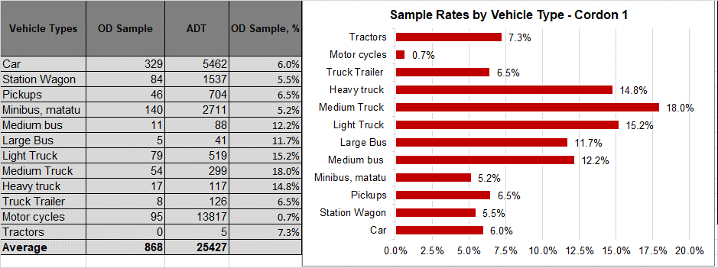

Figure 4-28: Sample rates by vehicle type for Cordon 2
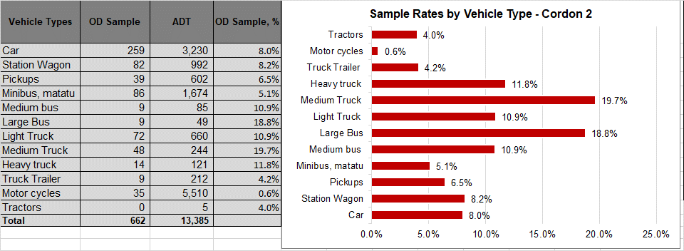

Figure 4-29: Sample rates by vehicle type for Cordon 3
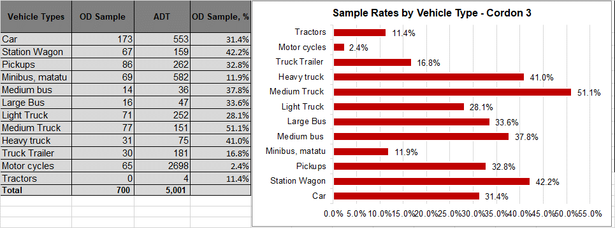

Figure 4-30: Sample rates by vehicle type for Cordon 4
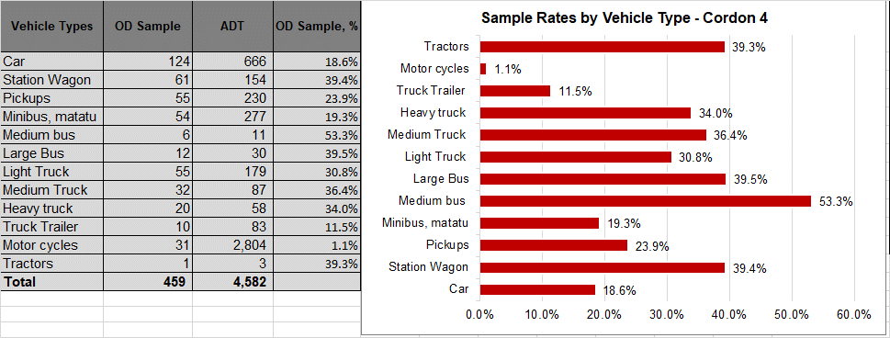

Figure 4-31: Sample rates by vehicle type for Cordon 5
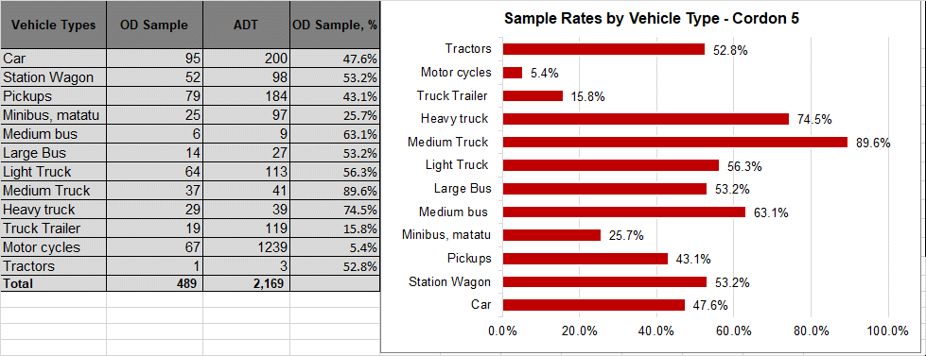

Observations
- Main objective for the above analysis is to ascertain the coverage of the OD surveys with regard to the various vehicle types. It is important to ensure that surveys covered all vehicle types at all or most survey stations.
- Sample rates for each vehicle type are generally low for Cordons 1 and 2 due to the high traffic volumes. Figures 4-1 and 4-2 show that the sample sizes are large enough, but the high average ADT values for the two cordons translate into lower sample rates. Sample rates increase with decreasing ADT in Cordons 3, 4 and 5.
- Sample rates for motorcycles were generally low, especially in Cordons 1 and 2 due to challenges in stopping them for survey.
- Overall conclusions:
    - all vehicle types were represented in the sample OD surveys at all cordon lines.
    - The spread of vehicle proportions was observed to be better at sites with lower traffic volumes (cordons 3, 4 and 5).
    - Stopping motorcycles for interview was difficult overall and this explains the low proportions at all cordon lines. They easily pass without stopping even when stopped and their up and down trip making nature means that a rider who has been interviewed once would not be willing to stop again.

Journey Purpose

Analysis Results
Figures 4-6 to 4-10 present a summary of the average journey purposes across the five cordon lines. Analysis for each survey site is included in Appendix C.
Figure 4-32: Journey purpose analysis for Cordon 1
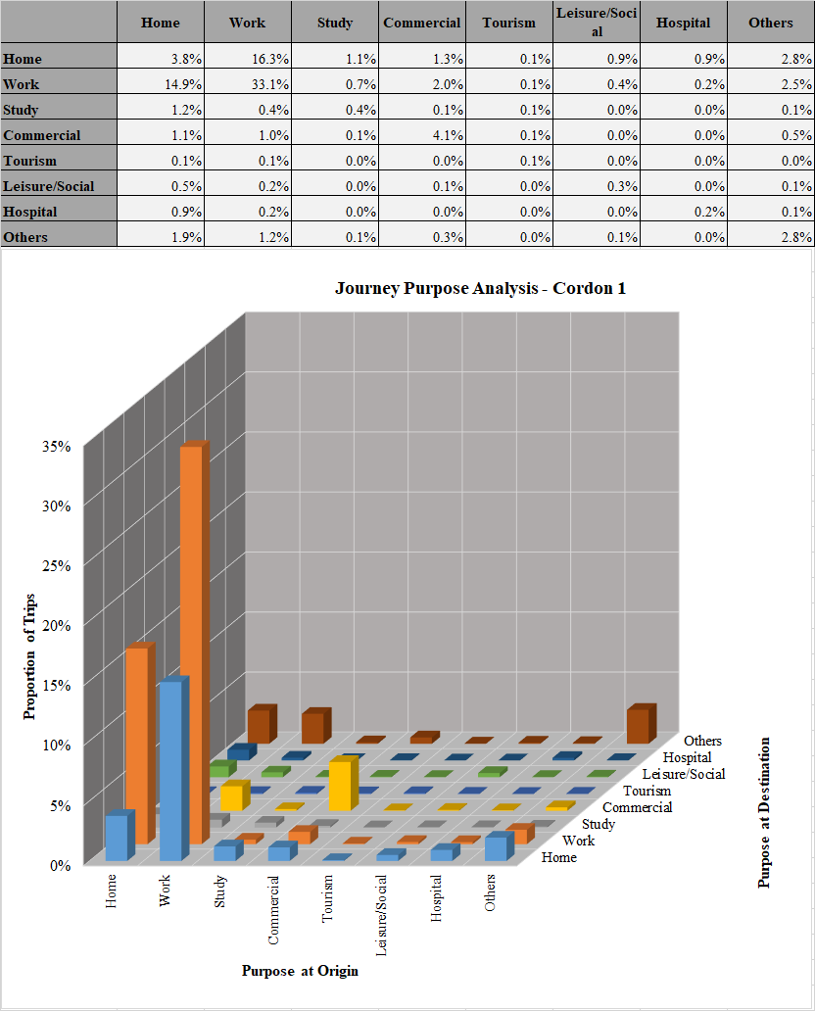

Figure 4-33: Journey purpose analysis for Cordon 2
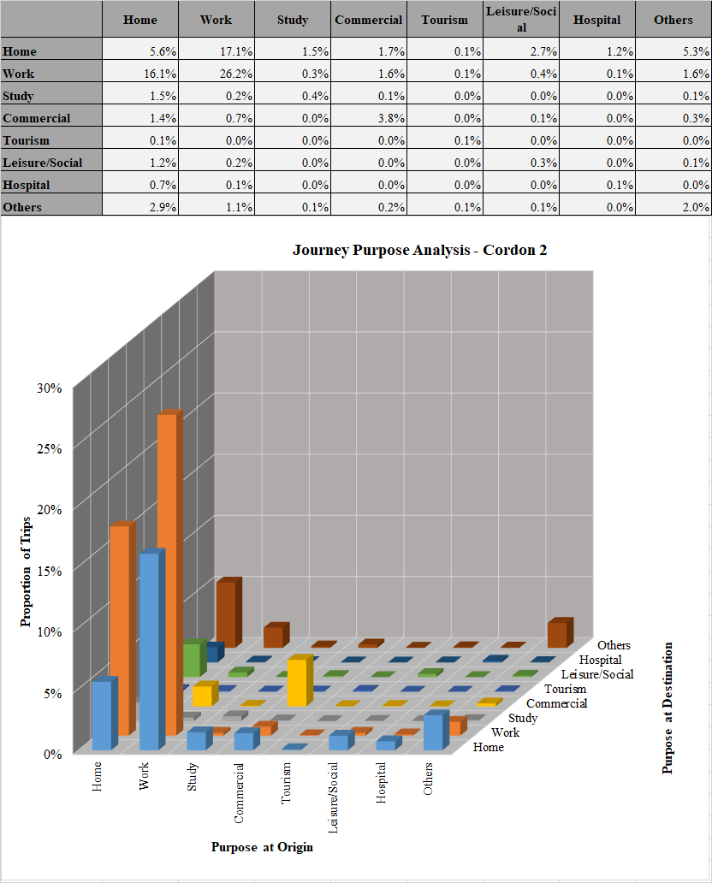

Figure 4-34: Journey purpose analysis for Cordon 3
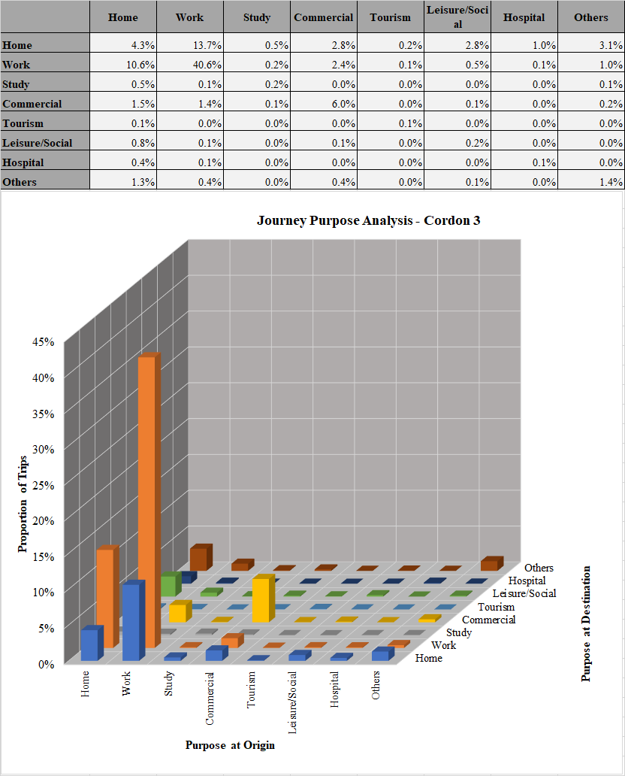

Figure 4-35: Journey purpose analysis for Cordon 4
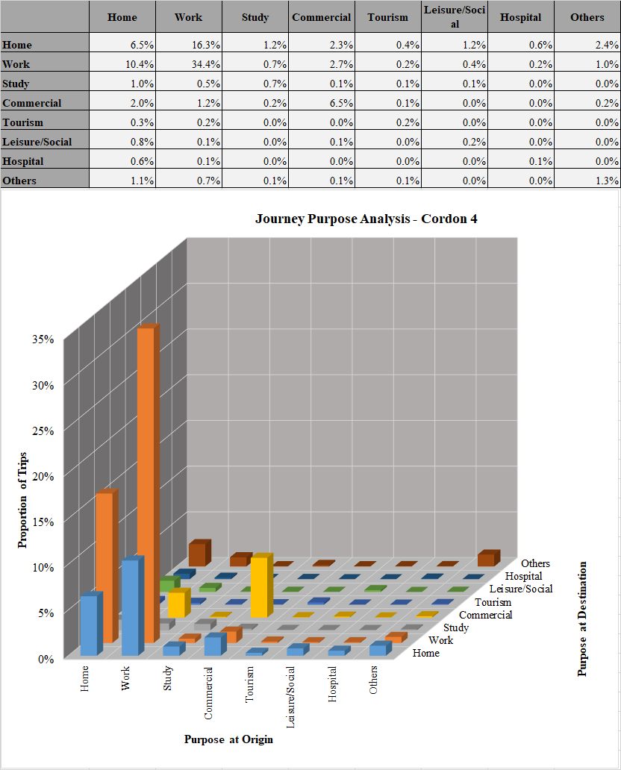

Figure 4-36: Journey purpose analysis for Cordon 5
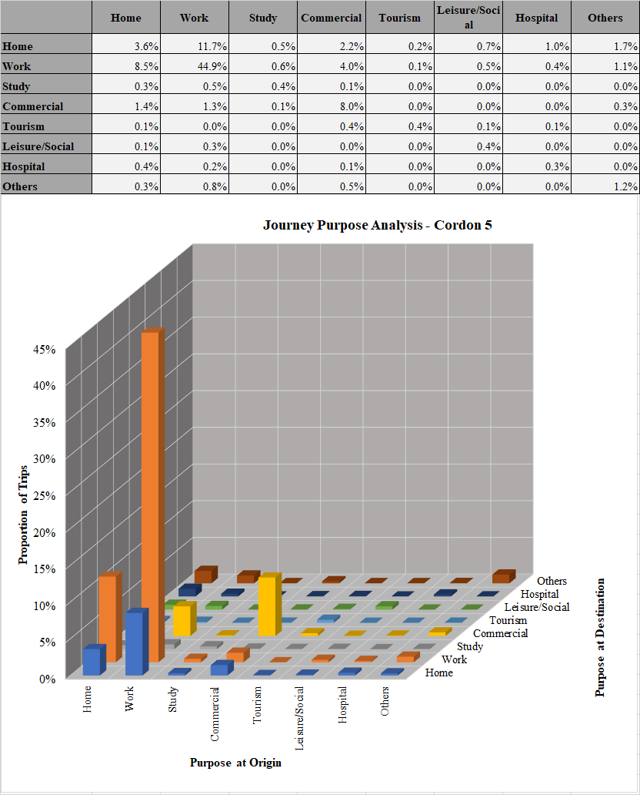

Observations
- The main objective of this analysis is to identify the various journey purposes observed in the OD surveys. The identification of the different journey purposes and their proportions helps to estimate the right influences for travel across the network.
- The dominant journey purposes are home-work, work-home and work-work. Home-home and commercial-commercial were also seen to be significant. These five journey purposes together account for 70% to 80% of all trips at all cordons.
- Tourism related trips account for 1.7% and 1.5% of all trips at Cordons 4 and 5 respectively. At cordons 1, 2 and 3, the average share for tourism related trips is 0.6%.
- Trips related to “Other” i.e. those that fall outside the seven main journey purposes are highest in Cordons 1 and 2, accounting for 12.5% and 14% respectively. For Cordons 3, 4 and 5, the average share is 7%.

Average Trip Length

Analysis Results
Figures 4-11 to 4-15 present a summary of the average trip length across the five cordon lines. Analysis for each survey site is included in Appendix C.
Figure 4-37: Average trip length for Cordon 1
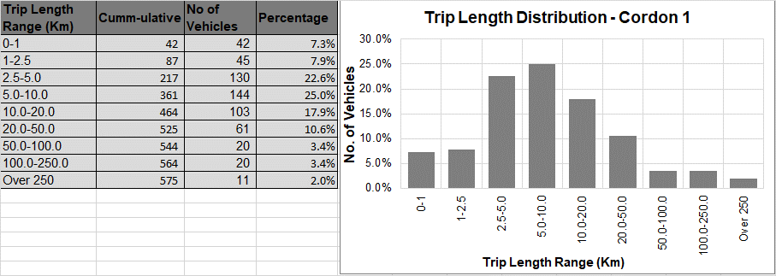

Figure 4-38: Average trip length for Cordon 2
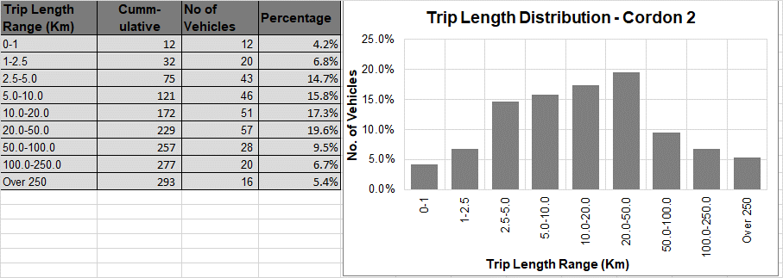

Figure 4-39: Average trip length for Cordon 3
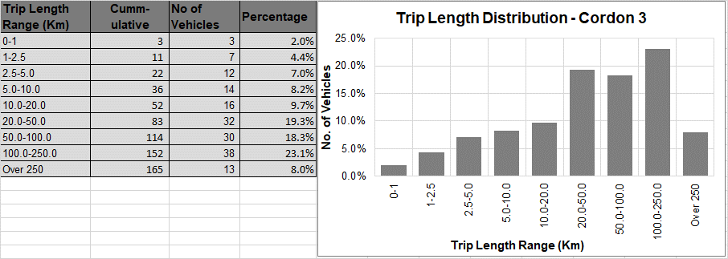

Figure 4-40: Average trip length for Cordon 4
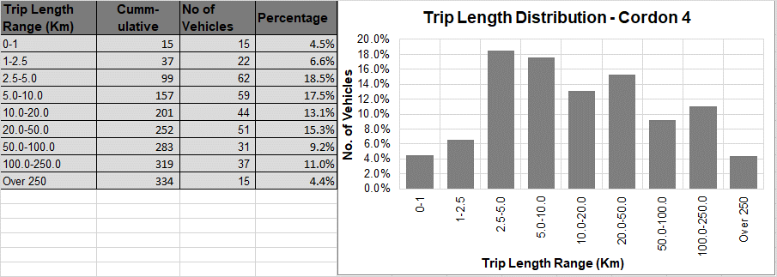

Figure 4-41: Average trip length for Cordon 5
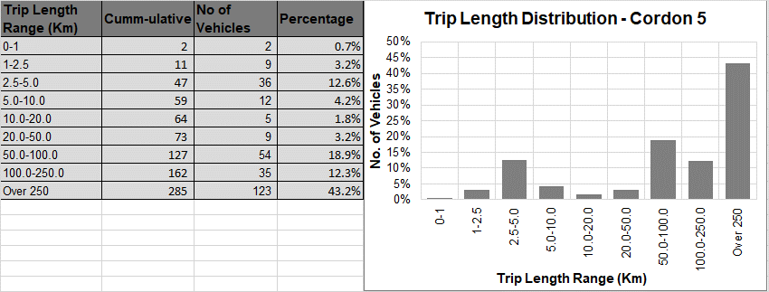

Observations
- For purposes of analysis of the distribution of trips by length of journey, the trip lengths have been classified as follows; short trips (0 – 20Km), medium trips (21 – 100Km) and long trips (over 100Km). Short trips are typically the distance travelled by an average commuter to Kampala City from the boundaries of the GKMA. The boundaries of the GKMA are 10 – 20Km from central Kampala.
- For C1, Figure 4-11 shows that the majority of the trips are short length trips (80.7%). Medium trips account for 14% of all trips and long trips are 5.4%. This pattern is expected for such an urban area.
- For C2, short trips reduce significantly compared to C1, accounting for 58.8%, medium and long trips take 29.1% and 12.1% respectively.
- At C3, the distribution of the trips is more even with short, medium and long trips accounting for 31.3%, 37.5% and 31.1% respectively.
- Cordon C4 provides an unexpected distribution. Short, medium and long trips account for 60.1%, 12.2% and 15.4% respectively. It would be expected that C4 follows similar trends for C2 and C3 i.e. short trips reduce and long trips dominate as one moves away from Kampala. Further analysis shows that the Western region (which forms the bulk of Cordon 4), 83% of all trips sampled start and end within the region as opposed to C3 where only 36% start and end within the boundaries of C3. The presence of major commercial centres such as Mbarara, Kasese, Hoima, Fort Portal and others seems to influence the local / regional nature of trips in C4. This nature of trip making in this area would likely influence expressway use.
- For C5, the distribution is 22.5%, 22.1% and 55.4% respectively for short, medium and long trips. Comparing C5 and C4 distributions, the absence of strong commercial centres in the Northern region seems to influence trip making in C5 and would influence expressway use.

Average Journey Time

Analysis Results
Figures 4-16 to 4-20 present a summary of the average journey time for all vehicles across the five cordon lines. Analysis for each survey site is included in Appendix C.
Figure 4-42: Average journey time for Cordon 1
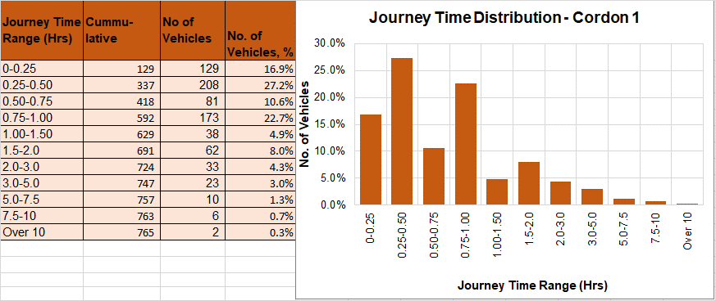

Figure 4-43: Average journey time for Cordon 2
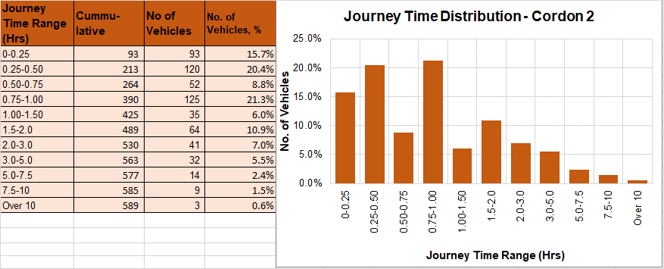

Figure 4-44: Average journey time for Cordon 3
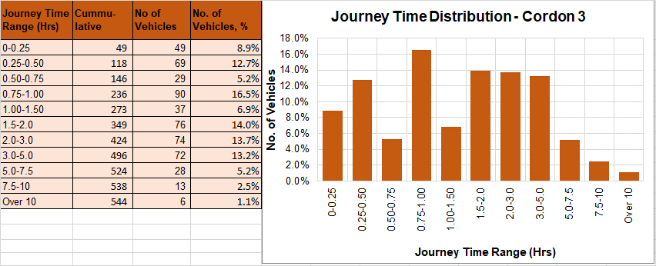

Figure 4-45: Average journey time for Cordon 4
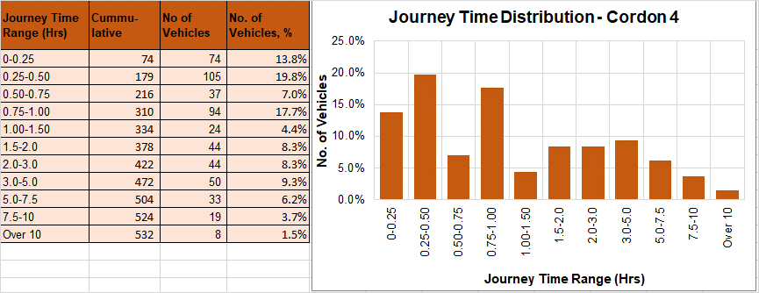

Figure 4-46: Average journey time for Cordon 5
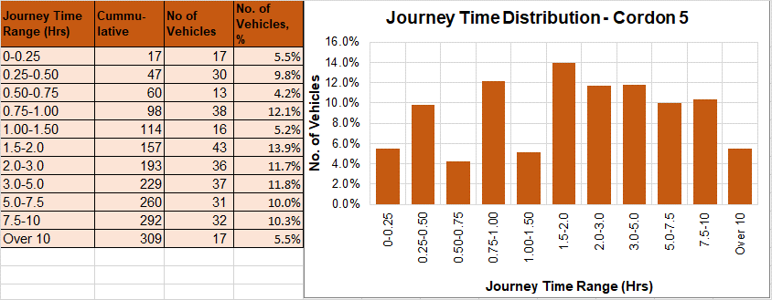

Observations
- For purposes of analysis of journey time data, trips have been classified as follows; short trips (up to 1 hour), medium trips (1 – 3 hours) and long trips (over 3 hours). Similar to the analogy of trip length, the average journey time (from data) for trips to Kampala central from the GKMA is one hour. Classifications for medium and long journey trips are based on this.
- For C1, short journeys account for 77.1%, medium and long journeys are 17.3% and 5.3% respectively. This is broadly in line with the trip length distribution.
- For C2, short journeys are 66.2%, medium 23.9% and long 9.9%. Short trips reduce and medium and long trips increase.
- For C3, short trips account for 43.4%, medium 34.5% and long 22.1%.
- The pattern at C4 is similar to the unusual pattern observed in the trip length distribution i.e. short, medium and long trips accounting for 58.3%, 21.1% and 20.6% respectively. Again, this pattern is expected to influence expressway use in the Western region, at least in the short term.
- For C5, short, medium and long trips account for 31.6%, 30.8% and 37.6% respectively. The trip length distribution shows that 55.4% are long distance trips, yet with regard to journey time, only 37.6% are categorised as long trips. This implies that long distance trips captured in C5, do not necessarily take long journey times (i.e. journeys longer than 3 hours). This is expected.

Trip Frequency

Analysis Results
Figures 4-21 to 4-25 present a summary of the analysis of average trip frequencies for all vehicles across the five cordon lines. Analysis for each survey site is included in Appendix C.
Figure 4-47: Average trip frequency for Cordon 1
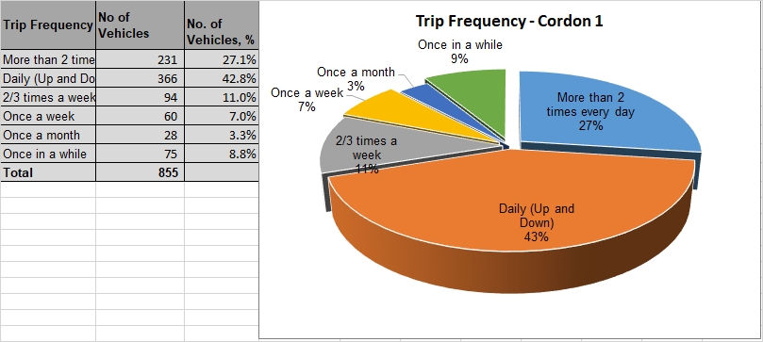

Figure 4-48: Average trip frequency for Cordon 2
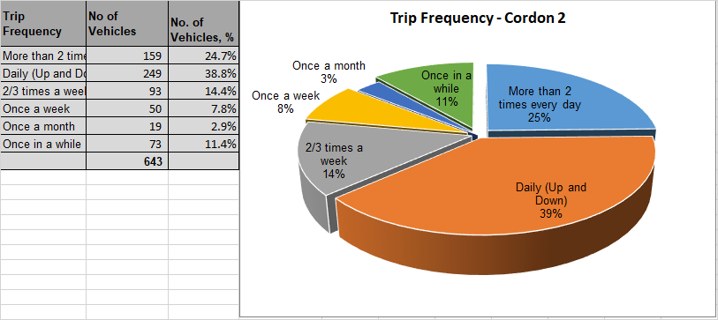

Figure 4-49: Average trip frequency for Cordon 3
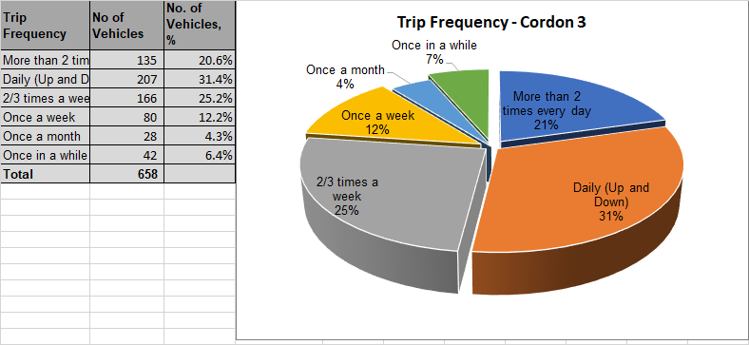
Figure 4-50: Average trip frequency for Cordon 4
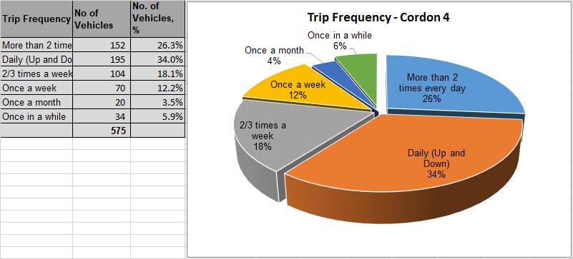

Figure 4-51: Average trip frequency for Cordon 5
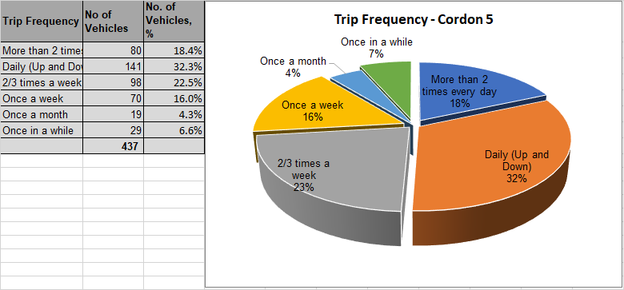

Observations
- For C1 (Figure 4-21), the majority of trips run daily (70%), with 43% being “up and down” and 27% running “twice daily”. Weekly trips account for only 18% and the remainder being those that are made occasionally. The high proportion of daily trips is not surprising and is likely heavily influenced by the high proportion of motorcycles and minibuses.
- At C2, the daily trips are somewhat lower at 64% with “up and down” trips accounting for 39% and “twice daily” trips, 25%. Weekly trips account for 22%. The increase in proportions is considered small, mainly because C2 also located in the GKMA is significantly urban in nature and the use of motorcycle and minibuses is significant.
- For C3, the daily trips reduce further to 52% and weekly trips increase to 37%. Occasional trips at C3 account for 10.7%.
- At C4, daily trips are 60% with up and down trips accounting for 34% and “twice daily” trips 26%. Weekly trips account for 30%. The pattern continues to strengthen the observations with trip length and journey time distributions for C4, that the trips observed at C4 are more local and regional compared to C5 for example.
- At C5, daily trips account for 40% and weekly trips 39%. Occasional (once a month and once in a while) trips account for 11%. This is broadly in line with the trip length and journey time distributions.
- Overall, there seems to be a direct correlation between trip length (distance and journey time) and trip frequency. Trips with lower distance and journey time characteristics seem to be associated with high trip frequency as observed at C1 and longer trips associated with lower trip frequencies.

Future Use of Expressways
As part of the OD surveys, motorists were asked whether they would use the proposed expressways to quicken their journeys. More data in this regard was also collected and has been analyzed as part of the Stated Preference Survey exercise.
The key responses analysed are two-fold; first, whether the respondent would use the available expressways to quicken their journey, and secondly, how much they would be willing to pay to use the expressway.
The questionnaire (included in Appendix A) that was used indicated the average journey time saving with expressway use to help appreciation by respondent. Also, the questionnaire indicated the potential toll charge – this was included to try and get the respondent to measure their responses accordingly. It was considered that this was the best way to ensure sensible results given the lack of experience of tolling in the country currently.

Analysis Results
Figures 4-26 to 4-30 present a summary of the outcomes for all vehicles across the five cordon lines. Analysis for each survey site is included in Appendix C.
Figure 4-52: Potential use of expressways and willingness to pay toll charges for Cordon 1
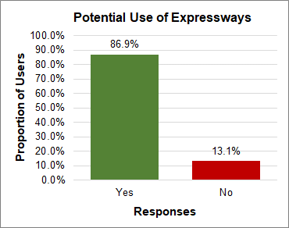 | 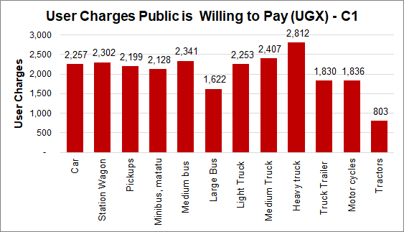

Figure 4-53: Potential use of expressways and willingness to pay toll charges for Cordon 2
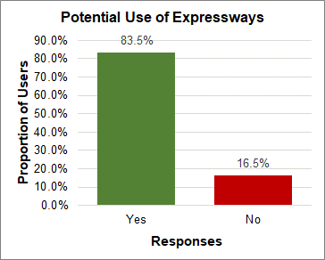 | 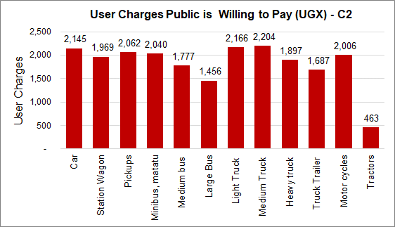

Figure 4-54: Potential use of expressways and willingness to pay toll charges for Cordon 3
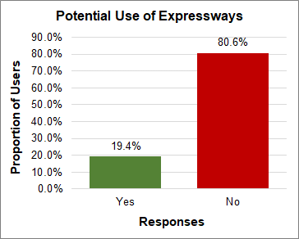 | 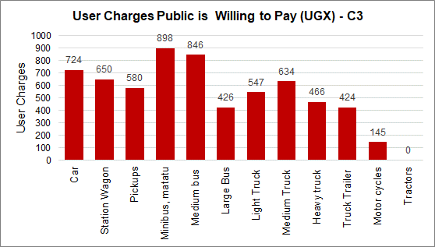

Figure 4-55: Potential use of expressways and willingness to pay toll charges for Cordon 4
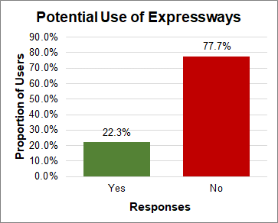 | 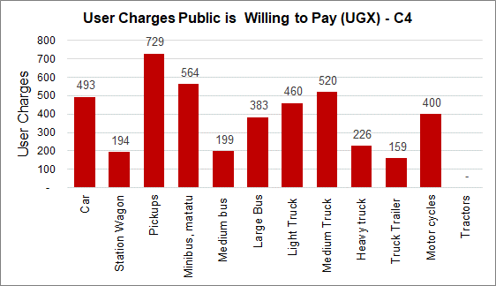

Figure 4-56: Potential use of expressways and willingness to pay toll charges for Cordon 5
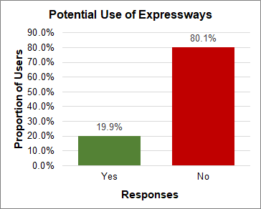 | 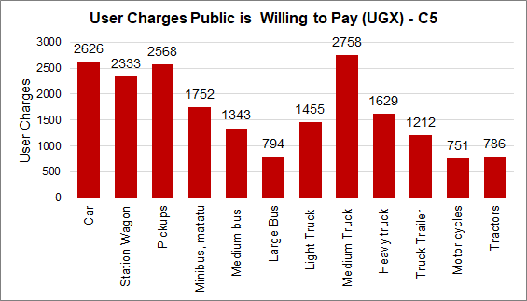

Observations
- From Figure 4-26 (C1), 87% of all respondents indicated that they would use an available expressway to ease their journey.
Those that indicated use of expressways also indicated that they would be willing to pay toll charges for the use of the expressway. Figure 3-30 shows that the charges they are willing to pay are relatively low; cars, station wagons, pickups, mini and medium buses paying UGX2,250 to UGX2,500. Willingness to pay for larger vehicles does not match the expectation that they would pay more than smaller vehicles. This is likely to be the drivers’ view and not the company (vehicle owner’s) view.
- For C2, willingness to use the expressway drops to 83.5% and toll charges that would be paid reduce to an average of UGX2,000 for the first five vehicle types. Charges for larger vehicles also reduce.
- At C3, the willingness to use expressways reverses, with only 19.4% responding in the affirmative and 80.6% negative. The main reason is likely to be that drivers at this point on the road network do not see a reason for using the expressways because of the less congestion. For those who would use the expressway network, the toll charges they would be willing to pay are also lower; on average UGX750 for the first five vehicle types.
- At C4, responses to the use of the expressway network are similar to C3. Toll charges that would be paid are also low; on average UGX500 for the first five vehicle types.`
- At C5, the potential use of the expressway network is 20%. However, for those willing to use the expressways, the toll charges that they are willing to pay are higher; on average UGX2,500 for car, station wagon and pickups. The analysis of the data also indicates evidence of willingness to pay higher tolls for trucks. The data also shows a recognition that longer distances (from C5 to Kampala) would incur higher tolls and does not support a “once for all” payment.
- In conclusion, willingness to pay data provides some indication of the likely acceptable toll charges especially for smaller vehicles.
    - For larger vehicles, data from extended surveys covering vehicle owners (such as from Stated Preference exercises) would likely provide better results.
    - Generally, drivers on the more congested roads (Cordons 1 and 2) showed an appreciation of the use of the expressway, with the large majority showing interest.
    - Willingness to pay was high for Cordons 1 and 2. However, what would be paid was generally on the low side. With currently no operating tolled expressway, there is likely to be a generally low appreciation of expressway use in the country. This would have influenced the responses.
    - Further detailed studies in this area are required, especially when the Kampala Entebbe Expressway starts toll operations. Data from this operation can be used to help streamline future expressway operations.

Nationwide OD Matrix
The ToR required the creation of a nationwide OD matrix by vehicle type. From the OD survey data, nationwide OD matrices have been created for each identified vehicle class and for all vehicles.

Vehicle Classes
The identified specific vehicle classes are as follows:
- Class 1 – Cars, utility vehicles and pickups
- Class 2 – Buses (minibuses, medium buses, large buses)
- Class 3 – Motorcycles
- Class 4 – Small trucks
- Class 5 – Medium trucks
- Class 6 – Heavy trucks
- Class 7 – Tractors and construction plant (graders, wheel loaders, etc)

Zone Structure
In order to create the OD matrices, the country was demarcated into zones covering all major domestic locations such as cities and significant towns, sub counties and districts. The zone system within the country was based on the countrywide parish and sub country structure.
In Kampala, the zone structure was based on parishes. That is, the various parishes in Kampala were the zones. Outside Kampala, the structure was based on sub counties. For districts close to Kampala, such Wakiso, Mukono, Mpigi and most of the central region where there is significant trip generation, each sub county was allocated a zone number. For more remote districts, sub counties were aggregated to form zones.
A total of 1,450 zones were identified. The zone structure including the aggregations is included in Appendix C.

OD Matrices
The created OD nationwide OD matrices are included in Appendix C for each of the identified vehicle classes and for all vehicles.

JUNCTION TURNING COUNTS (JTC) SURVEYS

Introduction and Methodology
Similar to MCC, JTC surveys are undertaken by traffic enumerators standing by the survey junction and recording each vehicle by category as it turns. They were undertaken at 5 locations within Kampala. The specific locations of the survey sites are given by the location coordinates presented in Table 2-12. The junctions were:
- Kitgum Junction;
- Clock Tower Junction;
- Kibuye Junction;
- Mulago Junction; and
- Nateete Junction.
All five survey junctions are significantly busy junctions. Again, similar to MCC surveys, errors in JTC data are usually due to unrecorded or unobserved traffic especially at road sections with significant volumes of traffic. The most critical vehicle type at all the junctions is the motorcycle. In order to ensure more robust data, turns that comprised of significant motorcycle movements were allocated a specific enumerator to collect motorcycles data.

Survey Period
As described in Table 1-1, the JTC surveys were undertaken for a total of three (3) days; two weekdays and one Saturday. On each day, the survey was undertaken for a 12-hour period between 7am and 7pm.

Survey Diary
No significant adverse weather was experienced on all survey days. There were no unusual traffic conditions that could affect the data quality at any of the junctions.

Results and Analysis
Tables 5-1 to 5-5 summarise all JTC data collected during the surveys. The tables present average daily traffic (ADT) for all turning movements at each of the junctions. It should be noted that for roundabout junctions (Mulago and Nateete), typical turning counts cannot be undertaken. For these junctions, only entries and exits on each arm are recorded.
Full survey results are included in Appendix D.
Table 5-25: Summary JTC data for Kitgum Junction (ADT)
SUMMARY JTC DATA FOR KITGUM JUNCTION
 |  | Access Road | Kampala Road | Yusuf Lule Road | Jinja Road | TOTAL
From Arm | Access Road | - | 3,603 | 9,382 | 13,555 | 26,540
From Arm | Kampala Road | 3,912 | - | 1,033 | 16,535 | 21,479
From Arm | Yusuf Lule Road | 6,516 | 585 | - | 18,945 | 26,046
From Arm | Jinja Road | 7,312 | 22,854 | 25,169 | - | 55,334
From Arm | TOTAL | 17,740 | 27,041 | 35,583 | 49,034

Table 5-26: Summary JTC data for Clock Tower Junction (ADT)
SUMMARY JTC DATA FOR CLOCK TOWER JUNCTION
 |  | Shoprite | Nsambya Rd | Queensway | Nakivubo Blue | TOTAL
From Arm | Shoprite | - | 34,611 | 45,584 | - | 80,195
From Arm | Nsambya Rd | 28,549 | - | 18,914 | - | 47,463
From Arm | Queensway | - | - | - | - | -
From Arm | Nakivubo Blue | 64,561 | 4,749 | - | - | 69,310
From Arm | TOTAL | 93,111 | 39,360 | 64,498 | -

Table 5-27: Summary JTC data for Kibuye Junction (ADT)
SUMMARY JTC DATA FOR kIBUYE JUNCTION
 |  | Kibuye RBT | Entebbe | Ndeeba | Katwe | Queens Way | Makindye | TOTAL
From Arm | Kibuye RBT | - | 49,696 | 15,804 | 50,331 | - | 27,620 | 143,451
From Arm | Entebbe | 44,619 |  |  |  |  |  | 44,619
From Arm | Ndeeba | 17,941 |  |  |  |  |  | 17,941
From Arm | Katwe | 25,187 |  |  |  |  |  | 25,187
From Arm | Queens Way | 38,140 |  |  |  |  |  | 38,140
From Arm | Makindye | 31,911 |  |  |  |  |  | 31,911
From Arm | TOTAL | 157,798 | 49,696 | 15,804 | 50,331 | - | 27,620

Table 5-28: Summary JTC data for Mulago Junction (ADT)
SUMMARY JTC DATA FOR MULAGO JUNCTION
 |  | Mulago Jn | Ku Bbiri | Kamwokya | Wandegeya | Yusuf Lule | TOTAL
From Arm | Mulago Jn | - | 19,974 | 24,755 | 33,016 | 13,014 | 90,759
From Arm | Ku Bbiri | 23,018 |  |  |  |  | 23,018
From Arm | Kamwokya | 25,763 |  |  |  |  | 25,763
From Arm | Wandegeya | 33,133 |  |  |  |  | 33,133
From Arm | Yusuf Lule | 19,089 |  |  |  |  | 19,089
From Arm | TOTAL | 101,002 | 19,974 | 24,755 | 33,016 | 13,014

Table 5-29: Summary JTC data for Nateete Junction (ADT)
SUMMARY JTC DATA FOR NATEETE JUNCTION
 |  | Nakawuka | Busega | Wakaliga | Ndeeba | TOTAL
From Arm | Nakawuka | - | 1,790 | 4,114 | 515 | 6,418
From Arm | Busega | 1,270 | - | 16,425 | 17,087 | 34,781
From Arm | Wakaliga | 3,527 | 8,315 | - | 1,634 | 13,476
From Arm | Ndeeba | 4,028 | 14,795 | 956 | - | 19,779
From Arm | TOTAL | 8,825 | 24,900 | 21,494 | 19,236

jOURNEY TIME AND GIS DATA

Journey Time Surveys

General Approach
Journey time survey data is important at traffic modelling stage to enable the correct calibration of the base traffic model to the existing journey times. Journey time surveys were undertaken over a period of 30 days in August/September 2019. The routes along which the survey was undertaken are presented in Figure 2-11 and Table 2-14. A total of 36 routes were surveyed.
The Moving Observer Method (also referred to as the Floating Vehicle Method) - a widely used method for undertaking this type of survey was employed. In the Moving Observer Method, a survey vehicle containing one driver and an enumerator is driven along the road link under survey, ensuring that it travels at the average speed of the road link on which it is travelling. To avoid spurious data, the driver of the survey vehicle in congested environments, should ignore vehicles moving at significantly faster or slower speeds than other vehicles. The enumerator records the time taken to move from one point to another within the road link.
However, to minimize the time required to survey such long routes, the use of GPS was also employed. Currently, satellite data from Google can be used to estimate journey time and distance. However, GPS data can suffer from inaccuracies due to poor receivers, characteristics of the surrounding landscape, positioning of the satellites as the time of measurement, traffic congestion, and others. As such, GPS data was only used to validate field journey time measurements.
The survey was undertaken in both directions on the selected routes. The road links were subdivided into shorter timing segments to ensure data accuracy. As the vehicle travelled along the link, the enumerator noted the start and finish clock time pertaining to each timing segments. The travel times for each segment were then computed at the end of the survey.

Survey Period
The approach for the survey was as follows:
- Each route and each timing segment was surveyed in each of the three travel periods; AM, IP and PM.
- In each of the periods, three measurements were undertaken i.e. in the AM, three measurements were undertaken, and the same was done for the IP and PM.

Survey Diary
No significant adverse weather was experienced on all survey days. There were no unusual traffic conditions that could affect the data quality at any of the junctions.

Journey Time Surveys - Results and Analysis
Tables 6-1 to 6-3 below summarise the results of the analysis of the journey time survey data. Detailed analysis is included in Appendix E.
Table 6-30: Journey time analysis results for routes JT1 to JT15
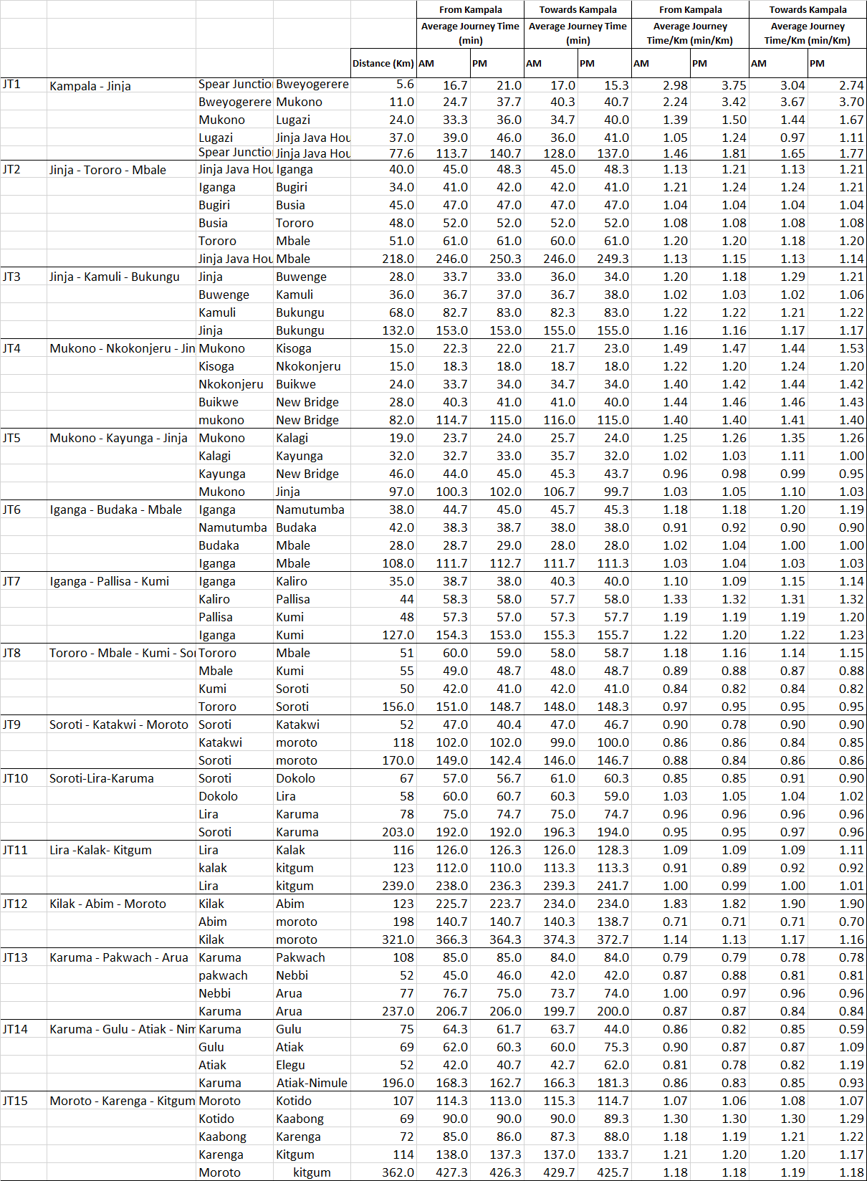
Table 6-31: Journey time analysis results for routes JT16 to JT28
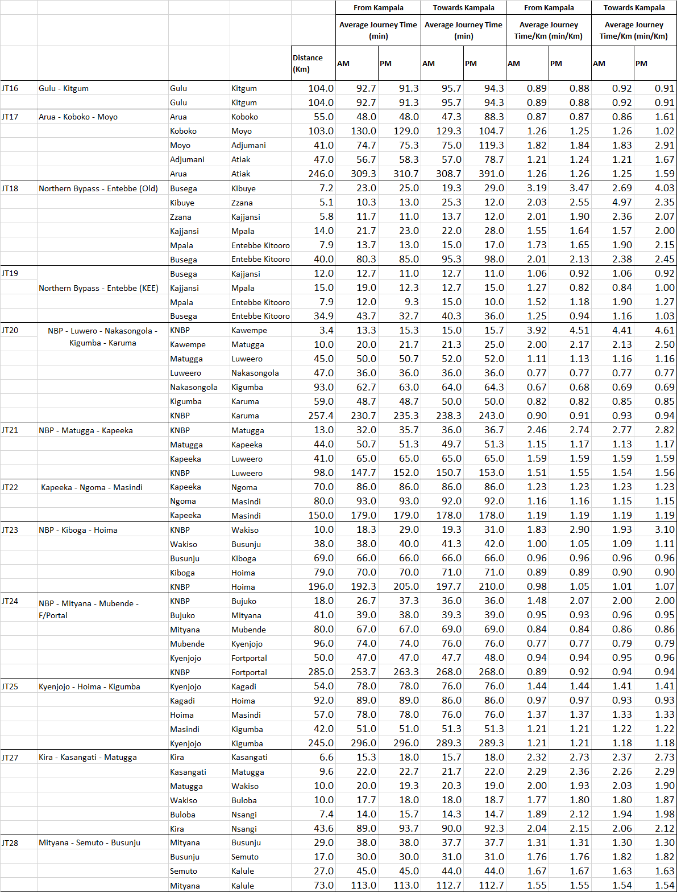

Table 6-32: Journey time analysis results for routes JT29 to JT36
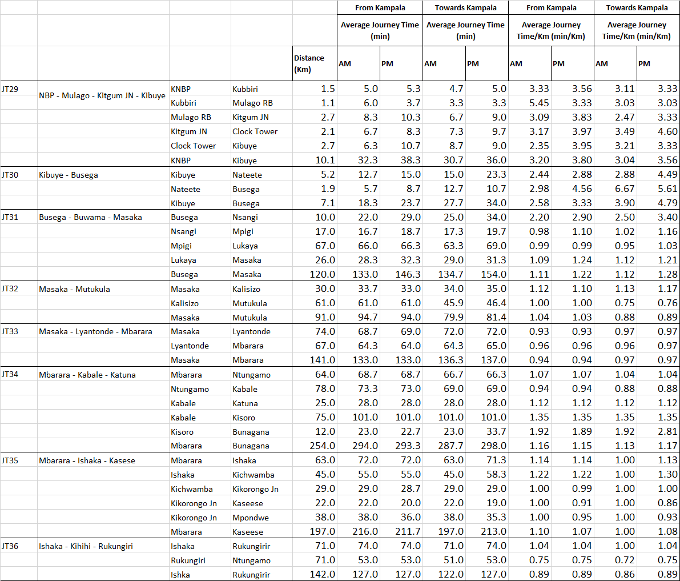

Tables 6-1, 6-2 and 6-3 provide an understanding of the journey time for each of the selected 36 routes. For each of the route, the tables also show the journey time for each of the individual sections on the route. From this segmentation, it is possible to understand the estimated time it takes to travel on each link.
However, absolute journey time values are less informative in trying to understand where actual delays occur. A long section will always result in longer journey time than a short section. Tables 6-1, 6-2 and 6-3 also present the journey time per Km values. These values attempt to measure the journey time for each section regardless of length. A higher journey time per Km means more delay on that link than on the other link.
To understand he journey time analysis, six key arterial routes were selected for a closer analysis. These were:
- JT1 Kampala – Jinja highway;
- JT18 Kampala Northern Bypass (Busega) to Entebbe (Old Entebbe Road)
- JT20 Kampala Northern Bypass – Luwero – Karuma
- JT23 Kampala Northern Bypass – Kiboga – Hoima
- JT24 Kampala Northern Bypass – Mityana – Mubende – Fort Portal
- JT30 Busega – Buwama – Masaka

Journey Time Analysis for JT1 Kampala – Jinja Highway
Figures 6-1 and 6-2 present the journey time analysis for Kampala – Jinja Highway for each of the directions; Kampala – Jinja and Jinja - Kampala. Figure 6-2 presents the journey time per Km for the route.
Figure 6-57: Average journey time by period for JT1 Kampala - Jinja
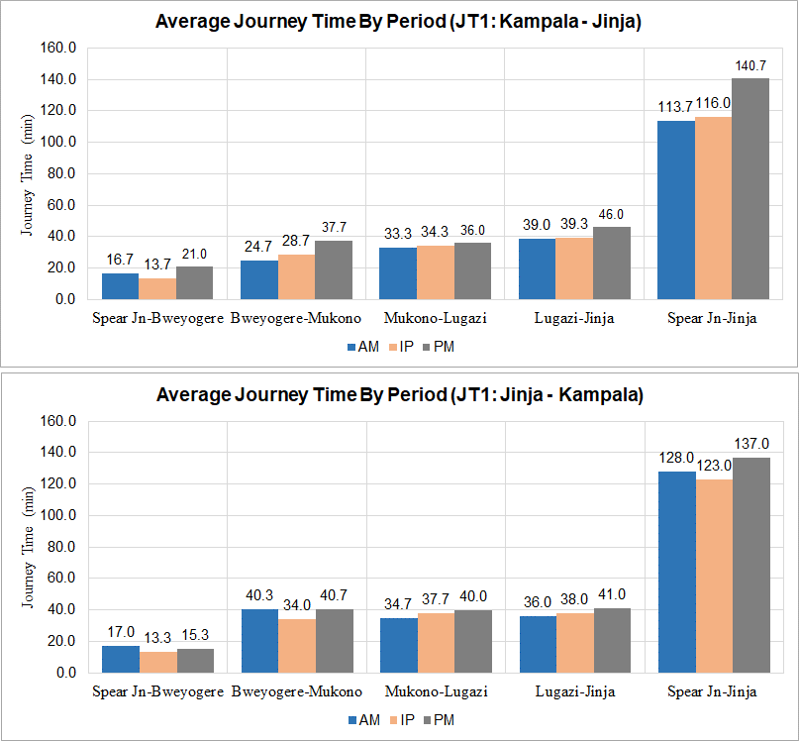
Figure 6-58: Average journey time per Km for PM for JT1 Kampala - Jinja
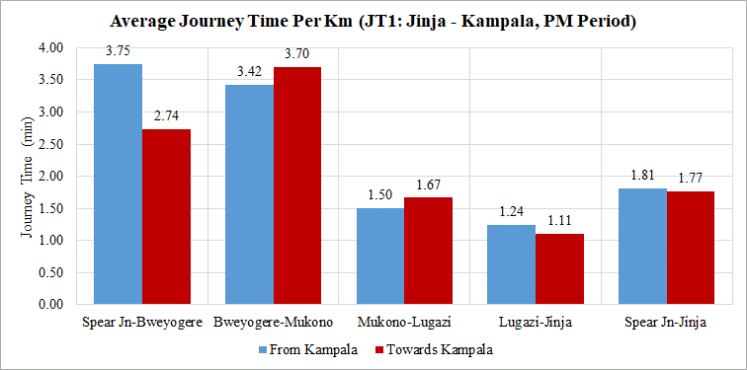
The following observations are with regard to Figures 6-1 and 6-2:
- Journey time: the total journey time for the route is 126 minutes or 2.1 hours on average. The stretch between Spear Junction and Mukono alone accounts for over 40 minutes on average.
- There is significant variability in journey time between the peak periods and between directions, especially in the Kampala – Jinja direction. For example, travel between Spear Junction and Bweyogerere varies between 17 minutes and 21 minutes, Bweyogerere to Mukono varying between 25 minutes and 38 minutes, and Lugazi to Jinja between 39 minutes and 46 minutes. The overall journey from Kampala to Jinja varies between 114 minutes and 141 minutes. This variation is significant.
- For both directions, the journey time in each direction is longest in the PM generally. In the PM, the total journey time in the Kampala – Jinja direction is longest with 140.7 minutes in journey time. This implies an average speed of 30 Kph for the entire journey.
- From Figure 6-2, it is observed that in the busier PM peak, the section between Spear Junction and Mukono incurs the highest journey time per Km in both directions; 3.75 min/Km towards Kampala and 3.70 min/Km towards Jinja. This implies and average speed of 16 Kph in this section. In the PM peak, it takes 70 minutes to travel the 20 Km section between Spear Junction and Mukono.

Journey Time Analysis for JT18 Kampala Northern Bypass (Busega) to Entebbe (Old Entebbe Road)
Figures 6-3 and 6-4 present the journey time analysis for Kampala Northern Bypass (Busega) to Entebbe (using the old Entebbe Road) for each of the directions; Busega - Entebbe and Entebbe - Busega. Figure 6-4 presents the journey time per Km for the route.

Figure 6-59: Average journey time by period for JT18 Busega – Entebbe (Old Route)
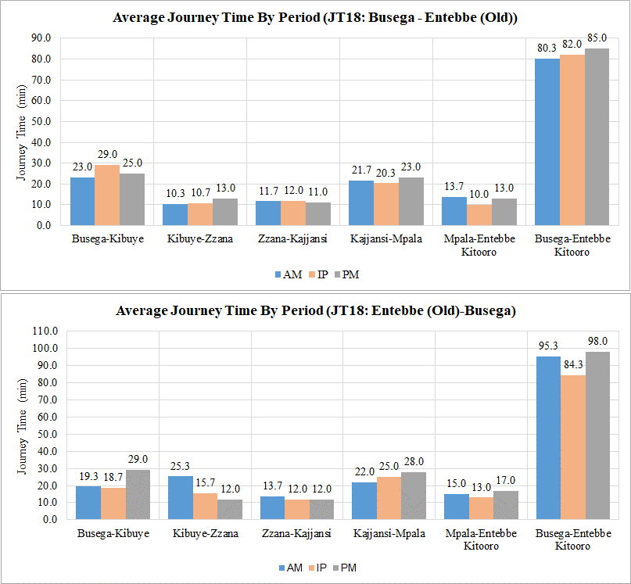

Figure 6-60: Average journey time per Km for PM for JT18 Busega – Entebbe (Old Route)
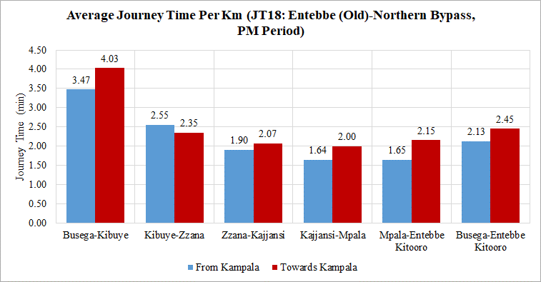

The following observations are with regard to Figures 6-3 and 6-4:
- Journey time: The total journey time for the route is 87.5 minutes (or 1.46 hours) on average. Busega – Kibuye and Kajjansi-Impala sections account for two-thirds of the journey time but are only 50% of the total distance.
- There is noticeable variability of journey time by section, by peak period and by direction. This is best demonstrated in Figure 6-4 for journey time rates between directions.
- The PM peak is the busier peak period of the three travel periods for both directions.
- Figure 6-4 confirms the Busega – Kibuye to be the slowest section especially in the Entebbe – Kampala direction (4.03 min/Km or 14.9 Kph). However, the entire route is generally slow, the quickest section on the route in the Entebbe – Kampala direction being Mpala – Kajjansi with 2 min/Km or 30 Kph.

Journey Time Analysis for JT20 Kampala Northern Bypass – Luwero – Karuma
Figures 6-5 and 6-6 present the journey time analysis for Kampala Northern Bypass to Karuma via Luwero for each of the two directions. Figure 6-6 presents the journey time per Km for the route.

Figure 6-61: Average journey time by period for JT20 Northern Bypass – Luwero - Karuma
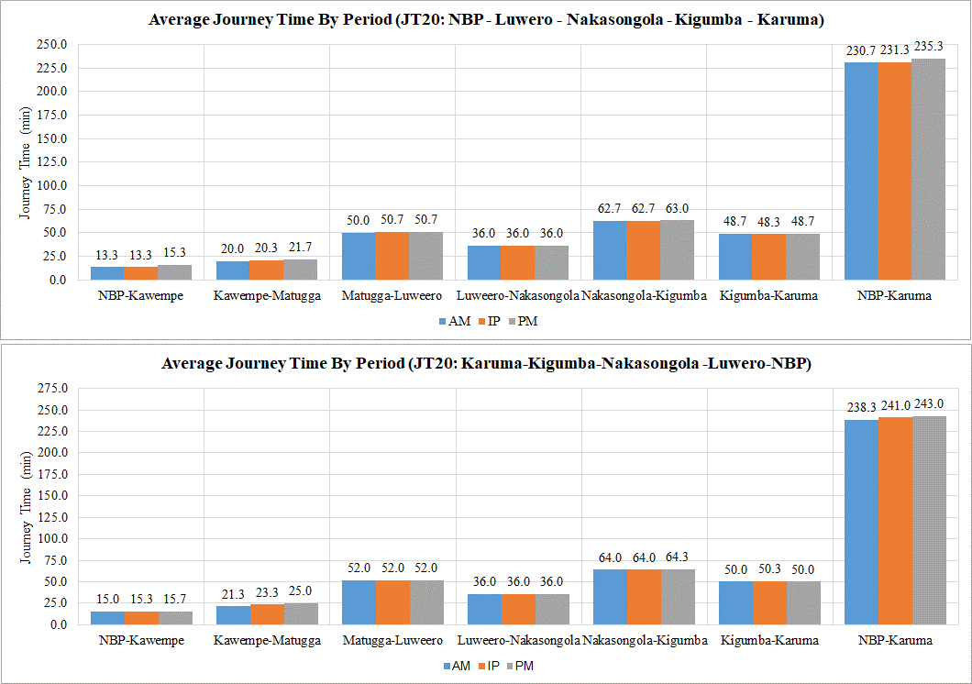

Figure 6-62: Average journey time per Km for PM for JT20 Northern Bypass – Luwero - Karuma
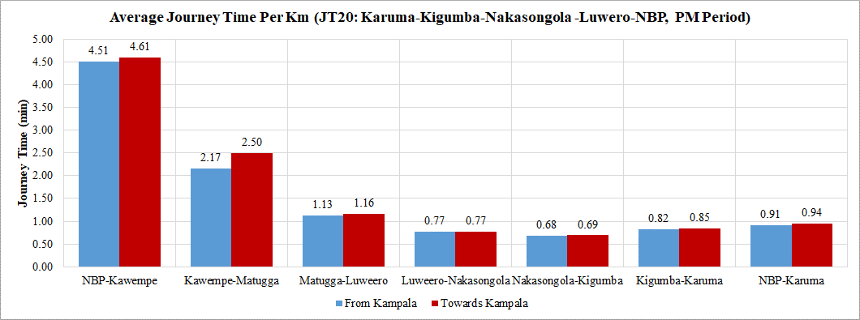

The following observations are with regard to Figures 6-5 and 6-6:
- Journey time: the total journey time for the route (257.4 Km) is 237 minutes or 3.95 hours on average. Nearly 50% of this is spent between Matugga - Luwero (50 min) and Nakasongola – Kigumba (63 min).
- There is little variability in journey time between Matugga and Karuma due to the semi-rural or rural nature of the route.
- Figure 6-6 shows that the slowest sections of the route as expected is the section between Northern Bypass and Kawempe with 4.6 min/Km and Kawempe – Matugga with 2.5 min/Km. This implies average speeds of 13 Kph and 24 Kph. The quickest section is the Nakasongola – Kigumba section with 0.68 min/Km or 88.2 Kph.

Journey Time Analysis for JT23 Kampala Northern Bypass – Kiboga – Hoima
Figures 6-7 and 6-8 present the journey time analysis for Kampala Northern Bypass to Hoima (Hoima Road) for each of the two directions. Figure 6-8 presents the journey time per Km for the route.
Figure 6-63: Average journey time by period for JT23 Northern Bypass – Kiboga - Hoima
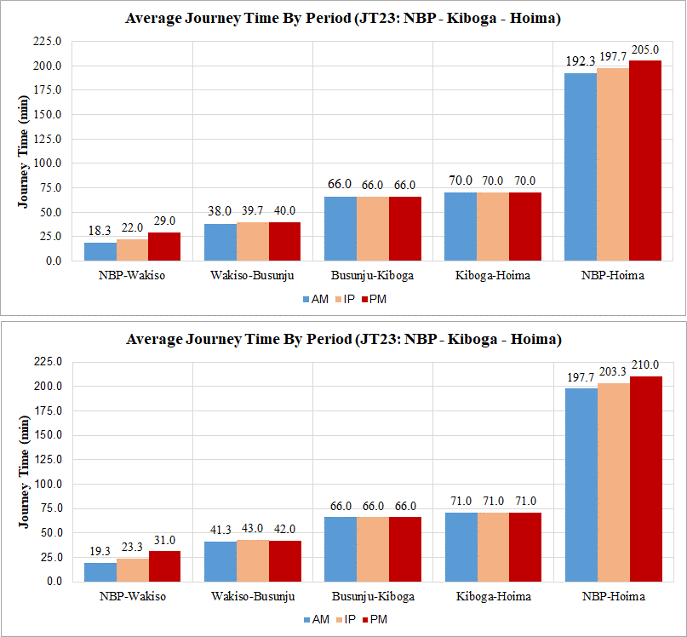

Figure 6-64: Average journey time per Km for PM for JT23 Northern Bypass – Kiboga - Hoima
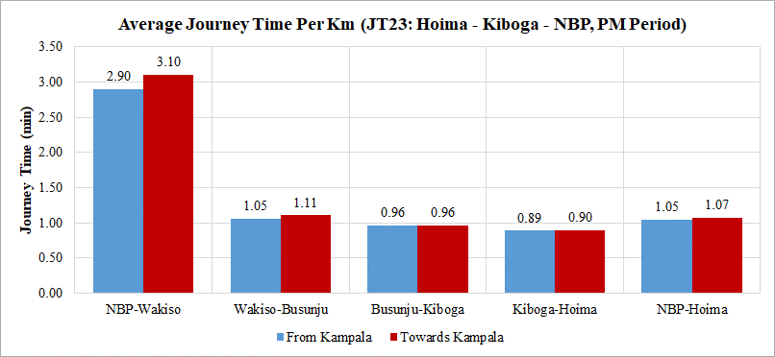
The following observations are with regard to Figures 6-7 and 6-8:
- Journey time: the total journey time for the route (196 Km) is on average 200 min or 3.35 hours. More that half of this is spent in the Busunju – Kiboga (66 min) and Kiboga – Hoima (70 min). These are also the longest sections on the route accounting for 75% of its length.
- Journey time variability between pea periods and directions is only noticeable in the Northern Bypass – Wakiso section. The PM peak accounts for the longest journey time in this section.
- Figure 6-8 confirms that Northern Bypass – Wakiso is the slowest section with 3 min/Km on average or 20 Kph.
- The remainder of the route travels well at an average of 60 Kph.

Journey Time Analysis for JT24 Kampala Northern Bypass – Mubende – Fort Portal
Figures 6-9 and 6-10 present the journey time analysis for Kampala Northern Bypass to Fort Portal (Mityana Road) for each of the two directions. Figure 6-10 presents the journey time per Km for the route.

Figure 6-65: Average journey time by period for JT24 Northern Bypass – Mubende – Fort Portal
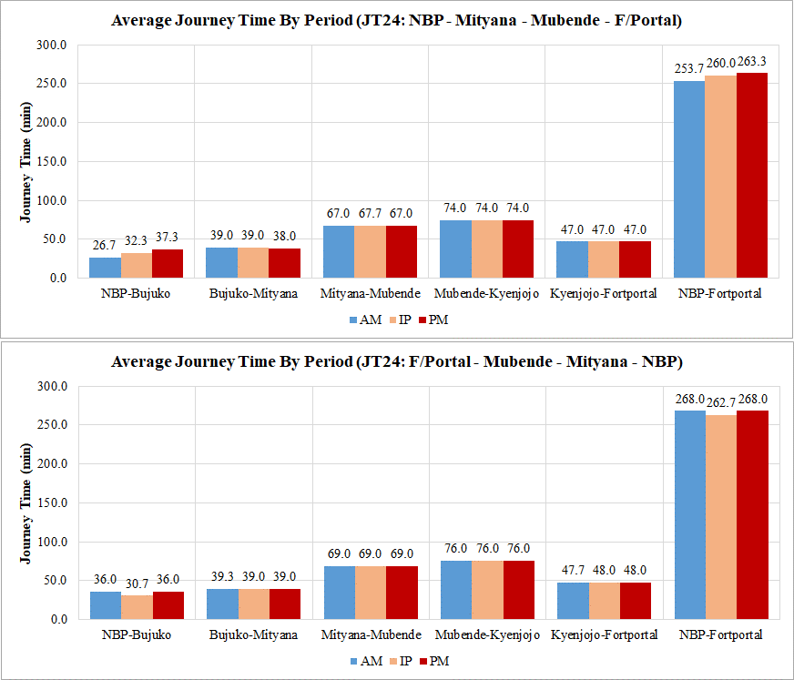

Figure 6-66: Average journey time per Km for PM for JT24 Northern Bypass – Mubende – Fort Portal
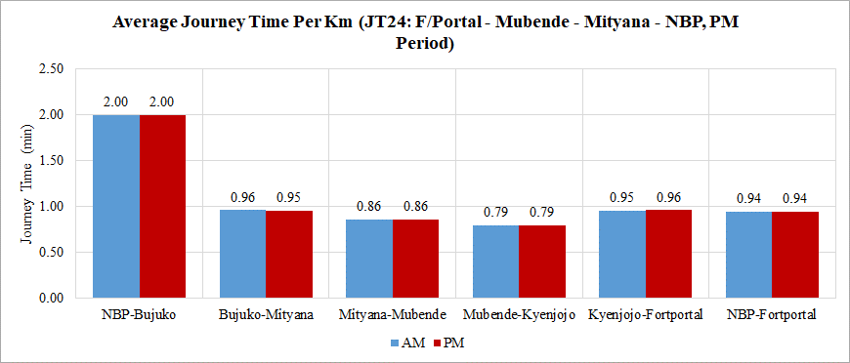

The following observations are with regard to Figures 6-9 and 6-10:
- Journey time: the total journey time for the entire route (285 Km) is about 263 minutes or 4.4 hours. More than 50% of the journey time is incurred in the section Mityana – Kyenjojo whch is the longest section (176 Km) accounting for 72% of the total length.
- Journey time variability only noticeable in the Northern Bypass – Bujuuko section, the most urbanised section on the route.
- The PM is the busiest peak period as with other routes.
- Figure 6-10 confirms that the Northern Bypass – Bujuuko section is indeed the slowest section with journey time per Km of 2 min/Km or 30 Kph. All other sections travel well at slightly over 60 Kph.

Journey Time Analysis for JT31 Busega – Buwama - Masaka
Figures 6-11 and 6-12 present the journey time analysis for Busega to Masaka (Masaka Road) for each of the two directions. Figure 6-12 presents the journey time per Km for the route.
Figure 6-67: Average journey time by period for JT31 Busega – Buwama - Masaka
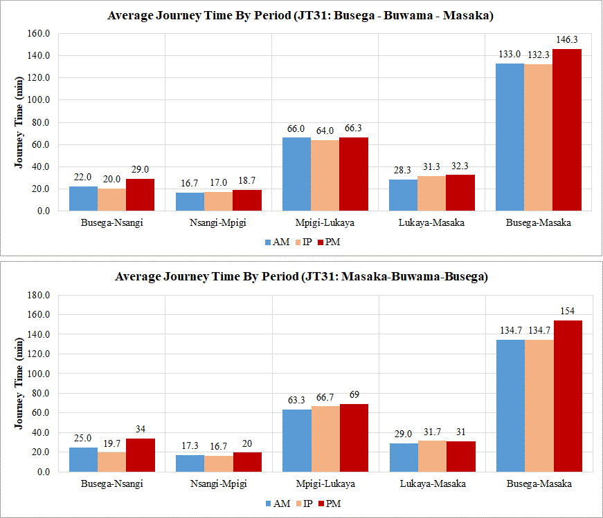

Figure 6-68: Average journey time per Km for PM for JT31 Busega – Buwama - Masaka
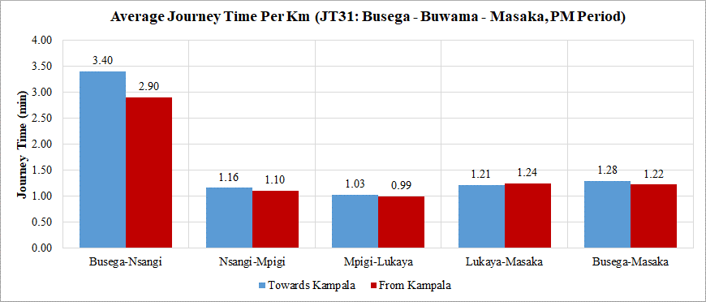

The following observations are with regard to Figures 6-11 and 6-12:
- Journey time: the total journey time for the entire route (120 km) is 139 min (or 2.31 hours) on average. This implies an average speed for the route of 51.9 Kph. The section between Mpigi and Lukaya (67 Km) accounts for the longest journey time (65 minutes).
- There is high variability of journey time between peaks and directions at all sections of the route. Generally the PM peak is the busiest peak.
- Figure 6-12 shows that the urban section Busega – Nsangi is the slowest section on average especially in the Masaka – Kampala direction with 3.4 min/Km. This implies a speed of 17.6 Kph on average.
- The quickest section is Mpigi – Lukaya with a journey time rate of about 1 min/Km or 60 Kph travel speed.

Overall Journey Time Analysis
- Journey time along the arterial routes is significantly influenced by the slow-moving urban areas of the GKMA.
- There is greater variability of journey time and hence unreliability of travel between peak periods and directions in the urban areas than other sections of the routes.
- The direction to Kampala is clearly the busiest direction of the routes.
- From the data gathered, the general speed profile along the arterial routes has been constructed and is presented in Figure 6-13 below.

Figure 6-69: Average speed profile for arterial routes in Uganda
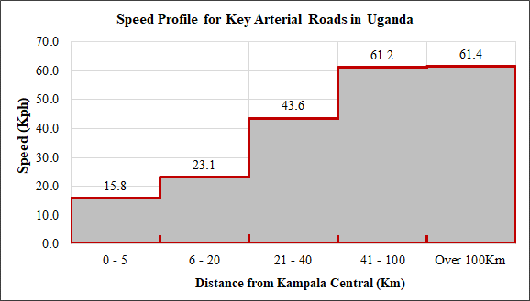

From Figure 6-13 above, the following observations are made:
- Within 5Km of Kampala City centre, the speed on the arterial roads is an average of just 16 Kph.
- Between 5Km and the boundary of the GKMA (approximately 20 Km from Kampala central), the speed increases slightly to 23 Kph.
- For the section 21 – 40 Km, the speed increases significantly to an average of 43.1 Kph. Beyond this distance, it was observed that the roads travel at just over 60 Kph on average and no higher. This is expected due to a number of factors. Key of these however is the significant presence of traffic calming measures especially near towns and the significant roadside activity in the bigger urban areas along the routes.

GIS Data
In line with the ToR with respect to road network GIS data, the Consultant conducted field and desktop (online GIS data) survey to update the road inventories (number of lanes, speed, pavement conditions). The GIS database provided by UNRA was accordingly updated.
In the future, when the expressway network is finally decided, the updated GIS database will be submitted by overlaying the future expressway network.
Figure 6-70: Statement on the Methodology of GIS Database

The following was collected and updated:
- Road link number;
- Length of road link (in kilometres);
- Number of lanes(each links)
- Travel speed(each links)
- UNRA Station in charge;
- Road class of the link;
- Road link name;
- Road surface type – sealed or unsealed;
- Region of country where link is located; and
The format of the collected and updated data is shown in Figure 6-14 below. All of the collected and updated GIS data is provided in Appendix E2.

Figure 6-715: Format of collected and updated GIS data
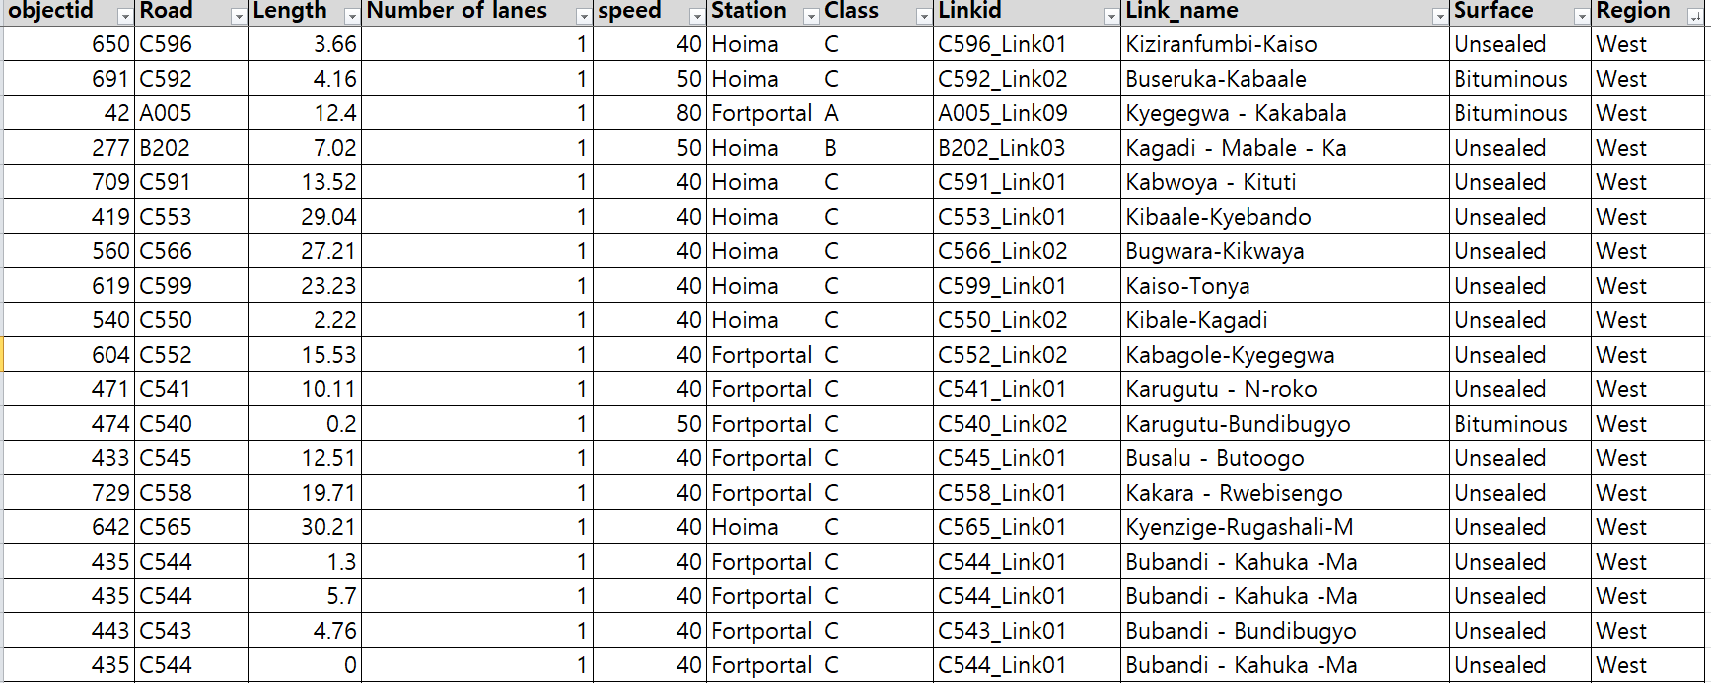

STATED PREFERENCE SURVEYS

Introduction
These surveys offer a great advantage for overcoming the problem of the “new option” such as a proposed tolled expressway system. Other transport scenarios where SP is useful are those when new transport modes such as high-speed rail, buses, etc are to be introduced. An analyst seeks to forecast the use of this new option, and requires to understand the public’s potential perception of the transport system.
Stated Preference (SP) surveys present hypothetical situations to the respondents, who are then asked to choose based on the given attributes for each alternative, without necessarily experiencing them in real situations.
As such, SP surveys are not usually carried out on the road like other surveys. Instead, key locations such as markets, bus and lorry parks, business and commercial parks and other such locations are used. The approach is to undertake interviews in which the respondents are asked to provide answers to hypothetical questions.
The proposed locations for undertaking stated preference surveys are presented in Table 2-16. The surveys were undertaken in 21 key towns and cities in Uganda. Within these locations, the surveys were undertaken at key terminals, car parking areas, markets and other such locations.

Methodology

Site Selection
The locations of the SP surveys were carefully chosen through stratification to maximise coverage of the entire country. Figure 7-1 below shows the location of the towns/cities where SP surveys were undertaken.
Figure 7-72: SP Survey Locations

Survey Personnel and Training
The following categories of survey staff were used at all survey locations:
- Survey manager with overall responsibility for the survey programme;
- Location supervisors with overall responsibility for the operations of each of the survey locations; and
- Four to six interviewers per location.
Survey staff used for SP surveys in this exercise were experienced socioeconomic survey staff, but were nonetheless trained prior to the survey. The training covered a range of issues including; details about the survey, the duties involved, roles and responsibilities, the associated health and safety requirements, interview procedure and detailed instructions on how to complete the survey questionnaire.

Survey Period
As described in Table 1-1, the SP surveys were undertaken for a total of three days at every location. The survey period was 7am to 7pm everyday survey day.

Willingness to Pay (WTP) Surveys
These are useful in providing data on unit costs of travel (value of time and unit vehicle operating costs) and the toll rates that the public would be willing pay in case a new road is to be tolled. Questions regarding the public’s willingness to pay for the use of the proposed expressway system were part of the SP survey questionnaire.

Sampling
Two relatively simple sampling methods were considered – simple random sampling and stratified random sampling. Simple random sampling involves taking random sample from the entire population. In this case, surveys would be taken randomly throughout Uganda.
On the other hand, the method of stratified random sampling involves taking samples of the population data subdivided into smaller groups known as strata. Stratification is the process of dividing members of the population into homogeneous subgroups before sampling. In this case, the country would first be divided into representative regions or towns and then random samples taken from these towns. Stratified random sampling is also referred to as proportional random sampling or quota random sampling.
From the above definitions, it is clear than stratified sampling would likely produce a better sample of the population (data). Simple random sampling risks disproportionately sampling one area of the country than the other, resulting sampling bias or error. Stratified sampling improves the precision of the sample by reducing sampling error.
To use stratified sampling, it is necessary that some prior information about the population is available before sampling takes place. This information is used to subdivide the population. For this survey, information available on key commercial centres in the country, areas that have been accorded city status, regional demarcations of the country, etc were all considered before the subdivisions were made. Based on this information, 21 locations were chosen to be representative of vehicular activity in the country. These were discussed with UNRA at inception and confirmed. They are presented in Figure 7-1 above.
An overall sample size of about 5,000 valid interviews was required, based on experience and the objectives of the survey i.e. to analyse travel behavior that would influence expressway use. So that target number of valid interviews per survey location was approximately 230.

SP Data Analysis Results

Summary Totals
A significant amount of data was collected as part of the SP surveys. Table 7-1 below summarises the number of valid interviews from each survey location.
Table 7-33: Number of SP interviews
NUMBER OF VALID INTERVIEWS FROM SP SURVEYS
Site | Description | Region | No. of Interviews
SP1A | Arua Park | Central | 74
SP1B | Kisenyi | Central | 182
SP1C | New Taxi Park | Central | 133
SP1D | Old Taxi Park | Central | 176
SP2 | Jinja | Eastern | 401
SP3 | Iganga | Eastern | 293
SP4 | Soroti | Eastern | 146
SP5 | Tororo | Eastern | 173
SP6 | Mbale | Eastern | 173
SP7 | Lira | Northern | 112
SP8 | Gulu | Northern | 178
SP9 | Arua | Northern | 417
SP10 | Hoima | Western | 347
SP11 | Kasese | Western | 250
SP12 | Luwero | Central | 312
SP13 | Masaka | Central | 266
SP14 | Mityana | Central | 270
SP15 | Mubende | Central | 304
SP16 | Mbarara | Western | 212
SP17 | Kabale | Western | 269
SP18 | Bushenyi | Western | 257
SP19 | Rukungiri | Western | 216
SP20 | Kitgum | Northern | 106
SP21A | Entebbe | Central | 241
SP21B | Wakiso | Central | 362
TOTALS |  |  | 5,870

Table 7-1 shows that a total of 5,870 interviews were undertaken and data collected as part of the SP surveys.
The distribution of the SP survey locations was also influenced by the need to investigation regional variations. For the main four regions of the country, a representative number of locations were surveyed. The analysis was therefore undertaken on a regional basis. However, for this report analysis results for the entire country is presented. Detailed region by region data is included in Appendix F.
The amount of data collected is significant and has a number of features as shown on the survey tool (Appendix A). All the data collected cannot feasibly be analysed. The aspects selected for analysis were based on what was considered relevant for the expressway master plan formulation. The following was analysed:
- Gender and age of respondents;
- Journey purpose by gender for a typical/representative journey;
- Number of respondents by typical journey distance;
- Number of respondents by typical journey time;
- Toll charges respondents were willing to pay by typical journey distance;
- Toll charges respondents were willing to pay by monthly income of the respondent; and
- Toll charges respondents were willing to pay by vehicle type operated.

Summary Results – All Regions
The analysis results are summarized below in a number of tables and figures.
- Figure 7-2 below shows that the interviews were conducted predominantly on males. This is because, the interviews targeted vehicle drivers and female drivers were significantly less than males. Female interviewees accounted for only 27.4% of all interviews.
- Further, Figure 7-2 below shows that the dominant age ranges interviewed were 30-39 (50.6%) and 40-49 (24.6%).

Figure 7-73: Gender and age of respondents
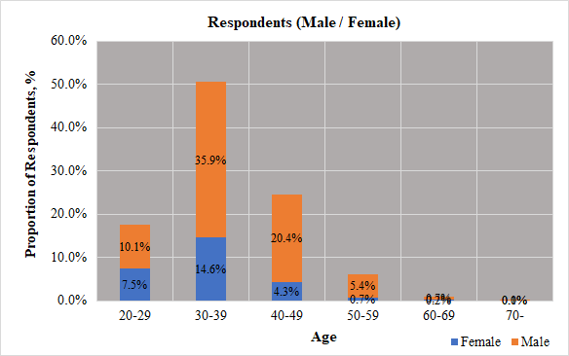

Figure 7-74: Journey purpose by gender or respondents – Eastern Region
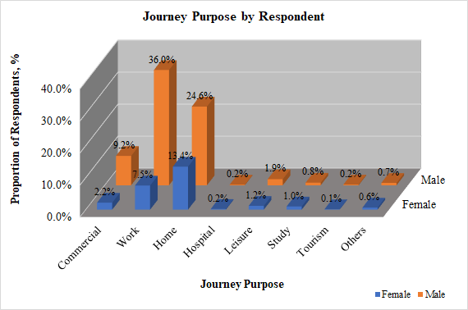

- Figure 7-3 above shows that the dominant number of trips work related i.e. the origin purpose was work (43.5%). The second highest trip purpose were home related i.e. home to work, home to school, etc. These accounted for 38% of all trips.
- Most male respondents were making work-based trips and most female interviewees made home-based trips.
Figure 7-75: Journey distance for a typical journey
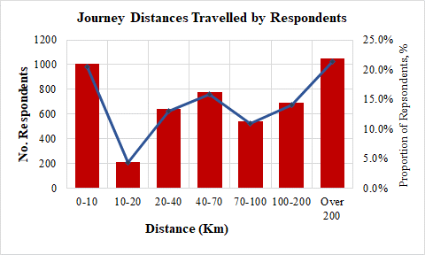

- Figure 7-4 above shows that the majority of respondents’ typical journeys were either very short or very long. Short journeys (0 – 10Km), accounted for 20.5% and very long journeys (over 200Km), accounted for 21.4%. Middle distance trips (typically 40-100 km) accounted for 26.8% of all trips.
Figure 7-76: Journey time for a typical journey
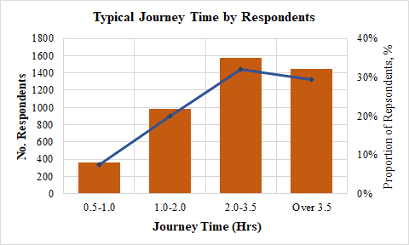

- Figure 7-5 above shows that the majority of respondents’ typical journey times were 2 hours and above. Those that travelled for 2 – 3.5 hours accounted for 32% and those travelling for over 3.5 hours were 29.4%.

Table 7-34: Willingness to pay toll charges by typical journey distance
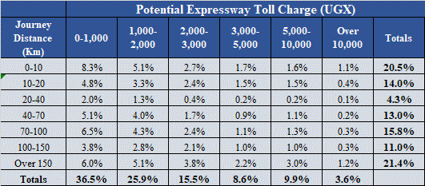

Figure 7-77: Willingness to pay toll charges by typical journey distance
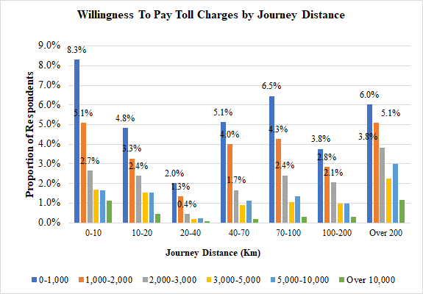

Table 7-2 and Figure 7-6 present the critical issue of willingness to pay. The toll charges that respondents were willing to pay for the use of expressways (toll per use) were compared to the typical journey distance. The charges are for each single journey regardless of distance. It would reasonably be expected that higher travel distance travelers would be willing to pay higher toll charges.
Table 7-2 and Figure 7-6 indicate the following:
- The largest majority of respondents would only be willing to pay up to UGX1,000. These account for 36.5%. Those willing to pay UGX1,000 – UGX2,000 were 25.9% of all respondents, UGX2,000-UGX3,000 were 15.5% and 22.1% were willing to pay higher than UGX3,000.
- For every range of journey distance, the data shows that the largest majority of respondents would pay up to UGX1,000. The proportion of these respondents does not clearly reduce with increase in journey distance.
- The data shows indications that long-distance travelers would be willing to pay higher charges. From Figure 7-6, the grey, yellow and light blue bars (representing toll charges between UGX2,000 and UGX5,000) clearly increase in length with increase in travel distance. For journey distance of over 200 Km, it is clear that the number of respondents willing to pay higher charges is significantly higher.
Table 7-35: Willingness to pay toll charges by income of respondent
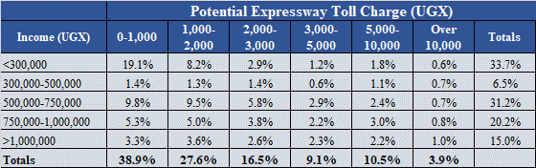

Figure 7-78: Willingness to pay toll charges by income of respondent
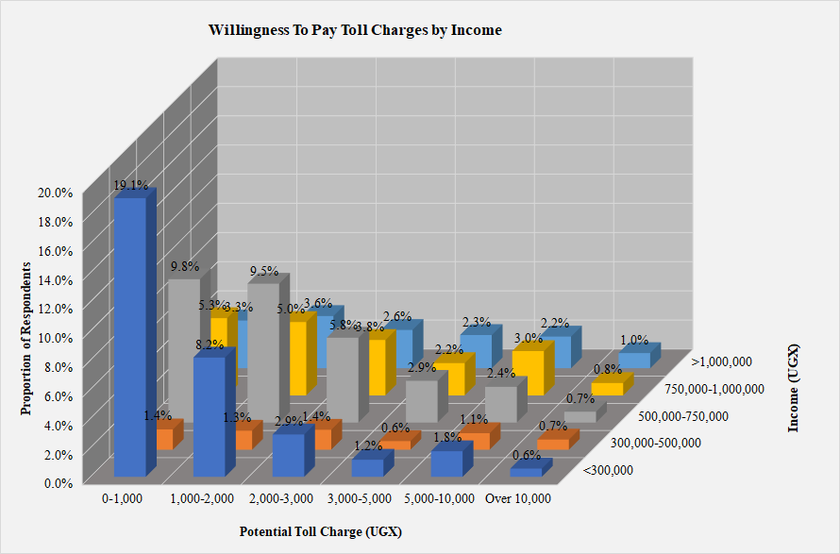

The toll charges that respondents were willing to pay for the use of expressways were compared to the stated income of the respondents. It would reasonably be expected that higher income earners would be willing to pay higher toll charges.
Table 7-3 and Figure 7-7 indicate the following:
- The largest majority of respondents would be willing to pay up to UGX1,000. These account for 38.9%. Those willing to pay UGX1,000 – UGX2,000 were 27.6% of all respondents, UGX2,000-UGX3,000 were 16.5% and 23.5% were willing to pay higher than UGX3,000.
- The data shows indications that higher income respondents would be willing to pay higher charges. From Figure 7-7, it is clear that the proportion of those willing to pay UGX3,000 and higher increases with increasing income.
Table 7-36: Willingness to pay toll charges by vehicle type
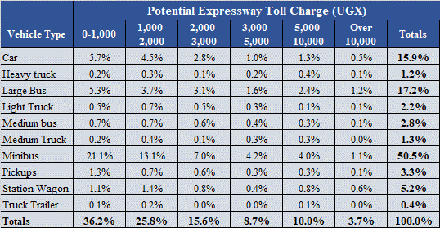

The toll charges that respondents were willing to pay for the use of expressways were vehicle type of the respondents. It would reasonably be expected that larger vehicles would be willing to pay higher toll charges.
Table 7-4 and Figure 7-8 indicate the following:
- The largest majority of vehicles would be willing to pay up to UGX1,000. These account for 36.2%. Those willing to pay UGX1,000 – UGX2,000 were 25.8% of all respondents, UGX2,000-UGX3,000 were 15.6% and 22.4% were willing to pay higher than UGX3,000.
- The data shows that a significant number of respondents were minibus drivers, although all other vehicle types are well represented in the large database.
- The data shows that for cars, minibuses, station wagons and large buses a significant number of respondents were willing to pay higher toll charges. The proportion of respondents who were willing to pay UGX3,000 and higher for cars, minibuses, station wagons and large buses were 2.9%, 9.3%, 1.8% and 5.1% respectively of all respondents. Overall, a total of 22.4% of all vehicle types were willing to pay UGX3,000 or higher.

Figure 7-79: Willingness to pay toll charges by vehicle type
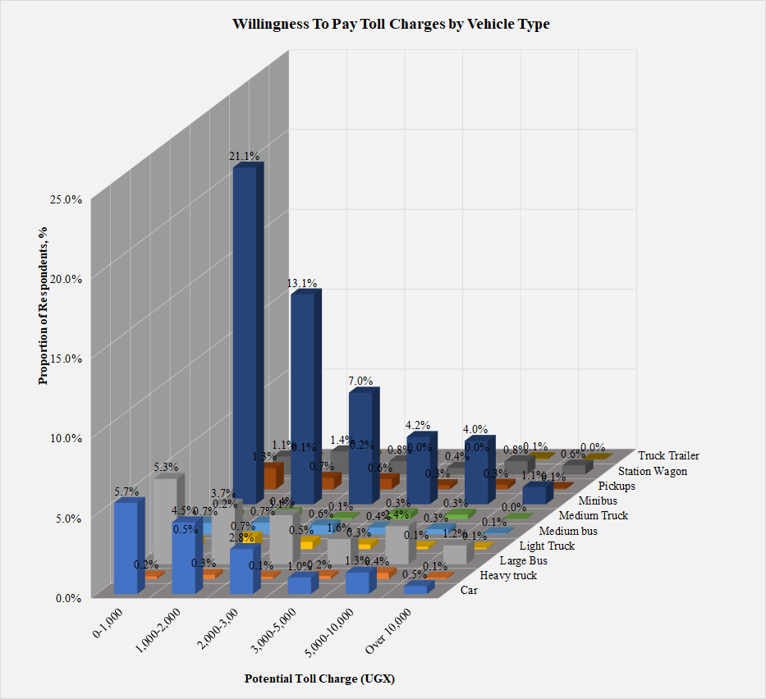

PUBLIC TRANSPORT (PT) SURVEYS

Introduction
Public transport surveys undertaken as part of the survey exercise focused solely on large buses. The main objective was to determine the large bus demand for key routes within the country.
Origin-destination surveys were not undertaken as part of this exercise. Only bus counts were undertaken. It was considered that OD surveys undertaken at roadside would provide data that could be required if needed.
The locations for undertaking PT surveys were the same as those where SP surveys were undertaken, with the exception of Iganga. Iganga did not possess a designated bus parking area. These were presented in Table 2-16. The surveys were undertaken in 20 key towns and cities in Uganda. Within these locations, the surveys were undertaken at formal bus terminals and key bus stops.

Methodology

Site Selection
The locations of the PT surveys were carefully chosen to maximise coverage of the entire country. The locations shown in Figure 7-1 where SP was undertaken are also the locations where PT surveys were undertaken generally.
Two key pieces of information were collected as part of the PT surveys:
- the number of buses passing in either direction through the bus terminal. Those arriving at the terminal (to the town) and those leaving the terminal (from the town);
- The number of boarding and alighting passengers for each stopping bus. For most towns, boarding and alighting of passengers is a small activity before the bus departs to travel farther on. At other towns that serve as end terminals for bus services, the activity takes a significant amount of time and the number of boarding or alighting passengers is significant.
Kampala, having a number of key bus terminals was considered for detailed surveys. The major bus terminals were also surveyed, a total of 11 bus terminals including; Global Coaches, Bismarkan Coaches, Jaguar, Easy Coaches, KK Coaches, YY Coaches, Trinity, Swift Coach, Post Bus, Modern Coaches and Link Buses.

Survey Personnel and Training
The following categories of survey staff were used at all survey locations:
- Survey manager with overall responsibility for the survey programme;
- Location supervisors with overall responsibility for the operations of each of the survey locations; and
- Two enumerators interviewers per location.
Survey staff used for PT surveys in this exercise were experienced socioeconomic survey staff, but were nonetheless trained prior to the survey. The training covered a range of issues including; details about the survey, the duties involved, roles and responsibilities, the associated health and safety requirements, interview procedure and detailed instructions on how to complete the survey questionnaire.

Survey Period
As described in Table 1-1, the PT surveys were undertaken for one day at every location. The survey period was 7am to 7pm everyday survey day.

PT Data Analysis Results

Summary Analysis - Kampala
Table 8-1 presents the PT survey summaries for Kampala. PT surveys in Kampala were undertaken at ten locations. Coach companies in Kampala largely operate at their own terminals. The largest coach operators were identified to be eleven (11). The PT surveys were therefore undertaken at the terminals of these identified operators. The identified operators were:
- Global Coaches;
- Bismarkan Coaches;
- Jaguar Bus Services;
- Easy Coaches;
- KK Bus Services;
- YY Coaches;
- Trinity Bus Services
- Swift Coaches;
- Posta Bus Services;
- Modern Coast Coaches; and
- Link Bus Services.
The collected data for Kampala is hence presented by operator. Detailed data is included in Appendix G.

Table 8-37: PT survey results for Kampala
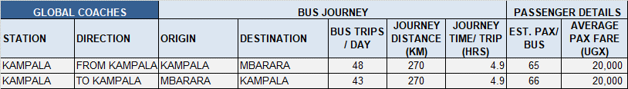
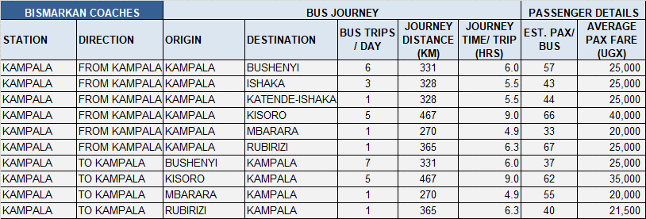
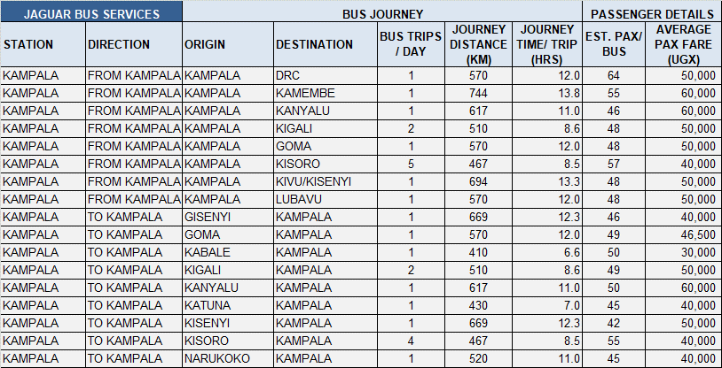
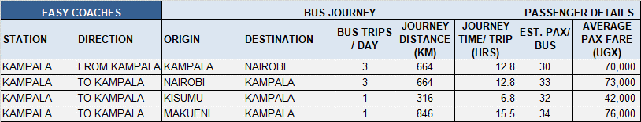
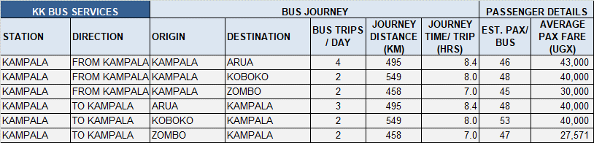
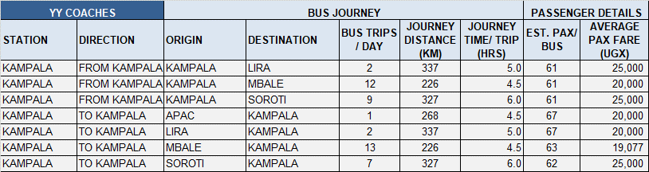
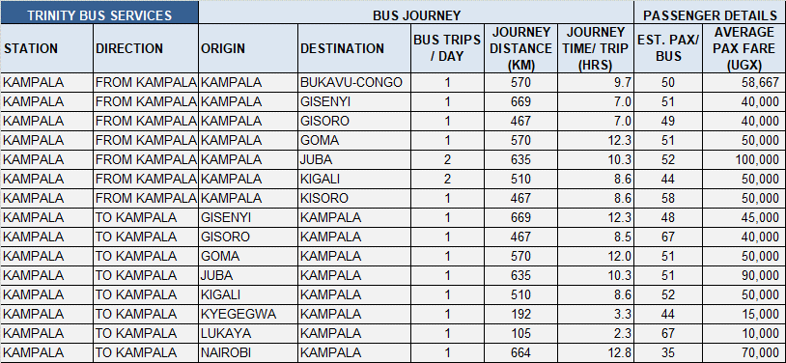
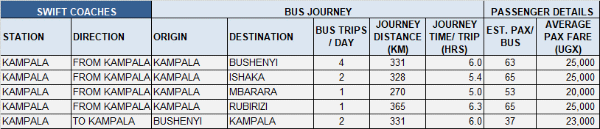
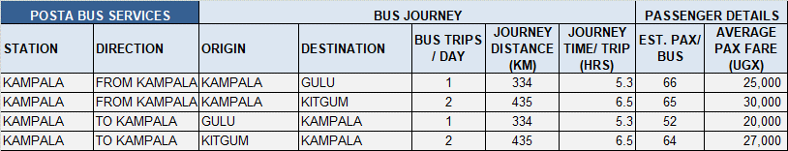
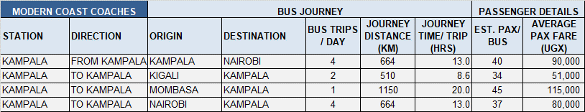
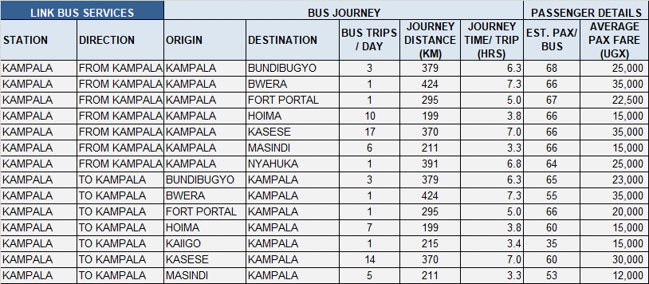

Summary Analysis - Countrywide
Table 8-2 presents the PT survey summary for all countrywide locations.

Table 8-38: PT survey results for Jinja
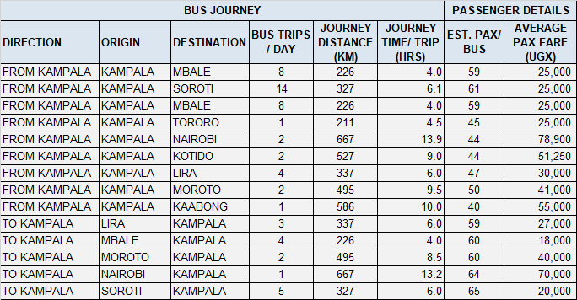

Table 8-39: PT survey results for Soroti
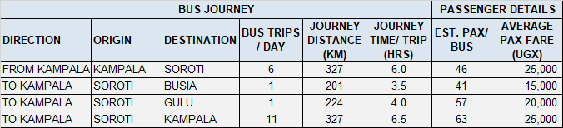
Table 8-40: PT survey results for Tororo
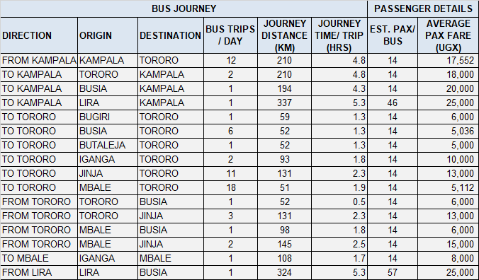
Table 8-41: PT survey results for Mbale
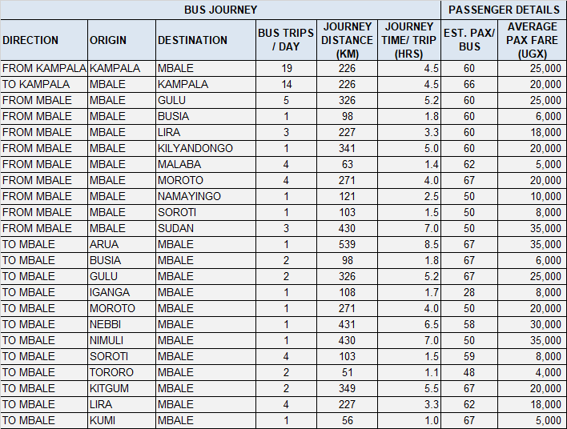
Table 8-42: PT survey results for Lira
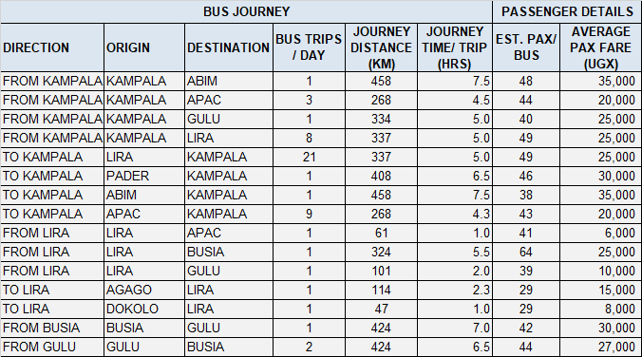

Table 8-43: PT survey results for Gulu
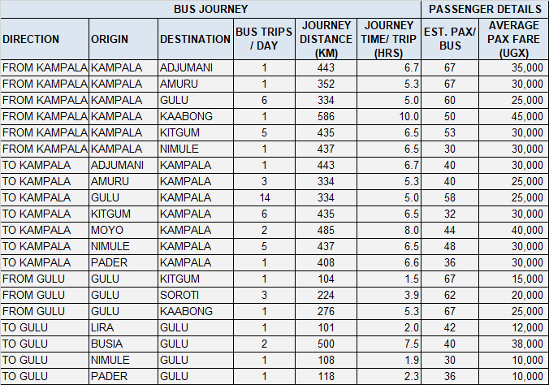
Table 8-44: PT survey results for Arua
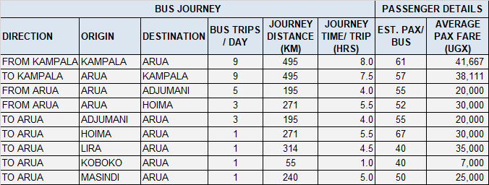

Table 8-45: PT survey results for Hoima
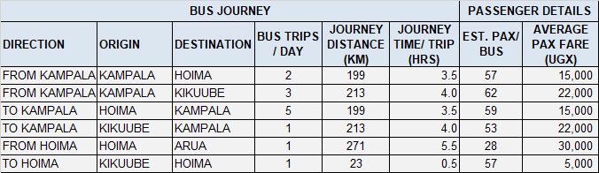

Table 8-46: PT survey results for Kasese
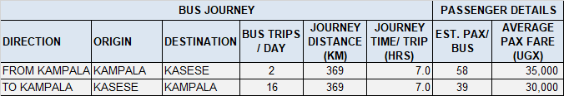
Table 8-47: PT survey results for Luwero
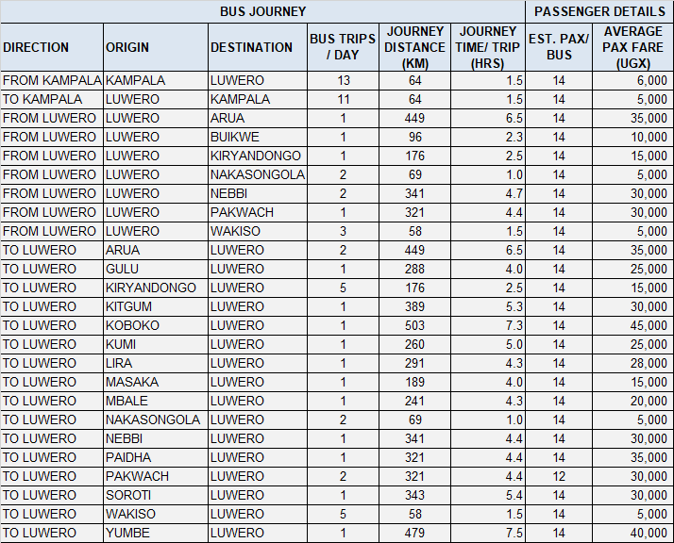
Table 8-48: PT survey results for Masaka
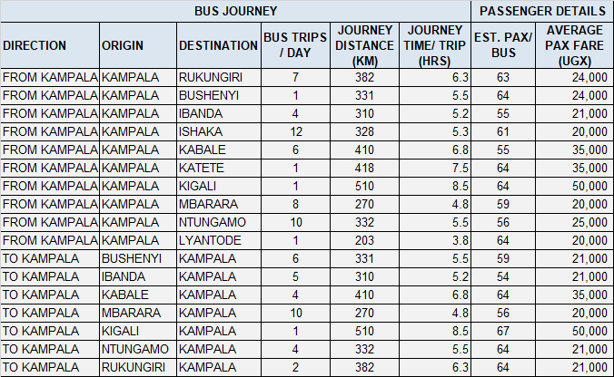

Table 8-49: PT survey results for Mityana
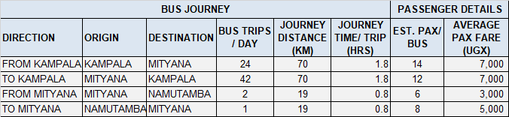

Table 8-50: PT survey results for Mubende
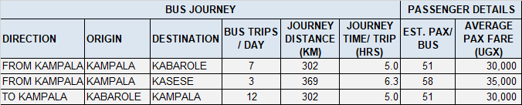
Table 8-51: PT survey results for Mbarara
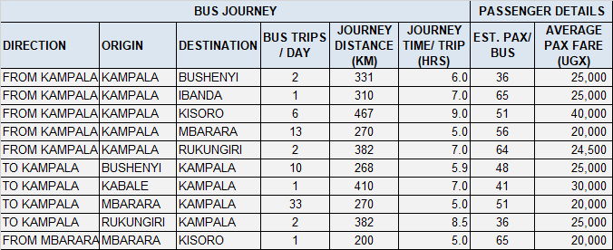

Table 8-52: PT survey results for Kabale
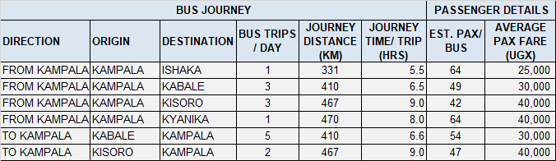

Table 8-53: PT survey results for Bushenyi
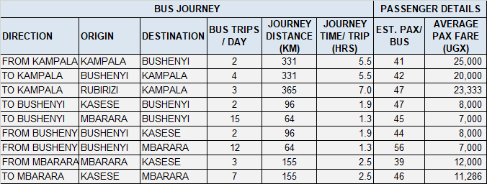
Table 8-54: PT survey results for Rukungiri
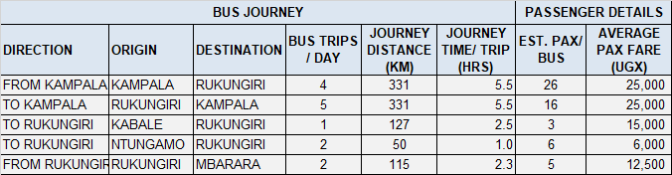

Table 8-55: PT survey results for Kitgum
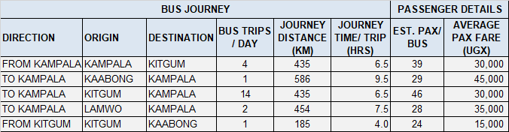

ACCIDENT DATA COLLECTION

Introduction
As part of the traffic survey exercise, it was required to collect accident data for all regions in the country. The actual locations from which data was to be collected were established at survey proposal stage.
Accident data was collected from district and regional police stations across the country. The following locations provided the required information; Jinja, Soroti, Tororo, Mbale, Lira, Gulu, Hoima, Kasese, Luwero, Masaka, Mubende, Mbarara, Kabale, Bushenyi, Rukungiri, Kitgum, Iganga and Arua.

Methodology
The data was requested from the District or divisional police station by means of a formal authority letter from Police Headquarters in Kampala.
Accident data was requested for at least the previous five years. This was to be annual data classified into fatal, serious and minor accidents with the Police Station’s jurisdiction.

Accident Data Analysis Results

Summary Results – Individual Stations
Figures 9-1 to 9-18 present the accident data analysis for all 18 stations on a station by station basis. Detailed raw data including monthly variations for selected stations is included in Appendix H.
Figure 9-80: Accident analysis – Jinja District
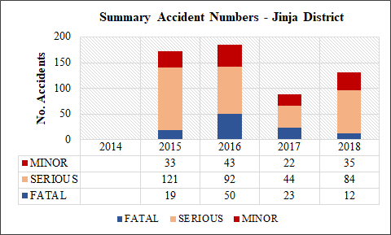

The following observations are made from the figure above (Jinja District):
- Data was only availed to the Consultant for the previous four years
- There is a reduction in total accidents mainly driven by the significant reduction in serious and fatal accidents.
Figure 9-81: Accident analysis – Soroti District
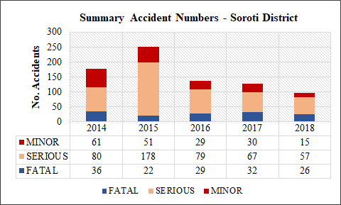

The following observations are made from the figure above (Soroti District):
- There is a significant reduction in total accidents mainly influenced by significant reduction in serious accidents.
- There is an observed doubling in recorded accidents in 2015 and a following reduction by about 60%.
Figure 9-82: Accident analysis – Tororo District
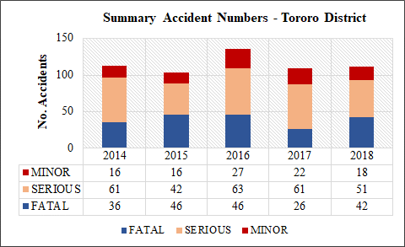

The following observations are made from the figure above (Tororo District):
- There seems no reduction in total accident numbers. There is however some reduction in fatal accidents.
Figure 9-83: Accident analysis – Mbale District
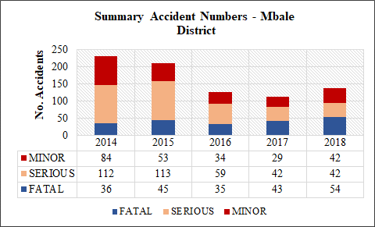
The following observations are made from the figure above (Mbale District):
- There is an observable reduction in total accident numbers influenced by a significant reduction in serious accidents. Recorded serious accidents reduced by 63% between 2014-15 and 2018. There is seems no reduction in fatal accidents.
Figure 9-84: Accident analysis – Lira District
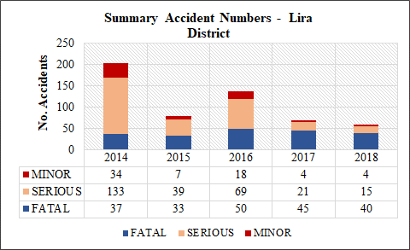

The following observations are made from the figure above (Lira District):
- There is a significant reduction in total accidents mainly influenced by significant reduction in serious accidents. Recorded serious accidents reduced by 89%.
- There seems to be a reduction in minor accidents. However, minor accidents are not comprehensively recorded because they are not inspected adequately.
Figure 9-85: Accident analysis – Gulu District
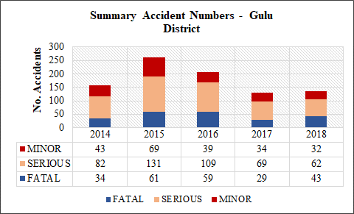
The following observations are made from the figure above (Gulu District):
- There is an observable reduction in total accident numbers influenced by a significant reduction in serious accidents. Recorded serious accidents reduced by 42% between 2014-15 and 2018. There is also a reduction in fatal accidents.
Figure 9-86: Accident analysis – Hoima District
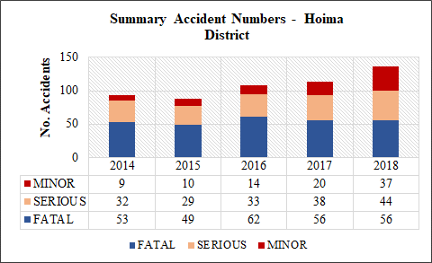
The following observations are made from the figure above (Hoima District):
- There is an observable increase in total accident numbers influenced by a slight increase in serious accidents between 2015 and 2018. There is also an increase in recorded minor accidents.
Figure 9-87: Accident analysis – Kasese District
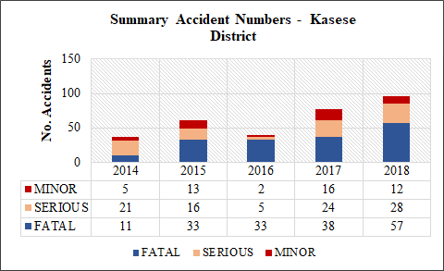
The following observations are made from the figure above (Kasese District):
- There is an observable increase in total accident numbers influenced by a 418% increase in fatal accidents between 2014 and 2018. There is also an increase in recorded minor accidents.
Figure 9-88: Accident analysis – Luwero District
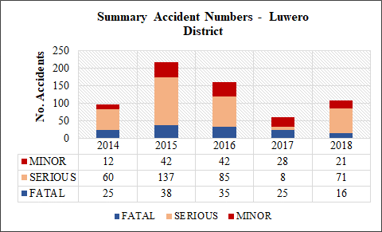
The following observations are made from the figure above (Luwero District):
- There is an observable reduction in total accident numbers influenced by a significant reduction in serious accidents. Recorded serious accidents reduced by 60% between 2014-15 and 2017-18. There is also a reduction in fatal accidents.
Figure 9-89: Accident analysis – Masaka District
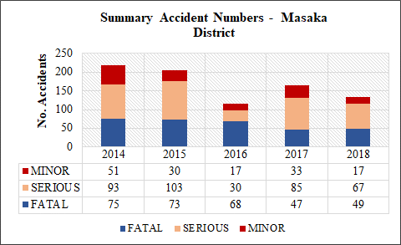
The following observations are made from the figure above (Masaka District):
- There is an observable reduction in total accident numbers influenced by a reduction in serious and fatal accidents. Recorded serious accidents reduced by 22% between 2014-15 and 2017-18 and fatal accidents reduced by 35% over the same period.
Figure 9-90: Accident analysis – Mubende District
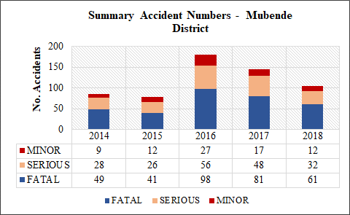
The following observations are made from the figure above (Mubende District):
- There is an observable increase in total accident numbers in the period 2017-18 compared to 2014-15, influenced by increases in serious and fatal accidents. The increase is influenced by the significant increase in recorded accidents in 2016. However, from 2016, there is a declining trend in all accidents.

Figure 9-91: Accident analysis – Mbarara District
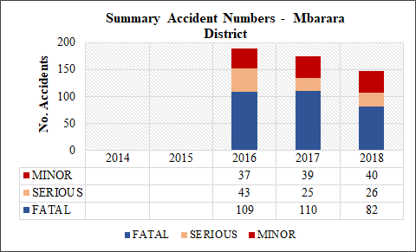
The following observations are made from the figure above (Mbarara District):
- Only data for the three years 2016, 2017 and 2018 was availed.
- There is a declining trend in all accident numbers. Fatal accidents are significantly high even though they are on a declining trend, likely driven by the busy Kampala – Mbarara – Kasese corridor.
Figure 9-92: Accident analysis – Kabale District
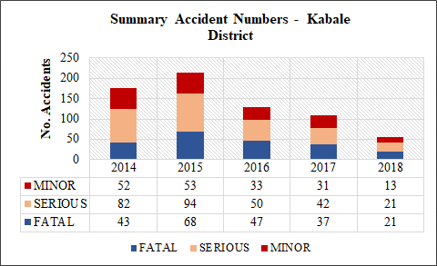
The following observations are made from the figure above (Kabale District):
- There is an observable reduction in total accident numbers influenced by a significant reduction in serious and fatal accidents. Recorded serious accidents reduced by 76% between 2014-15 and 2018. Fatal accidents reduced by 62% over the same period.

Figure 9-93: Accident analysis – Bushenyi District
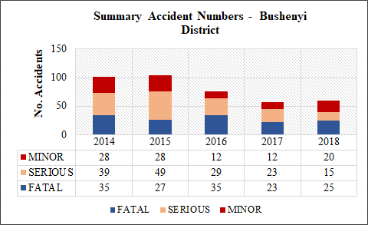
The following observations are made from the figure above (Bushenyi District):
- Similar to Kabale, there is an observable reduction in total accident numbers influenced by a significant reduction in serious accidents. Recorded serious accidents reduced by 67% between 2014-15 and 2018. Fatal accidents reduced by 19% over the same period.
Figure 9-94: Accident analysis – Rukungiri District
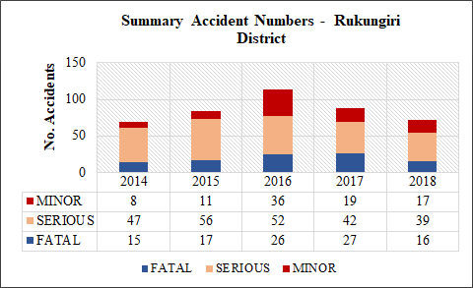
The following observations are made from the figure above (Rukungiri District):
- Recorded accidents in Rukungiri increased between 2014 and 2016 but have since been on a clear declining trend. The reduction is mainly influenced by a reduction in serious accidents between 2016 and 2018.

Figure 9-95: Accident analysis – Kitgum District
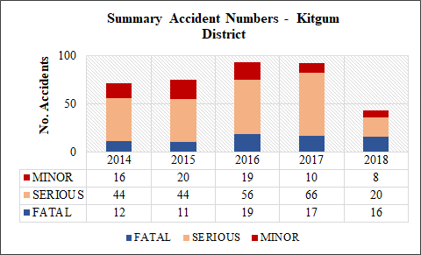
The following observations are made from the figure above (Kitgum District):
- Total accidents in 2018 are significantly lower than for the period 2014-17. There seems to have been an increasing trend between 2017-18. The 2018 record seems a sudden reversal of the 2017-18 trend. It may be an actual decrease in accidents or more likely an issue with accident recording.
Figure 9-96: Accident analysis – Iganga District
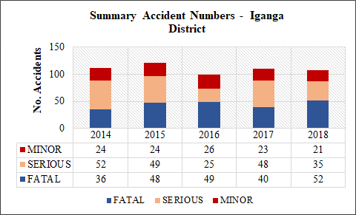

The following observations are made from the figure above (Iganga District):
- There seems no reduction in total accident numbers. There is no significant decline or increase variation in either serious or fatal accidents over the period 2014-2015.

Figure 9-97: Accident analysis – Arua District
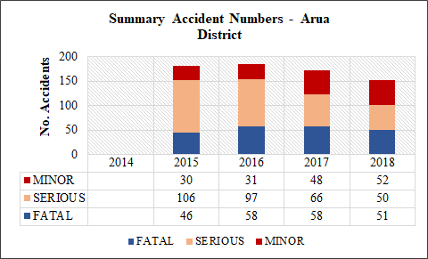

The following observations are made from the figure above (Arua District):
- Only data for the three years 2015, 2016, 2017 and 2018 was availed.
- There is a small decline in total accident numbers. Recorded serious accidents are clearly lower in 2018 than in 2015 but fatal accidents seem slightly higher.

Summary Results – Countrywide
Figures 9-19 presents the accident data analysis for all 18 stations combined. This analysis was used as a proxy to obtain a representative national accident trend.
Figure 9-98: Accident analysis – All stations combined
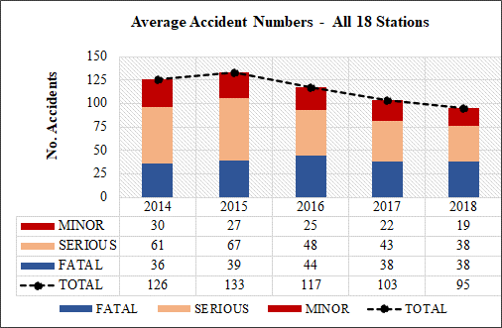

It is recognized that accident data was not collected from every district Police Station in Uganda and therefore cannot be fully representative of national statistics. In developing this national analysis, the average accident numbers at all 18 stations was taken.
Figure 9-19 indicates the following:
- There is a decreasing trend in recorded accidents.
- The decrease is observable in all three accident types but is most significant with serious accidents. Recorded serious accidents indicate a reduction of 62% over the period 2014 – 2018. Fatal accidents also indicate a 25% reduction over the 5-year period.
The reasons for the general decrease in accidents may vary from one region or district to another, especially with regard to the level of urbanization. However, at national level, the reduction in accidents seems to be the result of increase traffic police present on major highways. Nationally, the largest cause of accidents is reckless and dangerous driving, which accounts for nearly 80% of all accidents.

FERRY SURVEYS

Introduction
As part of the traffic survey exercise, traffic surveys on ferries was also conducted at UNRA ferry crossings. The objective of this survey was to determine the following:
- The schedule of the ferry services;
- The length and journey time of ferry services;
- The number of passengers boarding and alighting;
- The estimated freight volume alighting and boarding;
- The volume and vehicle types of motorized and non-motorized traffic carried by the ferries.
The last objective was considered most important. In the planning of the future expressway network, it is considered that some or all of the critical ferry crossings may be converted into road crossings. It is therefore important to understand the current and future traffic volumes carried by the ferries.
The locations of the ferry surveys were presented in Figure 2-17 and Table 2-18.

Methodology
In order to effectively undertake the survey, enumerators were stationed at one end of the ferry crossing. From this point, the amount of goods alighting and boarding, passengers, vehicular and non-vehicular traffic could be accurately recorded.
The ferry data was collected by means of a specific survey form. The format was well designed to enable the recording of the data specified above for every ferry service that arrived at the survey point.

Historic Ferry Data
As part of the survey process, historic data on the UNRA ferry routes was obtained. Table 10-1 presents an analysis of the data. The data provided was for the months of July, August and September 2019. The figures shown in the table are three month averages for traffic that crosses on the ferries.
Table 10-56: Analysis of historic ferry data (three-month ADT)
TRAFFIC CROSSING AT FERRY ROUTES (ADT)
Ferry Name | Route | Buses | Trucks | Cars/ Pickups | Motor-cycles | Bicycles | TOTAL
Kyoga Ferries | Zengebe-Namasale | 0 | 22 | 42 | 35 | 46 | 146
Bisina Ferry | Agule-Kokorio | 0 | 8 | 9 | 143 | 40 | 200
Nakiwogo Ferry | Nakiwogo-Buwaya | 0 | 63 | 40 | 115 | 101 | 319
Laropi Ferry | Omi-Laropi | 14 | 23 | 79 | 119 | 19 | 254
Obongi Ferry | Obongi-Sinyanya | 1 | 30 | 102 | 112 | 65 | 310
Albert Nile | Wanseko-Panyimur | 0 | 11 | 3 | 18 | 5 | 37
Kiyindi Ferry | Kiyindi-Buvuma | 0 | 13 | 16 | 50 | 10 | 89
Masindi Port | Masindi-Kungu | 2 | 32 | 29 | 168 | 58 | 290

Ferry Survey Data Analysis Results
The analysis was undertaken on a ferry by ferry basis. Nine ferries in total were surveyed. The presentation of results in this section is therefore made on a ferry by ferry basis. Detailed data is included in Appendix I.
Figures 10-1 to 10-9 present the analysis results for the ferry services.

Figure 10-99: Analysis results for Bukakata-Kalangala ferry
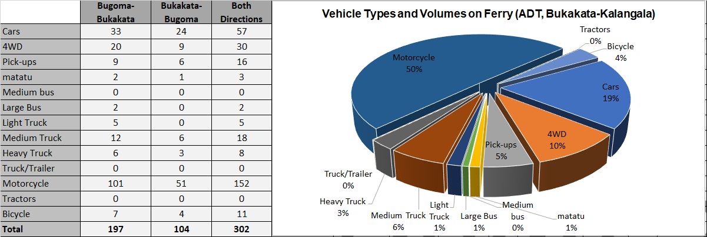

Figure 10-100: Analysis results for Zengebe-Namasale (Amolatar) ferry
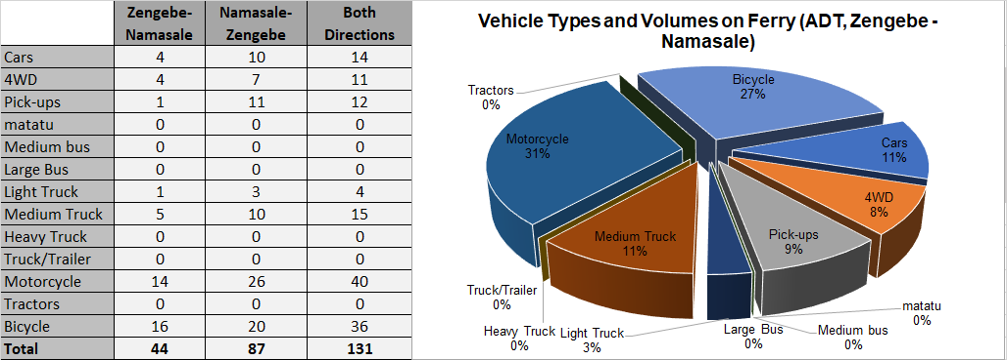

Figure 10-101: Analysis results for Agule-Kokorio (Lake Bisina) ferry
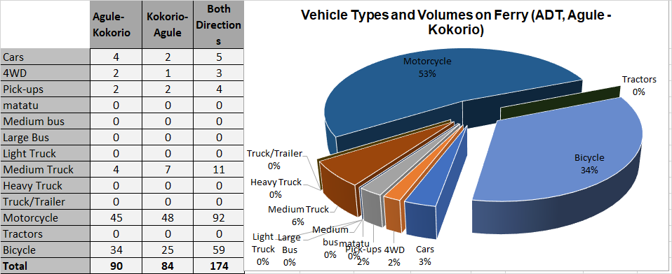

Figure 10-102: Analysis results for Nakiwogo-Buwaya ferry
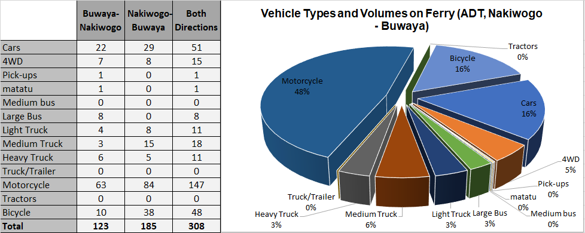

Figure 10-103: Analysis results for Omi-Laropi ferry
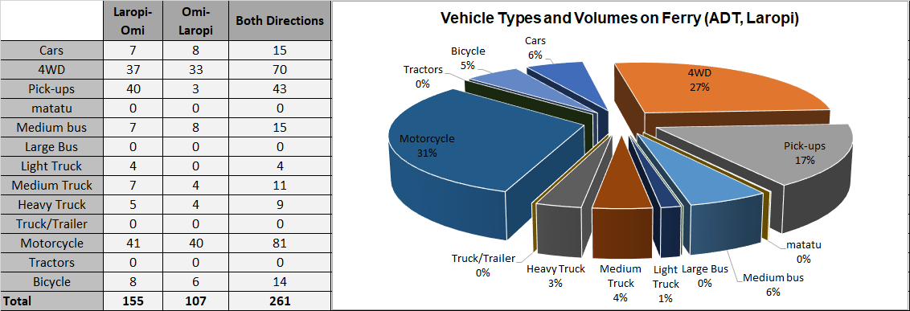

Figure 10-104: Analysis results for Obongi-Sinyanya ferry
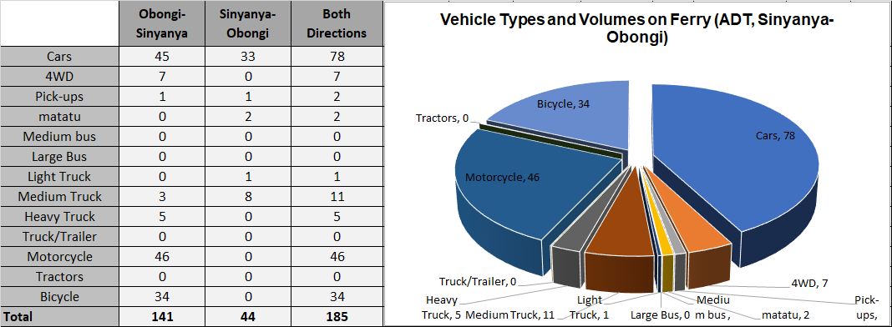

Figure 10-105: Analysis results for Wanseko-Panyimur ferry
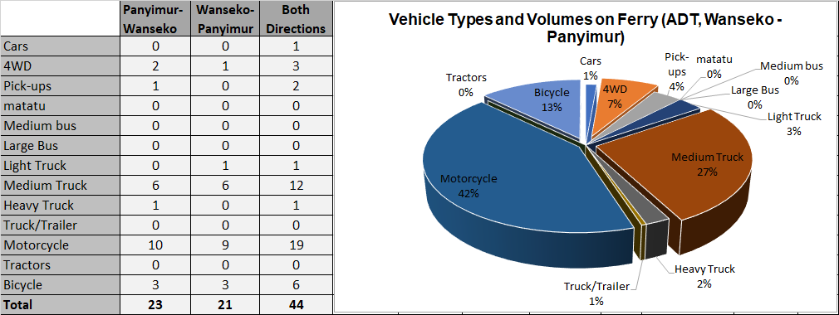

Figure 10-106: Analysis results for Kiyindi-Buvuma ferry
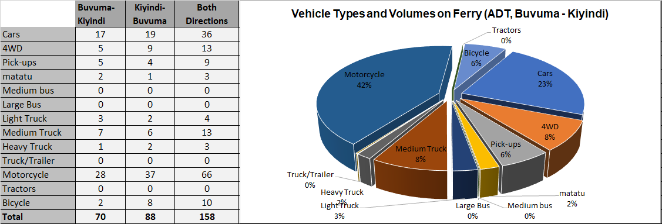

Figure 10-107: Analysis results for Masindi-Kungu ferry
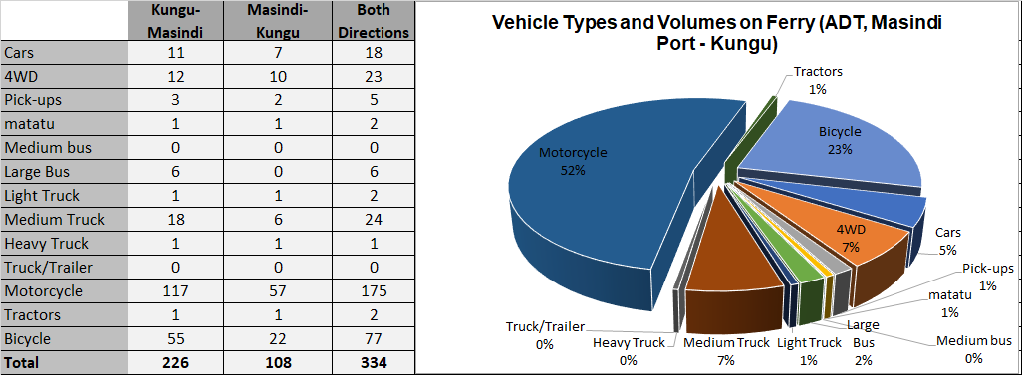

AUTOMATIC TRAFFIC COUNT (ATC) SURVEYS

Introduction
Roadside automated traffic counters are frequently used to count and classify traffic on heavily trafficked roads. The method has a number of advantages over manual counts, key of which is the convenience of not having to deal with large numbers of enumerators.
A comparison of the automated and manual counts is presented in Table 11-1 below.
Table 11-57: Advantages of ATC surveys
Advantages of ATC Surveys
- Eliminates the need to handle large numbers of enumerators and associated issues of training, mobilisation, late coming, etc
- Cheaper and convenient for counts spanning days and weeks
- More suitable for surveys at highly trafficked road sections
- Saves time as more survey stations can be done at the same time
- Produces better quality data by eliminating enumerators errors due to inexperience, inadequate supervision, tiredness, inclement weather, etc
- With regard to counting, the ATC method also produces more accurate data because it is able to record 24-hour counts on each day as opposed the normal manual method of taking 24-hour counts on only two days.
- Suitable for extended survey periods and regular assessment of traffic flows across the wider road network
- RSU can also measure vehicle speed
Advantages of MCC Surveys
- May be more accurate for low volume road for surveys spanning a few days using well trained enumerators
- Maintains human contact with road incidents that may impact on the quality of the data.
- Cheaper for smaller, shorter surveys

Objective of the Survey
The Kampala Northern Bypass is a critical highway for Kampala and the nation. The road was constructed to relieve traffic congestion within the city center, allowing cross-country traffic to bypass the city's downtown area. Since its opening, the Northern Bypass has become a highly trafficked, high-speed highway that facilitates the effective distribution of traffic to and from key arterial routes located north of Kampala.
The Kampala Northern Bypass is considered a key route in the proposed EDMP. An investigation of the section by section traffic volumes on the highway was considered key. For that reason, ATC surveys were planned with the objective of determining the ADT on the highway more accurately. This was the main objective of this survey.

Methodology

Method of Collection
The method involves installation of a roadside unit (RSU) from which two pneumatic tubes are laid across the road. As traffic moves across the two tubes, the RSU records the number of vehicles axles and their spacing for each tube. This information is then used by specialist software to determine the type and number of vehicles moving across the count station. The software utilises inbuilt or custom vehicle profiles that are representative of all vehicle types using on the road network.
ATC surveys were undertaken at 7 survey stations along the Kampala Northern Bypass highway as indicated in Table 2-20.

Site Selection
RSUs were installed at all 7 stations. The stations were carefully chosen along the relevant sections of the highway in accordance with RSU manufacturer’s recommendations. The following considerations were made in choosing the ATC survey sites:
- Sites where selected at points where most traffic is travelling at a constant speed. Sites where vehicles are accelerating or decelerating due to bends, steep inclines, traffic signals, or intersections where avoided as much as possible.
- Effort was made to avoid sites where vehicles stop over the tubes although this could not be totally achieved with the existing traffic jam of the highway.
- Sites were chosen to ensure that most traffic would cross perpendicular to the tubes.
- Sites were also chosen to minimise single tube hits due to excessive swerving or lane changing.
- Sites with a suitable securing point for the RSU, such as a post or tree were also given priority.
Good installation of the RSUs is key because it is the main determinant of the quality of data. Installation requires trained or experienced personnel but is largely simple. The following need to be observed when making each installation:
- The pneumatic tubes need to be installed at exactly one-metre spacing for optimal results;
- The length of both tubes should be equal particularly the length from the kerb to the RSU;
- The tension in each tube should be similar; and
- The tube should be pressed against the road surface for its entire length.

ATC Equipment

Vehicle Classification System
The survey employed the MC5600 roadside unit. This unit and other traffic survey technology are supplied by MetroCount Limited, a renowned traffic survey equipment manufacturer.
Using two pneumatic tubes, the MC5600 stores every axle and the length between axles. Subsequent to the survey, the user determines the method of classifying the recorded data. Each axle combination combined with the length between axles implies a certain vehicle type. All this information is stored in the RSU at the time of survey.
The interpretation of the stored data i.e. what type of vehicle is represented by a particular axle combination depends on the local vehicle classification system. For example, the UNRA classification system comprises of 10 vehicle types (Section 2.3). When the utility vehicle class is further subdivided into pure utility vehicles (4-wheel drives) and pickups, the vehicle classes are 11.

Calibration of the RSU
This process of calibrating the RSU to local traffic conditions was as follows.
The ATC equipment is supplied with windows-based “Traffic Executive” software. This software is used to read the recoded data. Within this software is eight (8) inbuilt vehicle classification systems that broadly represent various classification systems around the world. Some of these systems are newer versions of others. As such, four classifications were considered for calibration purposes. None of these systems would be expected to precisely match the UNRA system. This is because vehicle types and classes used in various countries differ.
The calibration approach sought to ascertain which classification system results in similar traffic volumes as those resulting from a controlled manual count. Once, a classification system is confirmed, the traffic volumes recorded by the RSU can then be disaggregated further into local classes in accordance with the vehicle type splits from the manual counts.
Control Manual Counts and Comparison With ATC Counts
The control manual counts were conducted for a period of two hours at three stations along the Northern Bypass; Kyebando – Kisaasi, Kisaasi – Naalya and Naalya – Bweyogerere. The period of the manual count was limited to 2 hours at each location on one day during the 7-day ATC at each of the three stations. All control MCC surveys were undertaken on 3rd February 2020.
It was intended to use one hour (the test hour) to compare with the ATC count (see Table 11-1). The period of the manual count was limited to ensure that it would be controlled as much as possible to avoid the common sources of error in MCC counts such as fatigue, loss of concentration, tiredness, etc.
Table 11-2 presents a comparison of the manual counts with the ATC counts from the selected classification systems. The classification system traffic volume that results in the smallest difference with the MCC count would be preferred. The vehicle classification systems selected from the RSU software are:
- AustRoads94 – this is an Australian vehicle classification scheme that was developed in 1994. It consisted of 12 vehicle classes. Details on this scheme are included in Appendix J.
- ARX - ARX is a modification of AustRoads94. It removes class 12, moves all other classes up by one, and inserts a motorcycle class as Class 1.
- Scheme F2 - Scheme F2 is USA classification system. It is an implementation of the Federal Highway Administration (FHWA)'s visual classification scheme as an axle-based classification scheme. Details are included in Appendix J.
- TNZ 1999 – TNZ 1999 is a scheme developed by Transit New Zealand. It has 14 classes. Details are included in Appendix J.

Table 11-58: Comparison of control MCC count with ATC count
COMPARISON OF CONTROL MCC COUNT WITH ATC COUNT
Section of KNBP | Test Survey Period | Test Hour | Test Hour MCC | Test Hour ATC count |  |  |  | Min Difference, %
 |  |  |  | Aust-Roads94 | ARX | Scheme F2 | TNZ 1999 | Min Difference, %
Kyebando - Kisaasi | 16.45-18.45 | 17.00-18.00 | 2,017 | 2,056 | 2,056 | 1,983 | 2,062 | 1.7%
Kisaasi - Naalya | 14.30-16.30 | 15.00-16.00 | 1,906 | 1,956 | 1,956 | 1,911 | 1,964 | 0.5%
Bweyogerere - Naalya | 12.15-14.15 | 13.00-14.00 | 946 | 1,047 | 1,047 | 1,026 | 1,071 | 1.1%
From Table 11-2 above, the US Scheme F2 seems to match the control MCC better than the others. It consistently results in a closer traffic volume to MCC volume. As it was decided to extract the ATC data from the RSU using Scheme F2.

ATC Data Analysis Results
The analysis was undertaken on site by site basis. Figures 10-2 to 10-8 present the summary analysis of the ATC data. In the analysis, a plot of ADT for each of the week is plotted to show daily variation of the data.
In additional the traffic volume profile for the Kampala Northern Bypass highway is plotted. The section between Bwaise and Gayaza Road was not surveyed. For purposes of this analysis, the volume for Bwaise and Gayaza Road is assumed to be equal to the volume in the Hoima Road to Bwaise section.
Detailed data is included in Appendix J.
Figure 11-108: ADT variation for KNBP Mityana Rd to Sentema Rd
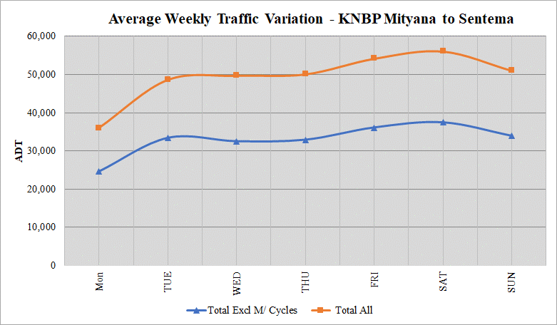

Figure 11-109: ADT variation for KNBP Sentema Rd to Hoima Rd
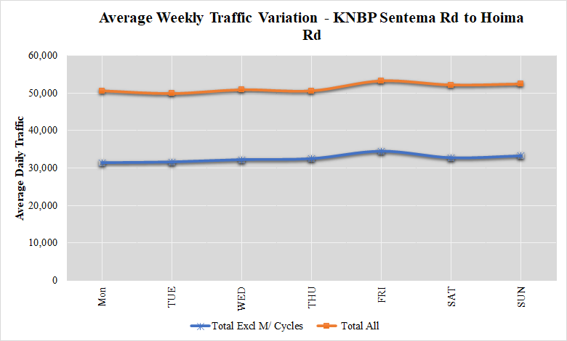

Figure 11-110: ADT variation for KNBP Hoima Rd to Bwaise Junction
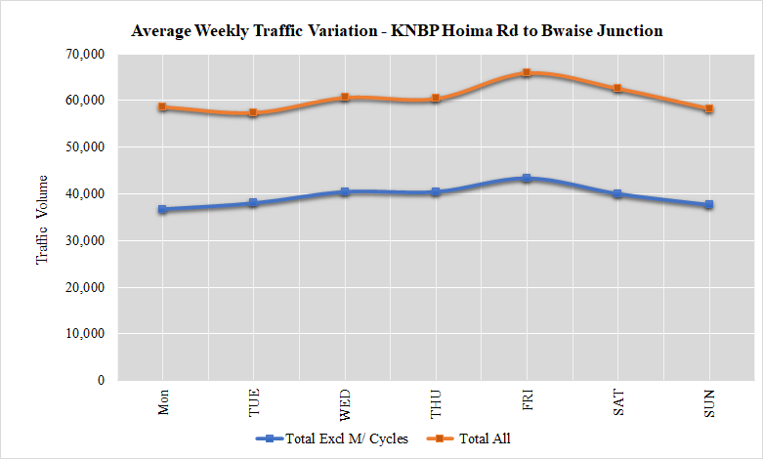

Figure 11-111: ADT variation for KNBP Gayaza Rd to Kyebando Rd
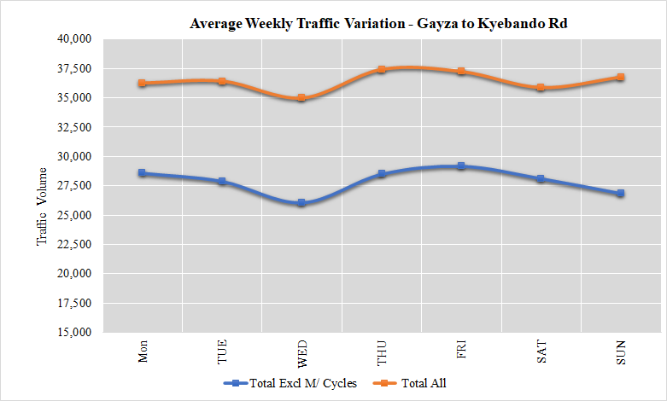

Figure 11-112: ADT variation for KNBP Kyebando Rd to Kisaasi Rd
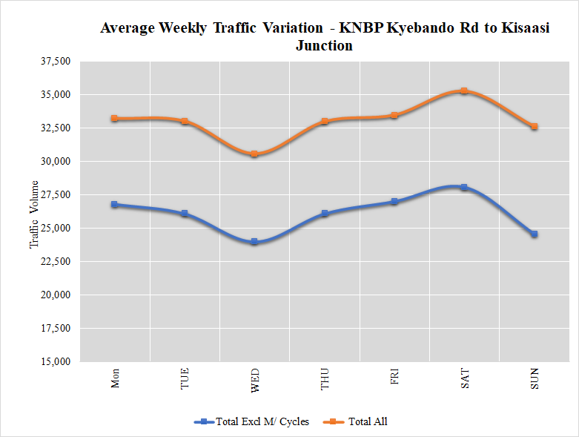

Figure 11-113: ADT variation for KNBP Kisaasi Rd to Nalya Junction
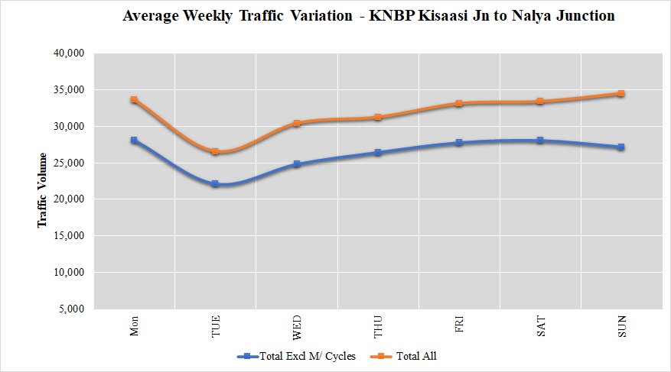

Figure 11-114: ADT variation for KNBP Nalya Junction to Bweyogerere
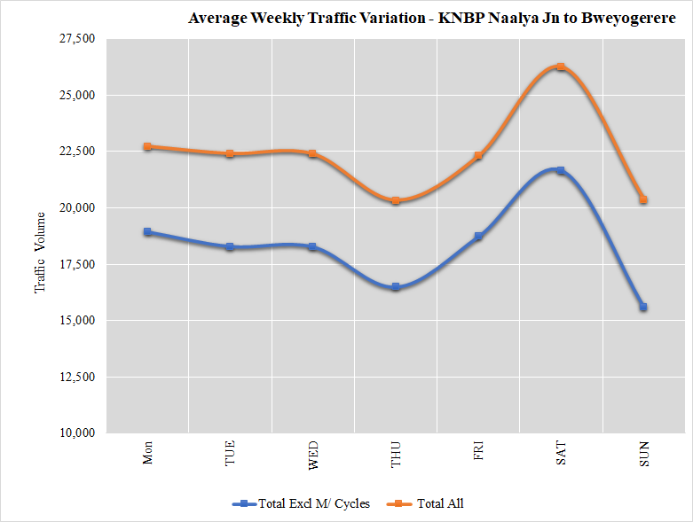

Figure 11-115: ADT profile for Northern Bypass highway
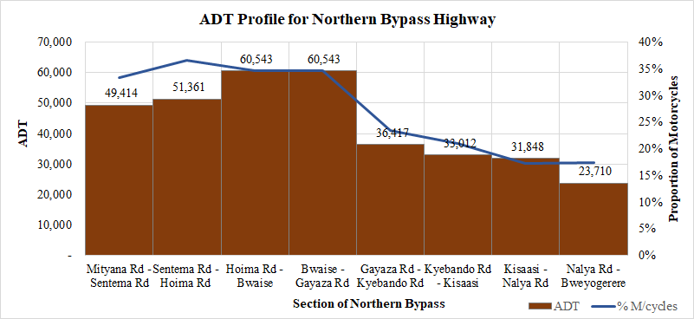

AXLE LOAD SURVEYS

Introduction
The main objectives of this survey were;
- to determine the level of loading of trucks on key highways; and
- to identify the type of loads carried on the selected highways

Location of Survey Sites
Axle load surveys were undertaken at 10 locations as described in Table 12-1 below.
Table 12-59: Description and location of axle load surveys
DESCRIPTION AND LOCATION OF ATC SURVEY SITES
Site Ref. | Highway / Link Name | Survey Type | Description of Site | Site Coordinates
AL1 | Kampala – Entebbe Highway | Axle | At the dual section of Kampala- Entebbe Road | 0.061179, 32.472757
AL2 | Kampala – Masaka Highway | Axle | Buwama | 0.064800, 32.109264
AL3 | Kampala – Mityana Highway | Axle | Bujuuko | 0.333394, 32.370712
AL4 | Kampala – Hoima Highway | Axle | Kakiri | 0.419596, 32.402159
AL5 | Kampala – Bombo Highway | Axle | Matugga | 0.472375, 32.518501
AL6 | Ishaka – Kasese Highway | Axle | Rubirizi town | -0.268438, 30.106536
AL7 | Kampala – Jinja Highway | Axle | Nakibizzi former Weighbridge location | 0.422428, 33.143343
AL8 | Mbale – Tororo Highway | Axle | Busoba town | 0.969742, 34.170843
AL9 | Karuma – Arua Highway | Axle | Purongo Town | 2.540505, 31.828369
AL10 | Gulu – Nimule Highway | Axle | Abelokodi village | 3.324474, 32.104841

Methodology

Survey Equipment
The surveys were undertaken using one Haenni Model 103 mobile weighbridge. The Haenni weighbridges are light weight, easy to use, accurate and generally have a number of features that have made them widely used mobile weighbridge.
The equipment was under valid calibration. It is a requirement that such equipment is calibrated annually by the Uganda National Bureau of Standards (UNBS) and must possess a valid calibration certificate. A copy of the calibration certificate for the equipment, valid at the time of survey was furnished to UNRA prior to commencement of surveys and is also included in Appendix K.

Survey Team
The survey team generally consisted of three members comprising of one supervisor and two scale operators. The scale operators also acted as the enumerators, recording scale readings, load types and other data
In addition, each site also consisted of two traffic police personnel to direct truck traffic to pull over and to ensure that traffic flowed safely around the survey site. The axle load measurements were undertaken on a lay-by adjacent to the main carriageway and therefore traffic generally flowed around the survey site adequately.

Survey Period
Axle Load Surveys were undertaken for three consecutive days at each station. The survey period was 12-hours (7am – 7pm) on each day.
The trucks were weighed one axle at a time and weights recorded on a pre-designed survey form attached in Appendix A. Each day’s completed form was verified in the field and then dispatched to the office for data entry, logical checks and general data cleaning.

Vehicle Classifications and Axle Load Configurations
Axle load surveys were conducted on truck vehicles only. The truck vehicle types according to the vehicle classification stated in Section 2.3 are four:
- Vehicle type 7 - Light truck (2 axle, gross weight of not more than 7 tonnes);
- Vehicle type 8 - Medium truck (2 axles, gross vehicle weight of between 7 and 15 tonnes);
- Vehicle type 9 - Heavy truck (3 or 4 axles, gross vehicle weight of up to 22 tonnes);
- Vehicle type 10 - Articulated truck (semi-trailer) (5 or more axles, gross vehicle weight of 22 - 56 tonnes);
Large buses were not considered for survey. Although load-carrying, from experience in load data analyses, buses do not particularly carry very bulky goods that are of significant influence on pavement deterioration. Also, the selected key routes had significantly high truck volumes. It is the truck loadings that are considered to be the main source of loading for the expressway network.
In order to record axle data accurately and to ensure that it is meaningful for further use, it is important to record the axle load configurations. Axle load configuration is the sequencing of tyre arrangements of any truck from front to back. Weights are taken for each configuration. The following guidance was used.
Figure 12-116: Truck configuration guide
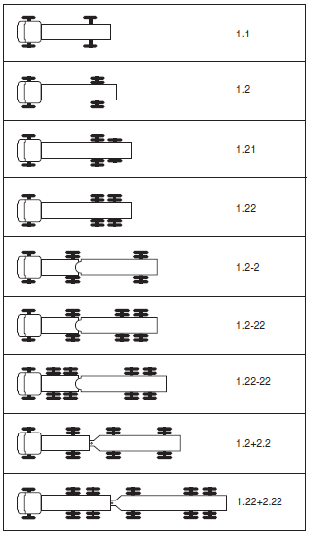

- Light and medium trucks generally have two axles i.e. 1:1 and 1:2. As such, for axle load record purposes, these two were merged as classified as one truck type “Light/Medium Trucks”.
- Heavy trucks typically comprise of three or four axles. However, the most common heavy trucks such as the Fuso 10-tyre truck comprises of three axles. Because semi-trailer and truck trailer trucks often comprise of four axles and above, for simplicity of analysis, heavy trucks were taken to comprise of only three axles i.e. 1:21, 1:2-2 and 1:22
- Semi-trailers and truck trailers were considered to comprise of four axles and above.

Axle Weight Limits
To enable a robust analysis of the axle load data, it is important to appreciate the weight limits imposed by UNRA on trucks carrying goods. Any truck is considered overloaded if the weight on any one axle exceeds the load limit for that axle by more than 5%. Figure 12-2 below sets out the axle weight limits for the various truck types and axles obtained from UNRA.
.

Figure 12-117: Axle weight limit guide
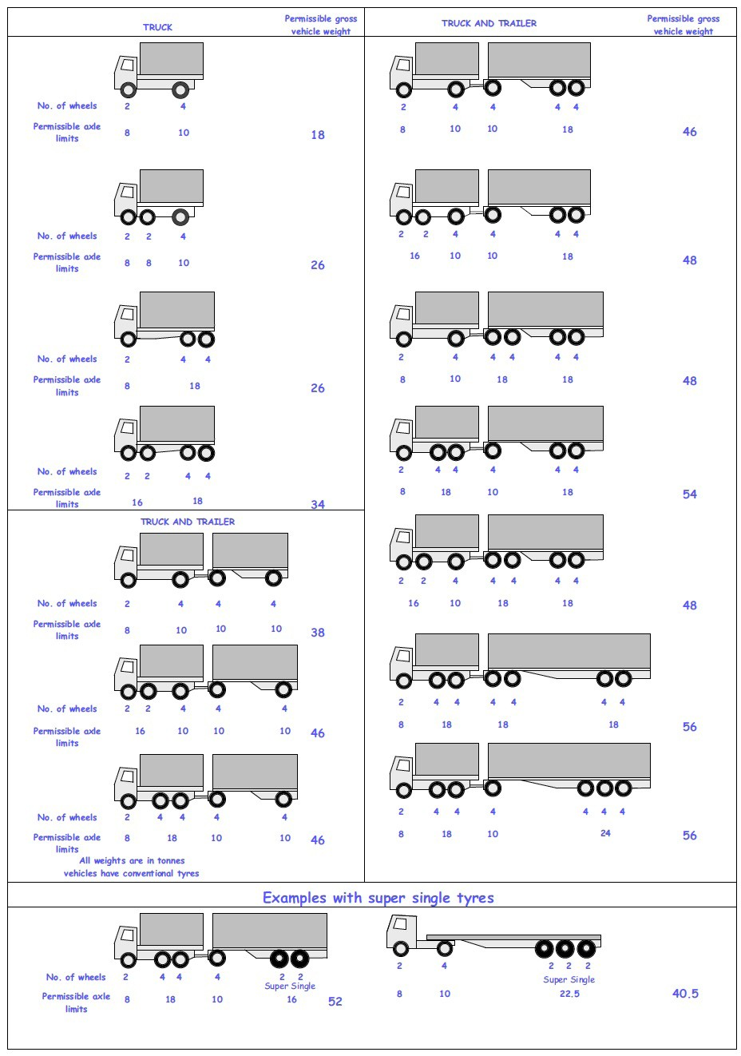

Axle Load Survey Samples
Similar to OD surveys, the trucks stopped for axle load measurements are considered a sample because all trucks cannot be measured. It is important that an adequate sample be obtained. The objective of the survey was to collect a 10% sample overall. From experience, this is most possible for low trafficked roads but a challenge for roads with high volumes.
Table 12-2 below presents the sample rates for each survey station. The survey on the Kampala – Masaka highway realized a smaller sample due to inclement weather. Nonetheless, the volume of trucks surveyed (147) was deemed large enough to produce a reliable analysis.
Overall, an average axle load sample of 19.8% was obtained.

Table 12-60: Description and location of axle load surveys
DESCRIPTION AND LOCATION OF ATC SURVEY SITES
Site Ref. | Highway / Link Name | Direction | Average 12-hr Sample | 12-hr Truck Traffic | Axle Load Sample, %
AL1 | Kampala – Entebbe Highway | Both | 290 | 900 | 32.2%
AL2 | Kampala – Masaka Highway | Both | 147 | 1,969 | 7.4%
AL3 | Kampala – Mityana Highway | Both | 135 | 931 | 14.5%
AL4 | Kampala – Hoima Highway | Both | 197 | 1,164 | 16.9%
AL5 | Kampala – Bombo Highway | Both | 608 | 2,246 | 27.1%
AL6 | Ishaka – Kasese Highway | Both | 100 | 426 | 23.5%
AL7 | Kampala – Jinja Highway | Both | 498 | 1,966 | 25.3%
AL8 | Mbale – Tororo Highway | Both | 280 | 2,343 | 12.0%
AL9 | Karuma – Arua Highway | Both | 83 | 683 | 12.2%
AL10 | Gulu – Nimule Highway | Both | 38 | 140 | 27.1%
Overall sample |  |  |  |  | 19.8%

Axle Load Analysis for Selected Routes
Axle load data analysis was undertaken for all 10 routes. The results of this analysis is included in Appendix K. However, in this section, the results of four key routes is highlighted. The selected routes are: Kampala – Jinja, Kampala – Masaka, Kampala – Hoima and Kampala – Gulu highways.
In general, the axle load data was analysed for the following:
- Average total loading per truck type – for this key aspect, the average total loading per truck type was analysed by direction. The vehicle load limit was also plotted to provide context.
- Proportion of overloaded trucks. Any truck is considered overloaded if the weight on any of its axles exceeds the specified load limit by more than 5%. The truck loads were therefore analysed by axle to determine the level of loading for each truck, and to determine whether it was overloaded or not.
- Percentage by which trucks are overloaded – from the analysis of loading per axle above, the proportion by trucks are overloaded is provided. This provide a picture of the extent of overloading.
- Description of loads – this analysis determines the most common load type on each of the highway by direction.

Kampala – Masaka Highway
Figure 12-118: Average total truck loading (Kampala-Masaka Highway)
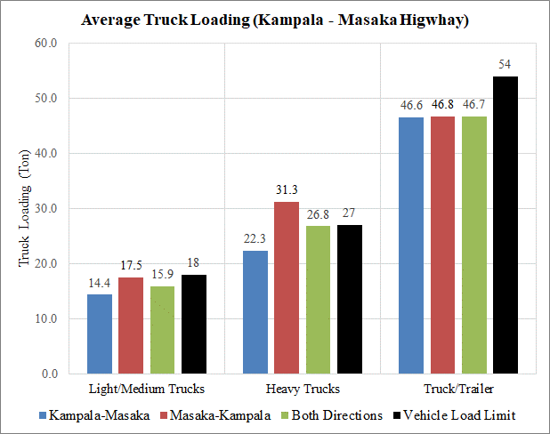

- The following observations can be made with respect average total truck loading (Figure 12-3). Analysis shows that total loading is broadly within the allowable total truck load limits. The exception is with heavy trucks in the Masaka – Kampala direction.
- Figure 12-4 however presents a different picture when the truck loading is analysed by axle. The analysis shows that trucks are highly overloaded. The Masaka – Kampala has the highest overloading with almost all trucks showing overloading.
- In the Kampala – Masaka direction, there is less overloading. Articulated trucks and truck trailers show the highest overloading in this direction.
Figure 12-119: Average proportion of overloaded trucks (Kampala-Masaka Highway)
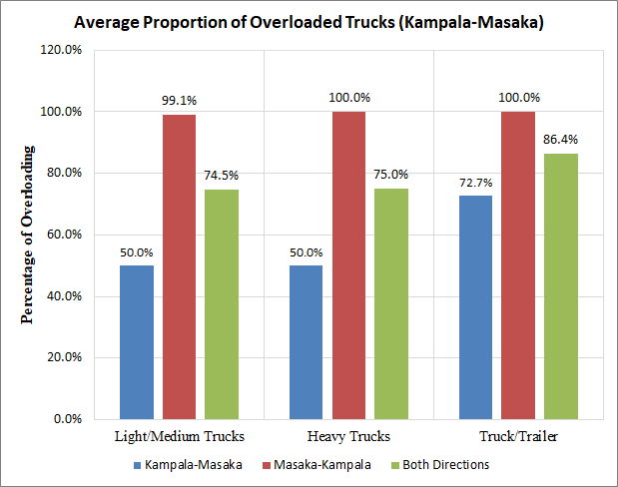

Figure 12-120: Percentage by which trucks are overloaded (Kampala-Masaka Highway)
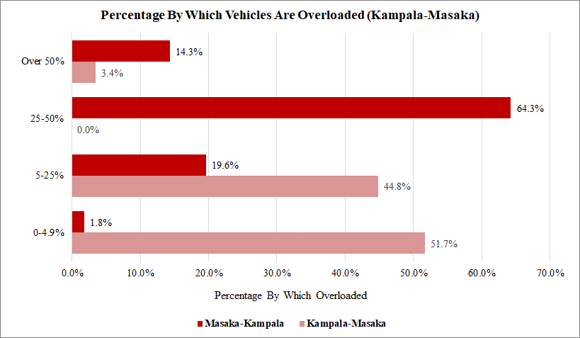
- Figure 12-5 above shows that 51.7% of all trucks in the Kampala – Masaka direction are within the allowable axle loads. The remainder of the trucks have axle loads between 5-25% above the loading limits (44.8% of all trucks) and a small amount (3.4% of trucks) have higher loads.
- For the Masaka – Kampala direction, only 1.8% have allowable axle loads.
- Most trucks exhibited loading of 25% - 50% above the allowable load limits. 14.3% of all trucks have loads that are 50% higher than the load limits.
- Figure 12-6 shows that in the Masaka – Kampala direction, the most predominant load type is construction material. This was observed to be most sand from the Lwera sand mining area. It is envisaged that the high overloading is due to the absence of a UNRA axle load weighing station between Lwera and Kampala (the destination of these products). There is a designated mobile weighing area at Buwama Town, however, based on the observed results, it may seem that this is not effective.
- The comparison between vehicle loading and axle loading to determine whether a vehicle is overloaded or not shows significantly different results. It may be a policy issue. There is a need to clarify on the basis to determine vehicle overloading.

Figure 12-121: Load description (Kampala-Masaka Highway)
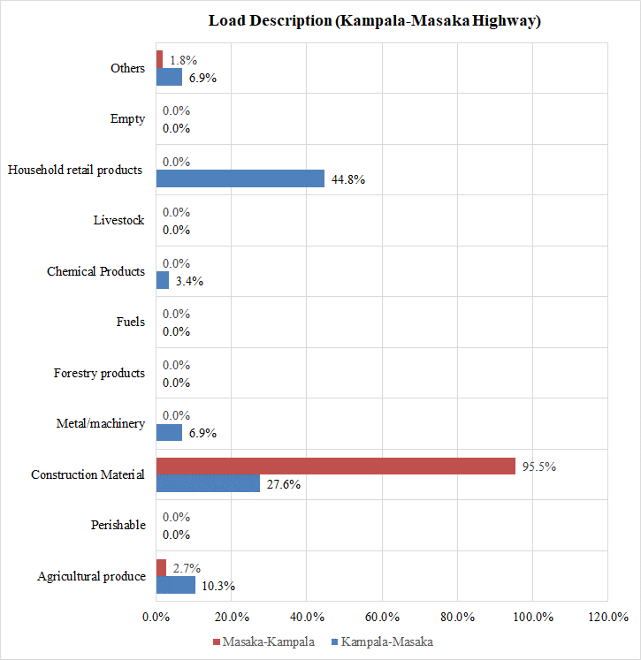

Kampala – Hoima Highway
Figure 12-122: Average total truck loading (Kampala-Hoima Highway)
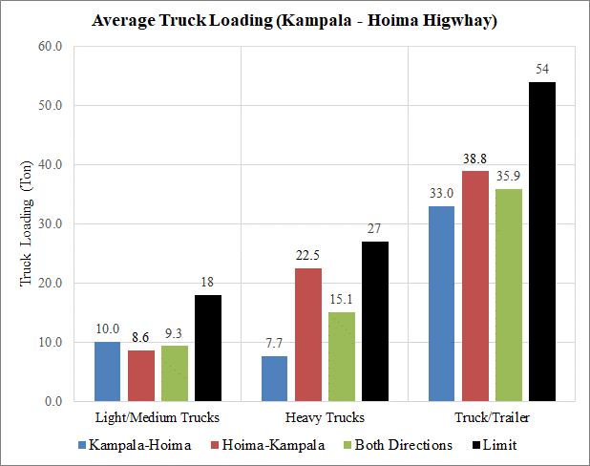
- Figure 12-7 above shows that with regard to total truck loading, the loading on the highway is below the allowable limit.
- However, with respect to axle loading, some overloading is observed (Figure 12-8). Truck trailers exhibited the highest overloading with an average of over 60% trucks overloaded in the two directions combined.
- However, a further examination of the axle loads (Figure 12-9) shows that most trucks (an average of 77% for both directions) are within the allowable load limits of 0 to 5%.
- Figure 12-10 shows that the predominant load type is currently agricultural produce.

Figure 12-123: Average proportion of overloaded trucks (Kampala-Hoima Highway)
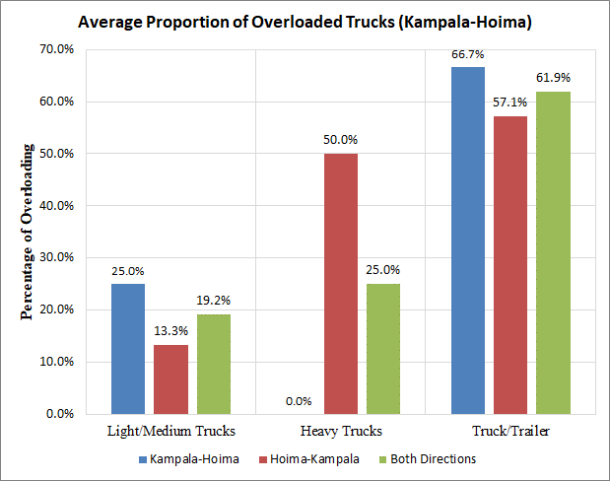

Figure 12-124: Average proportion of overloaded trucks (Kampala-Hoima Highway)
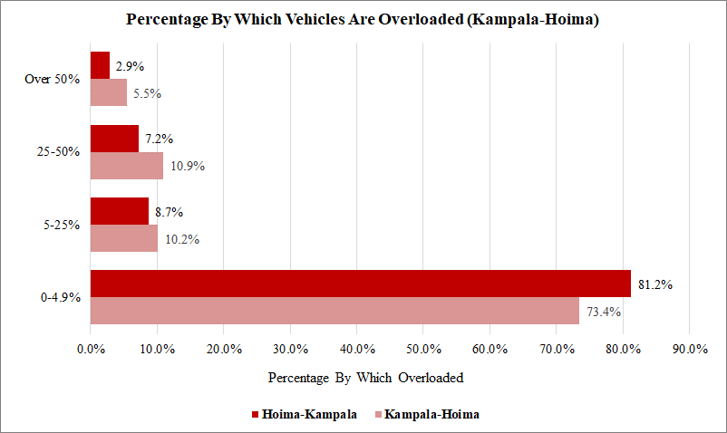

Figure 12-125: Load description (Kampala-Hoima Highway)
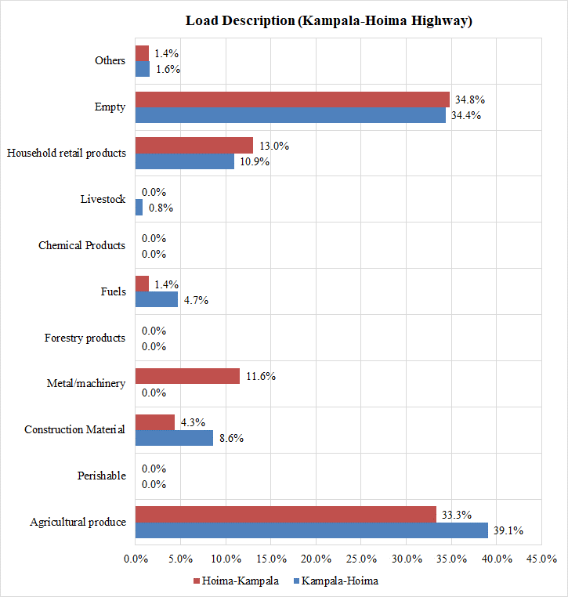

Kampala – Gulu Highway
- Figure 12-11 shows that the average total truck loads are below the allowable truck load limits except for truck trailers in the Kampala – Gulu direction.
- When the data is analysed by axle (Figure 12-12), some level of overloading is observed. The figure shows that overloading is highest for truck trailers, with an average of 73.1% overloaded for both directions.
- Figure 12-13 however shows that most trucks are within the allowable axle load limits (60.2% in the Kampala-Gulu and 51.4% in the Gulu-Kampala directions). Nonetheless, a significant amount of trucks are overloaded with 24% on average carrying loads which are 50% heavier than the axle load limits.
Figure 12-126: Average total truck loading (Kampala-Gulu Highway)
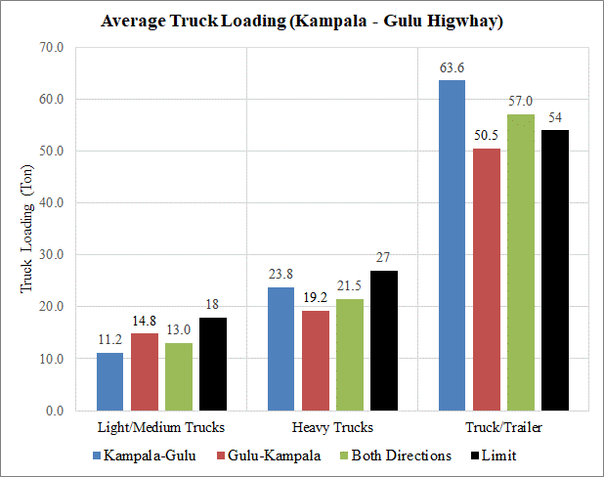

Figure 12-127: Average proportion of overloaded trucks (Kampala-Gulu Highway)
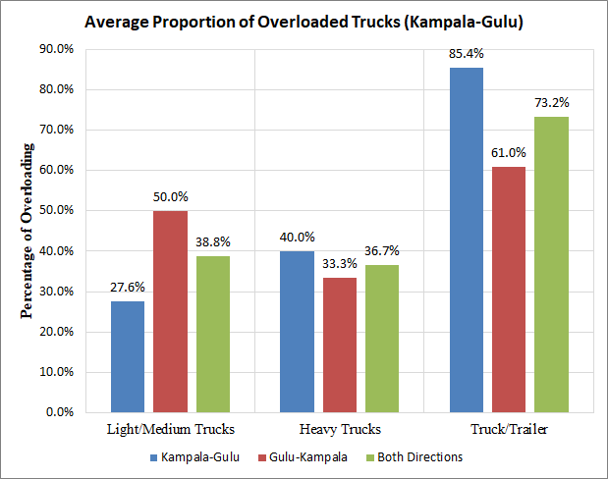

Figure 12-128: Average proportion of overloaded trucks (Kampala-Gulu Highway)
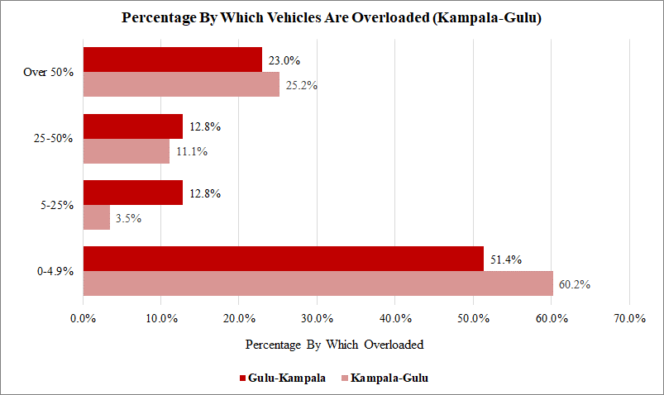
Figure 12-129: Load description (Kampala-Gulu Highway)
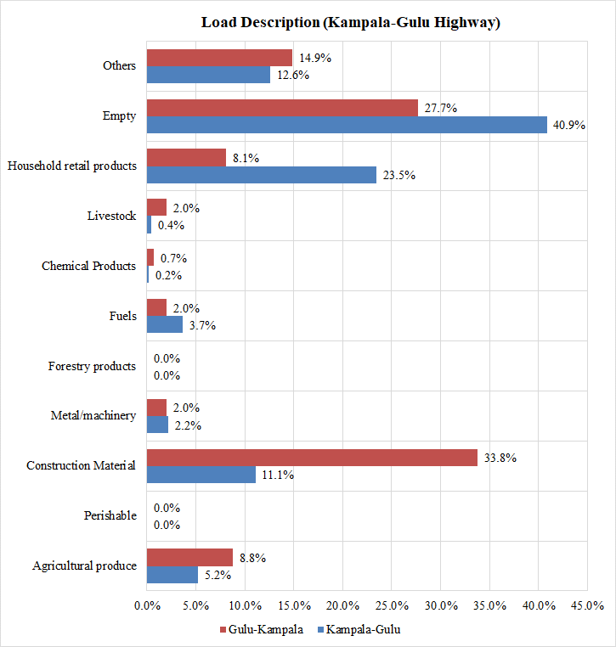

Kampala – Jinja Highway
- Figure 12-15 shows that average total truck loading is well below the allowable load limits for all truck types.
- Analysed for axle loading (Figure 12-16), the data shows that there is some overloading especially for heavy trucks in the Jinja-Kampala direction. However, Figure 12-17 shows that most of this observed overloading is within the allowable limits. The most affected direction is Jinja-Kampala, which has over 30% of trucks carrying loads that are above the allowable limits.
Figure 12-130: Average total truck loading (Kampala-Jinja Highway)
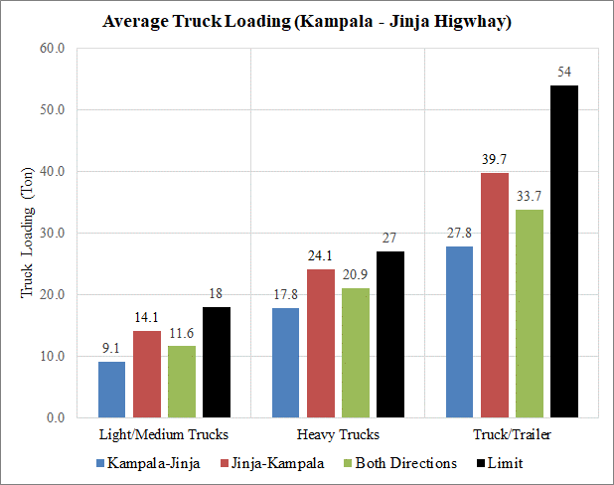
Figure 12-131: Average proportion of overloaded trucks (Kampala-Jinja Highway)
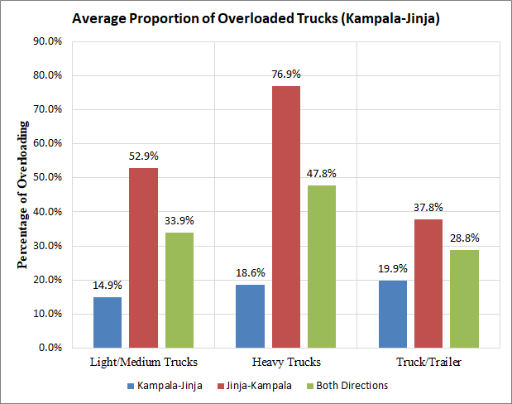

Figure 12-132: Average proportion of overloaded trucks (Kampala-Jinja Highway)
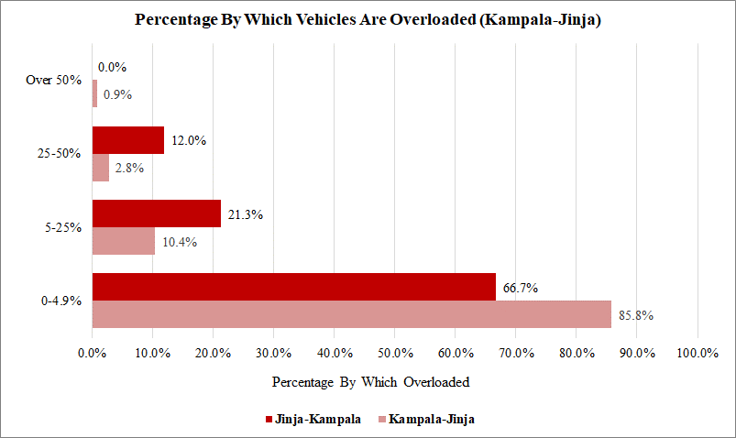
Figure 12-133: Load description (Kampala-Jinja Highway)
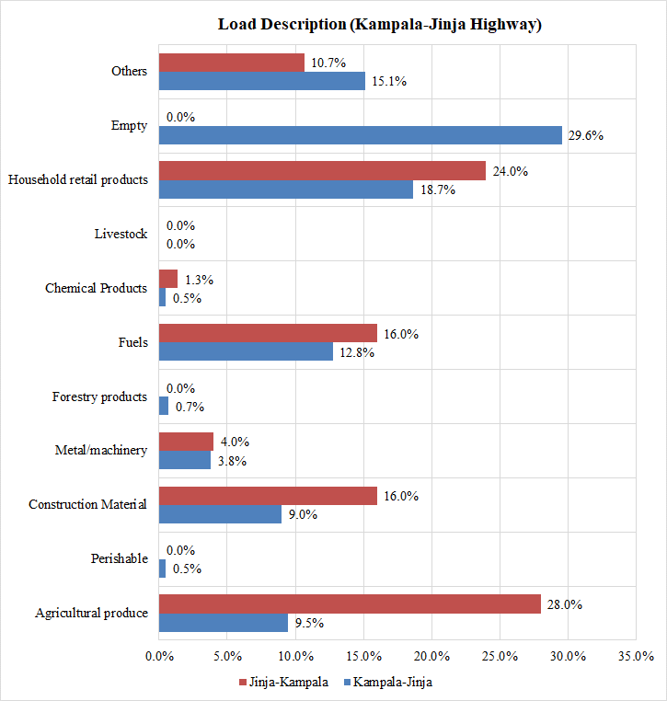

APPENDICES

Appendix A – Survey Forms

Appendix B – MCC Data Analysis Results

MCC Data – Cordon 1

MCC Data – Cordon 2

MCC Data – Cordon 3

MCC Data – Cordon 4

MCC Data – Cordon 5

Vehicle Registration Data (on CD)

Appendix C – OD Data Analysis Results

OD Data – Cordon 1

OD Data – Cordon 2

OD Data – Cordon 3

OD Data – Cordon 4

OD Data – Cordon 5

National OD Matrix (On CD)

Appendix D – JTC Data

Appendix E – Journey Time and GIS Data

Journey Time Data

GIS Data (on CD)

Appendix F – Stated Preference Data

Appendix G – Public Transport Data (on CD)

Appendix H – Accident Data (on CD)

Appendix I – Ferry Data Analysis

Appendix J –ATC Data

Appendix K – Axle Load Data Analysis

Ministry of Works and Transport database (2017) and UNRA data 2019
Table 20, Page 76, Manual for Road Investment Appraisal
According to URA, these are the years for which vehicle registration data is correctly recorded.
National Transport Master Plan Including A Transport Master Plan For The Greater Kampala Metropolitan Area (NTMP/GKMA), Abridged Version (MoWT, August 2009)
On the depreciation of automobiles: An international comparison (Karl Storchmann, Department of Economics, Yale University) – Published in Transportation journal (issue 31, 2004, pages 371-408)
OECD – Organisation for Economic Co-operation and Development
UK Design Manual for Roads and Bridges (DMRB), TA 11/09, Annex 8
Statistical Abstract 2019, Table 2.6.13
UNRA (Vehicle Dimensions and Load Control) Regulations, 2017

